
Field Newsletter (25) September 2026
Welcome to October. If you haven’t already submitted your Record of Experience, please try to do it soon.
Moving Indoors - Evelyn Roxburgh

The curtains are closing on the outdoor season and what a season it’s been with many officials involved in both the Commonwealth Games and European Championships.
For those of us who haven’t had enough of the rain and wind the cross-country events beckon.

Allocations for indoors will soon be dropping in our inboxes and maybe it’s time to move out of your comfort zone.
Remember to tick the boxes for things you haven’t tried and might enjoy: declarations, call room, tech team, results, presentations. These are all essential duties which contribute to the success of an event.

Thoughts from the Field - Caroline Johnston


In recent weeks you should have received an email from Colin Hutcheson regarding a survey. Thank you to all who took the trouble to complete it.

These questions were devised by a sub group of the Recruitment, Retention and Rewards committee (RRR) and we are always keen to receive your views on your experience as an official so that we can feed back to Scottish Athletics evidence of the general health and wellbeing of their most important asset, the Purple/Red Army.

So, if anything happens or an idea occurs to you during the year please get in touch
cpgs21@gmail.com

**Any minute now the indoor availability email will drop into the inbox. Yip, that time again. Nope, not going to mention how many shopping days to Christmas. The indoor season is a good opportunity for new officials to gain experience working closely with our more experienced colleagues.

BY FAR THE EASIEST WAY TO GET INVOLVED AND TO RECEIVE INFORMATION IS BY COMPLETING AN AVAILABILITY RETURN

With events usually taking place at the Glasgow International Arena (ex-Emirates Arena) we are all officiating under the same roof so the inexperienced can be paired up with the very experienced and pearls of wisdom can be passed on in situ. The majority of events will be post festive season, but there are some that will pop up soon so look out for them. Hope to see many of you there.

Article in the Herald about the Kelvin Hall – brought back memories
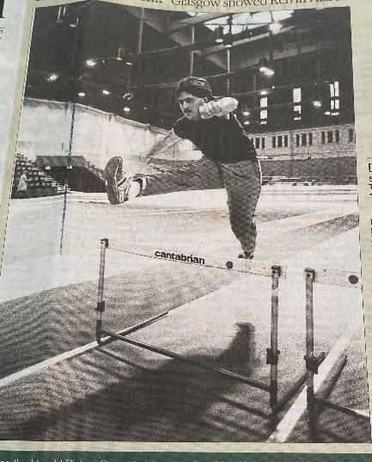
In November 1987, The Glasgow Herald hailed the opening of the Kelvin Hall as ‘one of the most imaginative and ambitious sports developments in the UK’.
The Kelvin Hall was to be not just for elite athletes; the facilities were available for hire. Charges would vary from £3.10 per hour for badminton court to £65 per hour for the athletics arena.
The picture shows an enthusiast trying out the indoor running track Perhaps someone might recognise him?
I think I was there from 1990 – but I’m sure some of our officials remember its opening day!
Current and Future Roles for AI and Advanced Technologies in Athletics
Pam Robertson sent information from a presentation by:
JOHN-PAUL CLARKE Ernest Cockrell, Jr. Memorial Chair in Engineering | The University of Texas Agenda
- Why do we need artificial intelligence (AI) and other advanced technologies in athletic
- What is AI?
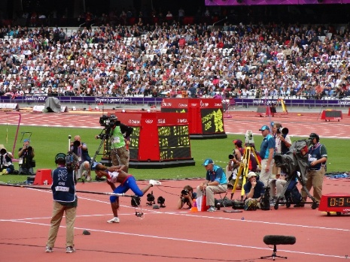
- What is possible with AI and other advanced technologies?
From Athens 1896, through to the present day, many technologies have been introduced and have evolved, but we still use a huge number of people to run an event.
The presentation outlines different systems of thought and behaviour and aims to explain Machine Learning and the technologies already available and developments to come.
If you are interested in reading this article – copy the link below and download the article:
https://web5.jamaica-gleaner.com/article/sports/20260303/track-and-fields-future-rely-ai-technology-dr-clarke

We are consistently trying to keep up to date with technology and during the outdoor season we have been testing an online equipment checking system which will be used at our Senior competitions to allow officials the opportunity to know what is required if selected for that role at a UK match.
During Indoors we hope to trial camera equipment at the take off board (working with our UK officials to consider best options)… more information about this will come out soon.

Indoor Events– Field Events

SAIL
- Sunday 15th November – choice of am, pm or both
- Sunday 6th December - choice of am, pm or both
- Sunday 24th January - - choice of am, pm or both
- Sunday 21st March – FINAL

FUN DAY
Sunday 25th October – U12 event TBC

Lots more events to come. The easiest way is to fill in an availability form when it comes – that way you will be reminded of dates as they approach and be given all relevant information.

