Starter and Starter’s Assistant - Level 2 Questions - Candidate
Level 2 Starter and Starter Assistant applications
Total marks = 83, Pass mark = 62 (75%)
Level 2 Starter’s Assistant only applications
Answer questions 1 to 30A.
Total marks = 46, Pass mark = 34 (75%)

Level 2 Starter applications only (if currently a Level 2 Starter’s Assistant)
Answer questions 31 to 48.
Total marks = 37, Pass mark = 28 (75%)
Please circle/tick/insert your answer for each question.
You can use the UKA Rule Book and WPA Rule Book
to support you in answering the questions
NAME -
1. |  | Who has overall authority at the Start? (1 mark)
 | A | Track Referee
 | B | Start Co-ordinator
 | C | Chief Starter’s Assistant
 | D | Meeting Manager

2. |  | Why is it permissible, in an echelon start, for the rear of the block to extend beyond the outer lane line and not the inner lane line? (1 mark)
 | A | Because the outer lane line is part of the athlete’s lane and the block would not obstruct another athlete
 | B | Because the rear of the block could obstruct the athlete in the inner lane
 | C | Because the outer lane line forms part of the athlete’s lane
 | D | Because the rear of the block would not obstruct the athlete in the outer lane

2A. |  | Please provide the relevant rule number for question 2 (1 mark)

3. |  | Which answers correctly describe how the blocks shall be constructed? (3 marks)
 | A | Only blocks constructed by an approved manufacturer can be used
 | B | The foot plates shall be flat
 | C | The foot plates must be covered with the same material as the track surface
 | D | The foot plates shall be attached to a rigid frame
 | E | There shall be two-foot plates

3A. |  | Please provide the relevant rule number for question 3 (1 mark)

4. |  | If an athlete is using their own blocks or brings a set of unusual or even home-made blocks, who should you notify? (1 mark)
 | A | The Chief Starter’s Assistant
 | B | The Track Referee
 | C | The Meeting Organiser
 | D | The Start Co-Ordinator

5. |  | What rule number covers athlete’s vests in a relay race? (1 mark)
 | A | TR5 S1(3)
 | B | TR5 S1(2)
 | C | TR24.1
 | D | TR5.1

6. |  | Where a kit exception is allowed relating to the start (under UKA rules) who makes this decision? (1 mark)
 | A | The Start Co-Ordinator
 | B | The Chief Starter’s Assistant
 | C | The Meeting Organiser
 | D | The Track Referee

7. |  | Where would you find the competition rules on spikes/shoes? (2 marks)
 | A | TR5.2
 | B | TR8.3
 | C | World Athletics Rules / Shoe Regulations
 | D | TR26.2

8. |  | What rule applies to the number and position of Competition Bibs required? (1 mark)
 | A | TR5.9
 | B | TR5.7
 | C | TR5.8
 | D | TR5

9. |  | If an athlete reports to the start with a bib that has been folded, and they tell you it is to make it more comfortable to wear, would you? (1 mark)
 | A | Encourage them to wear the bib as issued and explain they could be disqualified if they do not
 | B | Accept their explanation and take no further action
 | C | Allow them to cut the bib to remove the folds
 | D | Ask the Chief Starter’s Assistant to disqualify them

10. |  | If an athlete reports for a track race wearing only a front bib, because they have previously been competing in the Long Jump, what action should you take? (1 mark)
 | A | Refuse to let them run
 | B | Tell them it will be fine to only wear one bib
 | C | Ask if they have a second bib, if not send them away to obtain one
 | D | Ask if they have a second bib, if not either make up a bib using the back of a spare number and black marker pen

11. |  | In what circumstances could you expect hip numbers, to be required to be worn by athletes in a race? (1 mark)
 | A | In all competitions
 | B | Where Photofinish is in use with a front facing camera
 | C | Where Photofinish is in use, in any race where the athletes can break from their lane
 | D | Where Photofinish is in use, in all sprint races

12. |  | Where would you require athletes to fix the Hip Numbers when the Photofinish Camera is on the outside of the track? (1 mark)
 | A | On the front of their shorts
 | B | On the right-hand side of their shorts
 | C | On the left-hand side of their shorts
 | D | No hip numbers would be required.

13. |  | In the following list which do you consider are generally essential to have in your Starter’s Assistant bag? (8 marks)
 | A | Clipboard
 | B | Pens/Pencils
 | C | Spare Safety Pins
 | D | Tape Measure
 | E | Spare Hip numbers
 | F | UKA Rule Book
 | G | Highlighter Pens
 | H | Warning Cards
 | I | Spike Gauge
 | J | Stopwatch
 | K | Thick Waterproof Marker Pen
 | L | Waterproofs
 | M | Sunscreen
 | N | Water bottle
 | O | Cards/Sticks for lane draws

14. |  | Under UKA Rules which card would be shown in a Under 16 Boys 100m for a first False Start by any athlete? (1 mark)
 | A | No card
 | B | Red and Black diagonal card to the whole field and to the athlete who False Started
 | C | Yellow and Black Diagonal card to the athlete who False Started
 | D | Green card to the whole field

14A. |  | Please provide the relevant rule number for question 14 (1 mark)

15. |  | Under UKA Rules, which card would be shown in a Under 20 Women 100m for a first False Start by any athlete? (1 mark)
 | A | Red and Black Diagonal card to the athlete who False Started
 | B | Yellow Card to the athlete who False Started
 | C | Yellow and Black Diagonal card to the athlete who False Started
 | D | Green Card to the whole field

15A. |  | Please provide the relevant rule number for question 15 (1 mark)

16. |  | Under UKA Rules which card would be shown in a Senior Men’s 110m Hurdles Decathlon for a first False Start by any athlete? (1 mark)
 | A | A Red and Black Diagonal card to the athlete who False Started
 | B | Yellow and Black Diagonal card to the athlete who False Started and then to the whole field
 | C | A Red Card to the athlete who False Started
 | D | A Yellow Card to the athlete who False Started

16A. |  | Please provide the relevant rule number for question 16 (1 mark)

17. |  | Under UKA Rules which card would be shown in a Senior Women’s 200m Heptathlon for a second False Start by any athlete? (1 mark)
 | A | A Yellow and Black Diagonal card to the athlete who False started
 | B | A Red Card to the athlete who False started
 | C | A Red and Black Diagonal card to the athlete who False Started and a Yellow and Black Diagonal card to the rest of the field
 | D | A Red and Black Diagonal card to the athlete who False Started

17A. |  | Please provide the relevant rule number for question 17 (1 mark)

18. |  | If, in any of the scenarios in Q14-Q17, the Starter asked for a conduct warning card to be shown what colour would the card be? (1 mark)
 | A | Red card
 | B | Yellow card
 | C | Red and Black Diagonal card
 | D | Green card

19. |  | Why should any warning card be at least size A5? (1 mark)
 | A | So that it can be seen both at the Start and around the track
 | B | So that if fits comfortably on a clipboard/in your pocket
 | C | So that the athlete(s) can see it
 | D | So the Field Judges can see it

20. |  | If an athlete is identified as having withdrawn from a final but subsequently reports for another track race at the same meeting what would happen? (1 mark)
 | A | It does not matter, no consequences for the athlete(s). They are able to compete in the later race.
 | B | Athlete cannot compete in later race, as this is against the rules
 | C | Athlete may be able to compete if, they give the starters assistant a valid reason for withdrawing
 | D | Athlete says they had withdrawn from the previous final because of a muscle spasm and are okay now. They are able to compete in the later race

21. |  | Who would make the decision about the athlete competing in Q20? (1 mark)
 | A | The Meeting Manager
 | B | The Track Referee
 | C | The Start Co-Ordinator
 | D | The Chief Starter’s Assistant

22. |  | You are the Starter’s Assistant on a 200m race, Starter has instructed the athletes “on your marks” and although they are subsequently settled, you notice an athlete has part of their hand touching the start line. In the first instance, what would you do? (1 mark)
 | A | Nothing as it is a minor infringement
 | B | Raise your clipboard to alert the Starter
 | C | Move onto the track to the athlete’s lane to ask them to move their hand back
 | D | From the Starter Assistants’ position on the outside of the track, ask the athlete to move their hand behind the line

23. |  | In the same race as Q22 you are satisfied all athletes are correctly “on their marks”. Before the “set” command you notice that the knee of an athlete has lost contact with the ground. You ask the athlete to put their knee on the ground, and the athlete does not respond. What would you do?  (1 mark)
 | A | Nothing as the Starter will have seen it
 | B | Ask the athlete to put their knee back on the ground
 | C | Raise your clipboard to alert the Starter
 | D | Move onto the track to the athlete’s lane to ask them to put their knee back down

24. |  | You are the Starter’s Assistant on an 800m race, the Starter has instructed the athletes “on your marks” and although they have settled, you notice an athlete has one foot on the start line. What would you do? (1 mark)
 | A | From a position on the outside of the track, ask the athlete to move their foot behind the line
 | B | Nothing as it is an 800m race and it is important not to delay the start
 | C | Raise your clipboard to alert the Starter
 | D | Move onto the track to the athlete’s position to ask them to move their foot back

25. |  | If for any reason after the Starter has instructed the athletes either “on your marks” or “set” you raise your clipboard to alert the Starter to an infringement, what should you do? (1 mark)
 | A | You show the athlete a warning card
 | B | You advise the Starter (through the Chief Starter’s Assistant if there is one) why you have raised your clipboard and wait for the Starter to instruct the Starter’s Assistants and Athletes
 | C | Nothing it is up to the Starter to instruct the athletes
 | D | You speak to the athlete concerned to explain the infringement then raise your clipboard to the Starter

26. |  | In a meeting where Photofinish is in use why is it important that in sprint races the athletes are in their allocated lane wearing the correct bib as shown by the Start list?  (1 mark)
 | A | It allows the Announcer to introduce the athletes to the spectators
 | B | It allows the Track Judges to identify the athletes
 | C | It helps the Timekeepers to identify the athletes
 | D | It allows the Photofinish Officials to identify the athletes

27. |  | In a meeting where Photofinish is in use an athlete in the 200m sets up and starts in Lane 3 (because the athlete drawn in Lane 3 has not reported) and not Lane 7 as shown on the Start list, what could be the consequence of this? (1 mark)
 | A | They would be disqualified by the Track Referee
 | B | They would not appear in the official result
 | C | Photofinish would record the athlete and time under the wrong name
 | D | None of the athletes in the race would receive their correct position or time

28. |  | You are the Starter’s Assistant for a 100m, an athlete reports early to you and advises they are also competing in the Long Jump which is taking place at the same time. What would the best course of action be? (1 mark)
 | A | Tell them it is too early to report, and they should return 5 mins before the start of the 100m
 | B | Tell them that a track race takes precedent over a field event.
 | C | Tell them you will check them in now, carry out kit/bib check and that they should return in time to race at the scheduled time
 | D | Tell them you can ask the Starter to delay the race for a few minutes to give them time to report

29. |  | As a Starter’s Assistant, for a 100m race with athletes in all 8 lanes. Which letter, indicates the correct position you would stand at, to signal to the starter that the athletes are race ready?  (1 mark)
 | A
 | B
 | C
 | D
 | E
 | F
 | G

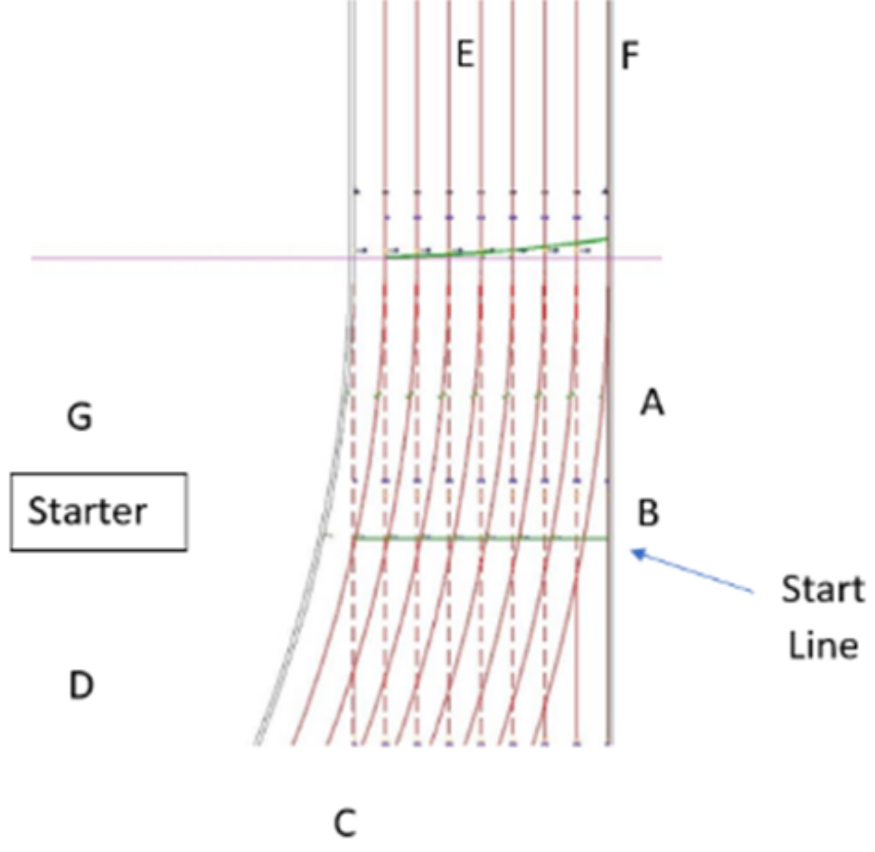
30. |  | You are the Starter’s Assistant for a 100m Wheelchair Race, and after the ‘set’ command, you notice the front of the leading wheel of the athlete in Lane 4, is over the start line. After signalling to the starter, what would you do? (1 mark)
 | A | No action is required, as the athlete’s torso is behind the start line
 | B | Ask the athlete to roll back, as the whole of front wheel must be behind the start line
 | C | Ask the athlete to roll back, so no part of the front wheel, that is in contact with the ground, is touching the start line
 | D | Ask the athlete to roll back, as the axle (centre point) of the front wheel is in-front of the start line

30A. |  | Please provide the relevant rule number for question 30 (1 mark)

31. |  | In the following list which do you consider are generally essential to have in your Starter’s bag?  (5 marks)
 | A | Clipboard
 | B | Pencils/Pens
 | C | Waterproofs
 | D | Safety Pins
 | E | Red Hat
 | F | Ear Defenders
 | G | Spare Numbers
 | H | Screwdriver
 | I | Walkie Talkie
 | J | Yellow Sleeve
 | K | Whistle
 | L | UKA Rule Book

32. |  | If you are using an Electronic Start system, which of the following statements are correct? (1 mark)
 | A | You do not need to use a yellow sleeve and/or red hat
 | B | Once the Start system has fired to start a race it cannot be fired again until it is reset
 | C | You do not need to set up;’ your starting position where the timekeepers can reasonably see you
 | D | The Electronic Start system and Recall must produce the same noise
 | E | The Recall must have a distinct, different, and audible noise identifying a false start
 | F | After a successful start you must take care not to fire the Electronic Start system again

33. |  | What do UKA rules advise about “hold” times? (1 mark)
 | A | The hold must be 2.5 secs
 | B | The hold must be as quick as possible
 | C | It does not matter if athletes are moving when you fire the device
 | D | The athletes must be motionless before you fire the device

34. |  | What reasons may you, as the Starter, have to abort a start and ask the athlete’s to “stand up”? Select all that apply (5 Marks)
 | A | Noise from spectators or elsewhere
 | B | Athlete raises their hand
 | C | Noise or interference from a Field Event
 | D | You are unsure if this is a heat or a final
 | E | Starter distracted
 | F | You are unsure what age group you are starting
 | G | All teams in a relay race need to have the same-coloured relay baton
 | H | Athletes take too long to settle

35. |  | If in your view an athlete is taking too long to settle “on their marks” what are your options? Select all that apply (3 Marks)
 | A | Continue with that start of the race, because only the moving athlete is disadvantaged
 | B | Ask the athletes to “stand up” (or “wheel back” if a wheelchair race)
 | C | Ask the athletes to settle much quicker and do not show the race any card
 | D | Ask the Starter’s Assistant to disqualify the moving athlete
 | E | Ask the Starter’s Assistant to ask the athlete what the problem is
 | F | Ask the athletes to settle much quicker and show the race a Green Card

36. |  | If you recall a race for a false start in a 100m, how should you identify which athlete the Starter’s Assistant should show a card to? (1 Mark)
 | A | Using the athlete’s lane number
 | B | Using the athlete’s name
 | C | Using the athlete’s club
 | D | Using the athlete’s bib identity

37. |  | In a sprint race, what determines a False Start? (1 Mark)
 | A | Any movement by an athlete
 | B | The athlete moving their hips
 | C | Any movement that results in a foot or hand losing contact with the ground
 | D | Moving their head up or down

38. |  | Which UKA Rule covers the criteria for False Starts? (1 Mark)
 | A | TR16.9
 | B | TR16.7
 | C | TR16.8
 | D | TR16.6

39. |  | What UKA rule would you disqualify an athlete for a False Start? (1 Mark)
 | A | TR16.8
 | B | TR16.9
 | C | TR16.7
 | D | TR16.6

40. |  | As the Starter you have disqualified an athlete for a False Start, the athlete complains to the Track Referee saying they believe they did not False Start. Who would decide on the fairness of your decision? (1 Mark)
 | A | Meeting Organiser
 | B | The Field Referee
 | C | The Track Referee
 | D | The Chief Starter’s Assistant

40A. |  | Please provide the relevant rule number for question 40 (1 mark)

41. |  | You are starting a 400m and have instructed “on your marks”, the athletes settle but you as the starter notices the athlete in lane 5 raises their hand. What would you do? Select all that apply (4 Marks)
 | A | Ask the athletes to “stand up”
 | B | Ask the Starter’s Assistant to find out from the athlete what the problem is and report to the Starter
 | C | Disqualify the athlete
 | D | Approach the athlete yourself to find out what the problem is
 | E | Ask the Starter’s Assistant to show a Red Conduct Warning
 | F | Consider what card should be shown
 | G | Ask the Starter’s Assistant to show the card you have decided on

42. |  | In the same race as Q41 what UKA rule would apply? (1 Mark)
 | A | TR16.5.1
 | B | TR16.5.2
 | C | TR16.5.3
 | D | TR16.5

43. |  | You are the Starter in a 200m having said “set” you notice the athlete in Lane 6 does not respond at once and you abort the start and ask the athletes to “stand up”. Potentially has the athlete (1 Mark)
 | A | Disturbed the start
 | B | False Started
 | C | Delayed the Start
 | D | Failed to comply with your command

44. |  | You are setting up to start a 200m and note there is a Shot Put competition taking place on the inside of the track adjacent to the 200m start lines. What action would you take? Select all that reply (4 Marks)
 | A | Adjust your starting position to move to the outside of the track
 | B | Delay starting the 200m until the Shot Put has finished
 | C | Liaise with the lead Shot Put official
 | D | Ask the lead official to assemble the Shot Put athletes away from the start, for safety reasons
 | E | Set up and retreat from start area until scheduled race time
 | F | Agree with the lead Shot Put official, to pause their competition whilst the start is underway
 | G | Go to start position just in time to start the race and when the Shot Put is paused

45. |  | You are the Starter for a 1500m Wheelchair Race, and two athletes collide within the first 50m of the race. What would you do? (1 mark)
 | A | Recall the race and ask the Starter’s Assistant to show a Green Card to the whole field
 | B | Recall the race and ask the Starter’s Assistant to disqualify both athletes by showing a Red and Black Diagonal card to each one
 | C | Recall the race and ask the Starter’s Assistant to show a yellow/black diagonal card to both athletes for committing a False Start
 | D | No requirement to recall the race, as it is classed as a ‘racing incident’

45A. |  | Please provide the relevant rule number for question 45 (1 mark)

46. |  | You are the Starter for a 100m T11 Track Race, and the Guide Runner of one of the athletes False Starts? What would you do? (1 mark)
 | A | Recall the race and ask the Starter’s Assistant to show a Red/Black diagonal card to the athlete of the Guide Runner who false started and then show a Yellow/Black Diagonal Card to the rest of the field
 | B | No action required, as the race can only be recalled if the athlete had committed the False Start, not the Guide Runner
 | C | Recall the race and ask the Starter’s Assistant to show a Red and Black Diagonal card to the Guide Runner who False Started. The athlete will run without a Guide Runner for the race
 | D | Recall the race and ask the Starter’s Assistant to show a Red and Black Diagonal card to the athlete of the Guide Runner who False Started.

46A. |  | Please provide the relevant rule number for question 46 (1 mark)

47. |  | For a 100m race with athletes in all 8 lanes.  Which letter should the recall starter be positioned at? (1 mark)
 | A
 | B
 | C
 | D
 | E
 | F
 | G

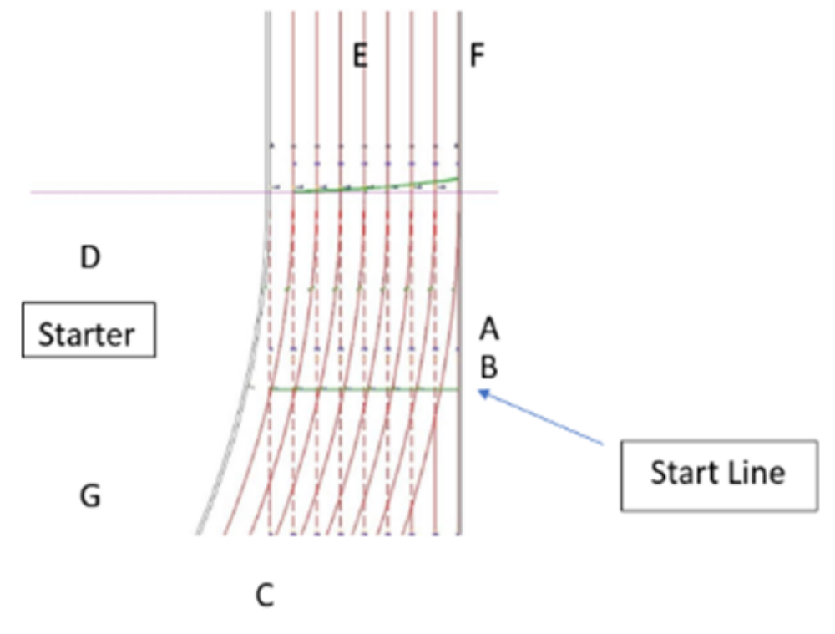

48. |  | For a 400m start, there are athletes in all 8 lanes. The starter is back beyond the finish line on the outside of the track. Where should the lead Starter’s Assistant signal from? Please select the letter to indicate the correct position. (1 mark)
 | A
 | B
 | C
 | D
 | E

