
Field Newsletter (22) June 2026
Welcome to June Please get in touch with ideas for your Newsletter.

What is the answer to this cryptic clue?
The least, important consideration for Field Officials.

High Jump – A jump off - Thanks to Evelyn for this reminder

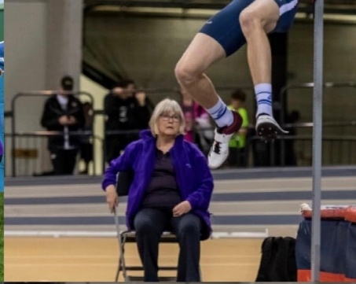
As we all know, there’s really no rushing a high jump especially when it seems you’re the only event in the stadium at the end of the day! If you reach the point where two or more competitors clear the same maximum height and cannot be separated by standard tie-breaking rules i.e.
- The fewest failed attempts at the height at which the tie occurred
- The fewest failed attempts throughout the competition
then you have to implement a jump-off (jump-off only in a Championship event).
The jumpers are given one additional attempt at a new height to decide the winner.

How the Jump-Off Process Works – see rule TR26.9.3
When athletes tie for a placement (only for first place in a competition), the rules outline a very specific sequence for the jump-off:
- The Starting Height: The bar is set to the next height above the highest height cleared by the tied athletes during the main competition.
- The Attempts: Each jumper is allowed exactly one attempt at this height.
- Determining the Winner: If one jumper clears the height and the other misses, the one who clears wins.
- If the Tie Continues: If both jumpers miss (or both clear), the bar is raised (if both missed, it is lowered) by 2cm and the jump-off continues until someone successfully clears a height that the others miss.

Competitor | Main competition |  |  |  |  |  |  | Trials at  Height  cleared | Total  Failures | Placing  Before  jump off
 | 1.75m | 1.80m | 1.84m | 1.88m | 1.91m | 1.94m | 1.97m
A | o | xo | o | xo | x | – | xx | 2 | 2 | 1=
B | – | xo | – | xo | – | – | xxx | 2 | 2 | 1=
C | – | o | xo | xo | – | xxx |  | 2 | 2 | 1=
D | – | xo | xo | xo | xxx |  |  | 2 | 3 | 4

Jump-off |  |  | Final Place
1.91m | 1.89m | 1.91m
x | o | x | 2
x | o | o | 1
x | x |  | 3
 |  |  | 4

In the example jump-off, the final cleared height is 1.88m, at which A B C and D each have one failure.
D has two failures at lower heights compared to one each for the other three, who proceed to a jump-off at the next height above the final cleared height. C is eliminated in the second round of the jump-off 1.89m, then B wins in the third round.

If an athlete is not jumping at a height, they automatically forfeit any claim to a higher place. If only one other athlete then remains, they are declared the winner regardless of whether they attempt that height.
In 2009, though, a new rule was introduced where the jump off was made optional, which meant that athletes could share the top spot if it was mutually agreed upon.

Thoughts from the Field

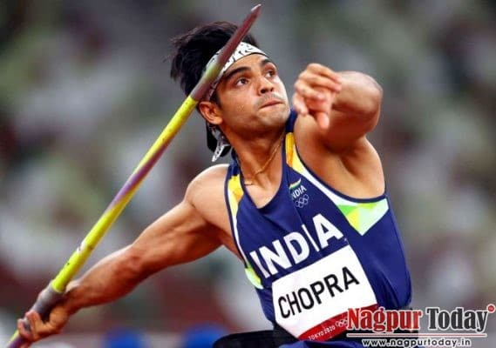
And suddenly its June! Competitions at every level are popping up everywhere. This is the ideal time to widen your experiences and give those slightly scary duties a go. Chief on the high jump with a stalwart official standing beside you is one. The warm up always seems to go on for ever, but once mastered the rest falls into place. Ask to have a go at the EDM. Lots of support around to see you through this one. And finally, the elephant in the field .... validity on the javelin. I would suggest you shadow an experienced official a couple of times before taking on this one. Lots if advice about.
This Photo by Unknown Author is licensed under CC BY-SA-NC

Most of all, enjoy the experience. We have lots of blossoming talent coming through all age groups. Add yours to theirs.

HEALTH & SAFETY: (always worth revisiting)

GENERIC
- Be alert and aware of your surroundings including kerbing, cables, starting blocks and hurdles
- Always look in both directions before crossing the track or any runway
- Do not cross or enter the infield or throwing sectors unless you are officiating on an event
- Check any equipment/implements/facilities are positioned safely and correctly and in good working order e.g., judges stand, starters podium
- Immediately notify/report to meeting management/ event organiser any concerns, accidents, injuries or near misses
- Please speak to your event leader, chief or referee if you are uncomfortable or not confident enough to undertake any role or duty assigned to you, so an alternative duty can be identified for you. This is especially important
if you have limited mobility that does not allow you to officiate in front of the throwing line/cage/circle
- If you suffer from any medical condition, that can impact on your concentration levels, please let the referee/chief know in advance or on the day, so appropriate duties and support can be arranged for you

A timely reminder:
It was highlighted at a recent SNAL match that some nails and pins were found in the sandpit (see pic below) …. Important that we remind ourselves when on raking duties or being in the tech team and responsible for digging the pit that we should be checking to ensure pit is clear. It is everyone’s responsibility to ensure safety and check the pit before and after competition.
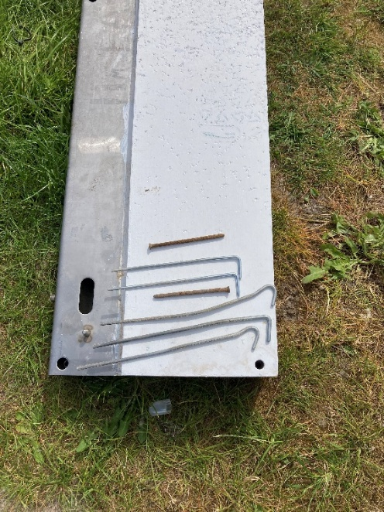
Sad News
Some of you will know our friend and colleague John Askew, England Athletics Official, who lost his fight for life at the end of March. England Athletics put a lovely tribute to John on their EA website, and I wanted to share this with you for those that knew and worked with John. John worked in the Tech Team at the World Indoor Athletic Championships at the Emirates, Glasgow in 2024.
John Askew: 1957-2026 - England Athletics

June and July– Field Events
Wed, 03 Jun | Disability | SDS Junior Championships | Grangemouth | Ally Love | alasdhair.love@scottishathletics.org.uk
Fri, 05 Jun | Schools | Secondary Relay Championships | Hutchison GS Glasgow | Margaret McInally | theoaks4@aol.com
Sat, 06 Jun | Schools | Scottish Schools Pentathlon Champs & Primary Track Relays | Grangemouth | Margaret McInally | theoaks4@aol.com
Sun, 07 Jun | League | Forth Valley League | Grangemouth | John McOmish | admin@forthvalleyleague.org.uk
Tue, 09 Jun | Open Graded | Kilbarchan AAC Open Graded Meeting 3 | Linwood | Jason Pender | jasonpender64@outlook.com
Fri, 12 Jun | Schools | Scottish Schools T&F Championships | Grangemouth | Margaret McInally | theoaks4@aol.com
Sat, 13 Jun | Schools | Scottish Schools T&F Championships | Grangemouth | Margaret McInally | theoaks4@aol.com
Sun, 14 Jun | Disability | Red Star Games | Crownpoint | Eddie Mcloone | eddiemcloone@hotmail.com
Wed 17 Jun | Open Graded | Ayrshire OG Meet 2 | Kilmarnock | William Marshall-Watt | secretary@ayrseaforth.co.uk
Sat, 20 Jun | Open Graded | GAA Sprints Gala (Track & Field) | Crownpoint | Nikki Manson | glasgowathleticsassociation@gmail.com
Sun, 21 Jun | League | Youth Development League Div 1 &2 | Grangemouth | Leslie Roy | leslie.roy1@virginmedia.com
Sun, 21 Jun | League | Youth Development League North East Div | Aberdeen | Leslie Roy | leslie.roy1@virginmedia.com
Sat, 27 Jun | Scottish Championships | SUPERteams Final | Kilmarnock | Ally Love | alasdhair.love@scottishathletics.org.uk
Sun, 05 Jul | League | Scottish National Athletics League | Aberdeen | Leslie Roy | leslie.roy1@virginmedia.com
Sun, 12 Jul | League | Central & South Scotland League Div 1 | Grangemouth | Barbara Knox | cssal1972@gmail.com
Sun, 12 Jul | League | Central & South Scotland League Div 2 / 3 | Crownpoint | Barbara Knox | cssal1972@gmail.com
Sun, 12 Jul | League | RAM League - East | Dundee | Carol Rose | carolvrose@hotmail.co.uk
Sun, 12 Jul | League | RAM League - North | Inverness TBC | Carol Rose | carolvrose@hotmail.co.uk
Sun, 26 Jul | Championship | Ayrshire T&F Championships | Kilmarnock | William Marshall-Watt | secretary@ayrseaforth.co.uk

