Outdoor – Ideal Starters’ Assistant Positioning

Straight line races

P2 P2
A2
A1

P1 P1
A2
A1

P1 8 7 6 5 4 3 2 1
I/C

P2
I/C

A3
P2

P1
A3
I/C
In Control (I/C) – Ensures athletes are lined up in a straight line prior to start, approx. 2-3mtrs behind start line, in preparation for presentation then Starters’ instructions. Then proceeds to check athletes in lanes 1-8 are settled for race as per duties given.
Assist 1(A1) – Assists I/C in preparation for race as per duties given. Then proceeds to follow in A2 check feet are in contact with blocks for lanes 5-8, then takes up relevant position dependant on level of meeting on outside of track in for start of race.
A1
Assist 2 (A2) – Assists with preparation for race as required per duties given. Then proceeds to lead, checking feet are in contact with blocks for lanes 4-1, then takes up relevant position dependant on level of meeting for the start of the race.
A2
Assist 3 (A3) – Takes up position 30m up track to prevent excessive run-outs of athletes. Then makes way to relevant position dependant on level of meeting on outside of track.
A3

Echelon races
I/C
In Control (I/C) – Ensures athletes are lined up in their lane prior to start, approx. 2-3mtrs behind start line, in preparation for presentation then Starters’ instructions. Then proceeds to check athletes in lanes 7-8 as per duties given.
Assist 1(A1) – Assists I/C in preparation for race as per duties given. Then proceeds to check athletes in lanes 4-6 in a position that requires the least amount of movement (none) where possible.
A1
Assist 2 (A2) – Assists with preparation for race as required per duties given. Then proceeds to check athletes in lanes 1-3 in a position that requires the least amount of movement (none) where possible.
A2
Assist 3 (A3) – Takes up position 30m up track to prevent excessive run-outs of athletes. Then makes way to relevant position dependant on level of meeting on outside of track.
A3

A2

A1

P1
A3

I/C

P2
A3

1500m, 3000m/5000m, 10000m
I/C
In Control (I/C) – Ensures athletes are lined up in a straight line prior to start, approx. 2-3mtrs behind start line, in preparation for presentation then Starters’ instructions. Then proceeds to check athletes are ready for the race as per duties given.
Assist 1(A1) – Assists I/C in preparation for race as per duties given. Then proceeds to take up a position at the side of track behind athletes so that any infringements may be spotted as per duties given.
A1
Assist 2 (A2) – Takes up position 40-50m up track to prevent excessive run-outs of athletes. Then makes way to relevant position dependant on level of meeting on outside of track.
A2

P1
A2

P2
I/C
A2
A1

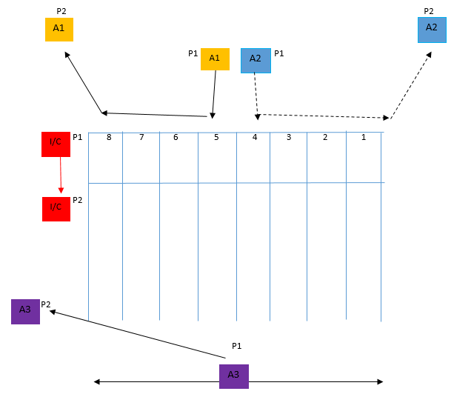
*Alternative for Straight Starts (CSA will advise on the day)*

400m Standard Oval Track – Starters Assistants Positioning
P1 = 1st position to take / P2 = 2nd position to take
When positioning yourself to check athletes on their start line, you should ideally position yourself in a place that lets you see what you need to with minimal movement.

Straight Line Races
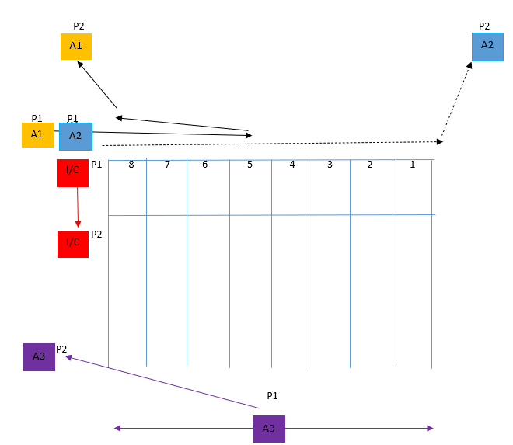
*dependant on track, A1/A2 may be positioned beside each other at the side of track prior to block check*
 | In Control (IC) | Ensures athletes are lined up in a straight line prior to the start, approximately. 2-3mtrs behind the start line, in preparation for the presentation, then the Starters’ instructions. Then proceeds to check that athletes in lanes 1-8 are settled for the race as per the duties given.
 | Assist 1 (A1) | Assists IC in preparing for the race as per assigned duties. Then proceeds to follow in A2 check feet are in contact with blocks for lanes 5-8, walks back and takes up relevant position dependent on the level of the meeting outside the track for the start of the race.
 | Assist 2 (A2) | Assists with preparation for the race as required per duties given. Then proceeds to lead, checking feet are in contact with blocks for lanes 4-1, then takes up a relevant position dependent on the level of the meeting for the start of the race.
 | Assist 3 (A3) | Takes up position 30m up the track to prevent excessive run-outs of athletes. Then makes way to the relevant position dependent on the level of the meeting outside the track.

Echelon Races
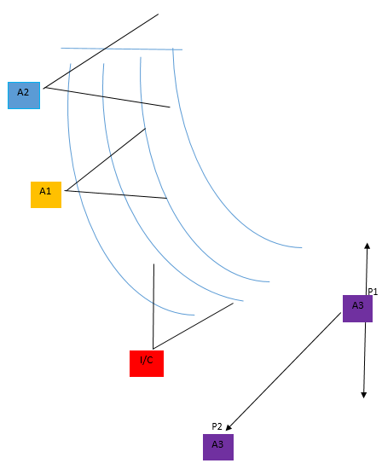
 | In Control (IC) | Ensures athletes are lined up in their lane prior to start, approx. 2-3mtrs behind the start line, in preparation for the presentation, then the Starters’ instructions. Then proceeds to check athletes in lanes 7-8, per duties, in a position that requires the least movement, preferably none, where possible.
 | Assist 1 (A1) | Assists IC in preparation for the race as per duties given. Then proceeds to check athletes in lanes 4-6 in a position that requires the least amount of movement (none), where possible.
 | Assist 2 (A2) | Assists with preparation for the race as required per duties given. Then proceeds to check athletes in lanes 1-3 in a position that requires the least amount of movement (none), where possible.
 | Assist 3 (A3) | Takes up position 30m up the track to prevent excessive run-outs of athletes. Then makes way to the relevant position dependent on the level of the meeting outside the track.

1500m, 3000m/5000m, 10000m

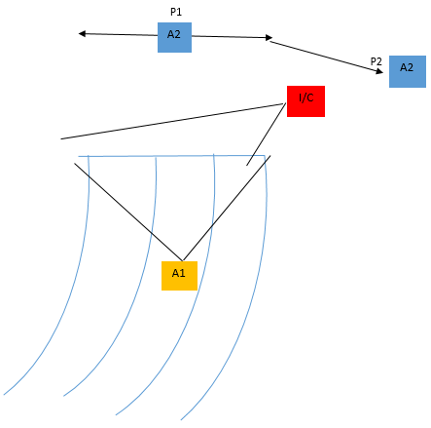

 | In Control (IC) | Ensures athletes are lined up in a straight line prior to the start, approximately. 2-3mtrs behind the start line, in preparation for the presentation, then the Starters’ instructions. Then proceeds to check that athletes are ready for the race as per duties given.
 | Assist 1 (A1) | Assists IC in preparation for the race as per duties given. Then proceeds to take up a position behind athletes so that any infringements may be spotted as per duties given.
 | Assist 2 (A2) | Takes up position 40-50m up the track to prevent excessive run-outs of athletes. Then makes way to the relevant position dependent on the level of the meeting outside the track.

Short Track – Starters Assistants Positioning
P1 = 1st position to take / P2 = 2nd position to take
When positioning yourself to check athletes on their start line, you should ideally position yourself in a place that lets you see what you need to with minimal movement.

Straight Line Races
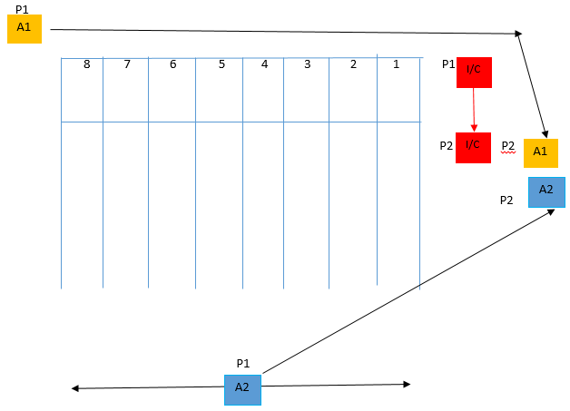

 | In Control (IC) | Ensures athletes are lined up in a straight line behind starting blocks prior to the start, in preparation for the presentation, then the Starters’ instructions. Then proceeds to check that athletes in lanes 1-8 are settled for the race as per the duties given.
 | Assist 1 (A1) | Assists IC in preparation for the race as per duties given. Then proceeds to lead, check feet are in contact with blocks for lanes 8-1, then takes up relevant position behind IC, ready for the start of the race.
 | Assist 2 (A2) | Takes up position 30m up the track to prevent excessive run-outs of athletes. Then makes way to the relevant position dependent on the level of the meeting outside the track.

Echelon Races

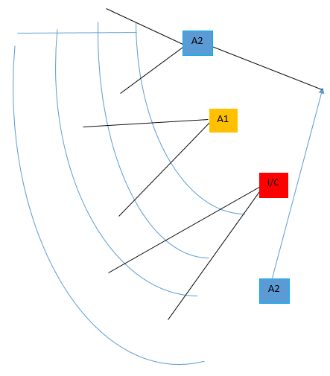
 | In Control (IC) | Ensures athletes are lined up in their lane prior to start, approx. 2-3mtrs behind the start line, in preparation for the presentation, then the Starters’ instructions. Then proceeds to check athletes in lanes 5-6, per duties, in a position that requires the least movement, preferably none, where possible.
 | Assist 1 (A1) | Assists IC in preparing for the race as per assigned duties. Then, proceeds to check athletes in lanes 3-4 in a position that requires the least amount of movement, preferably none, where possible.
 | Assist 2 (A2) | Assists with race preparation as required per assigned duties. Then proceeds to check athletes in lanes 1-2 in a position that requires the least amount of movement, preferably none, where possible.
 | Assist 3 (A3) | Takes up position 30m up the track to prevent excessive run-outs of athletes. Then makes way to the relevant position dependent on the level of the meeting outside the track.

