

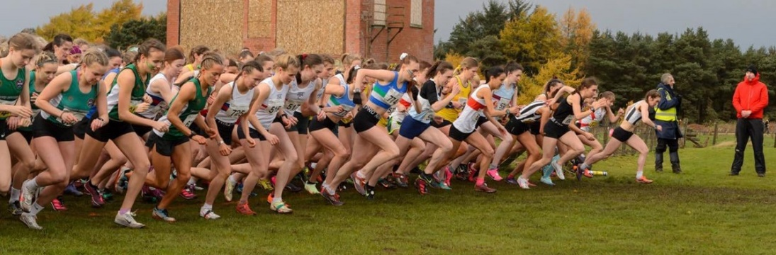

Starter & Starters Assistants Handbook
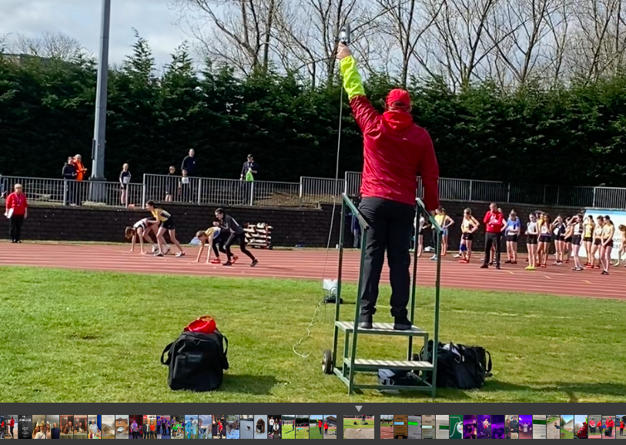

UKA Rules for Competition incorporating World Athletics Rules 2026–2028 have been used to inform this booklet.
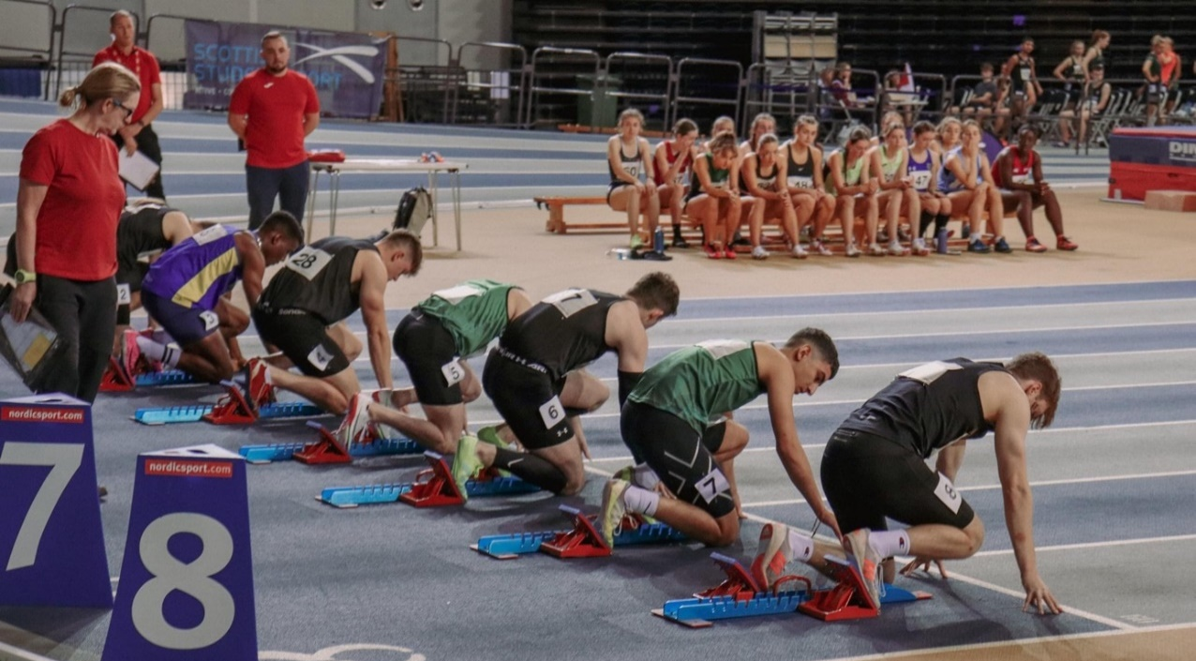

Introduction

The scottishathletics Start Team Peer Group has developed this handbook to encompass all relevant documentation, providing a single go-to source containing all relevant information used by scottishathletics Starters and Starters Assistants at Athletics events on short track (200m standard oval track with ‘inside’ 60m straight)) and 400m standard oval tracks, plus endurance races in Scotland.

The handbook outlines the various duties and roles within the Start Team, along with ancillary information, making it a useful tool for all Technical Officials, across all disciplines.

With the index hyperlinked, you can easily click between sections.

A huge thanks must also go to my fellow Starter/Starters Assistant Officials, many of whom contributed to the development of the handbook or provided valuable feedback on the contents.

Andrew Minnis
scottishathletics Starters/Starters Assistants Discipline Head and UKA Level 3 Starter & Level 4 Starters Assistant

Updates since the last edition
- Terms updated to reflect even age groups
- UPDATED TR15.1 – Starting Blocks
- UPDATED CR18.1 – Conduct warnings
- ADDED TR16.5.3 – twitching at the start
- ADDED TR44.6.3 – short track 800m starts
- Subgroup composition and remits
- Generic Briefing Notes/Starters Briefing
- Starter/Starters Assistant standard duties

Table of Contents
Start Team Structure & Organisation 3
Section I – Track & Field Guidance 3
Abbreviations 3
Start Coordinator (SC) 4
Start Referee (SR) 4
Starter (S) 5
Start Recaller(s) 5
Chief Starters Assistant (CSA) 6
CSA Duties 6
Lead Starters Assistant (LSA) 6
Starters Assistants (SA) 6
Equipment 8
Duty Sheets 9
400m Standard Oval Track – Starter Assistants Positioning 11
Short Track – Starter Assistants Positioning 14
Scottish Start Team - Generic Start Team Briefing Notes 16
Starters Generic Briefing 19
Meetings Check list for Start Coordinator 20
Section II – Endurance Guidance 21
Section III – Protocols & Rules 23
Scottish Athletics - Blue Card Protocol 23
Scottish Athletics - Radio Training and Protocols 25
Warning / Disqualification (DQ) Cards 25
Disqualification (DQ) Guide 26
Key Rules and Regulations – Relating to the Start 27
Section IV – Starting Equipment 32
TESS (The Electronic Start System) 32
SIS (Start Information System) 34
The ZCT ……..……………………………………………………………………………………………………………………………………………………………………………… 35
Section V - Scottish Start Team Peer Group 36
Section VI - Conduct 41

Section I – Track & Field Guidance

Start Team Structure & Organisation

The Scottish Start Team Discipline is comprised of all active Starters and Starters' Assistants. Throughout the document, all references to the Start Team include these officials.
All Officials of the Start Team must be well informed about the current Rules and how they should be interpreted. The Start Team must be in agreement on the procedures it will follow when implementing the Rules, to ensure events run smoothly.
Officials of the Start team must also understand each member's respective duties and roles.
A full description relating to each member of the Start Team (Start Coordinator, Starter, Recallers and Starters Assistants can be found below, also within Rules CR22 and CR23 of the UKA Rule book.

Abbreviations
SR - Start Referee
TK - Timekeeper
TM - Technical Manager
TR - Track Referee
UKA - UK Athletics
W - Warning issued to athlete
WA - World Athletics
WD - Withdrawn
WMA - World Masters Athletics
WPA - World Para Athletics
YC - Yellow Card
YRC - Yellow/Red Card
ZCT - Zero Control Test

BCP - Blue Card Protocol
CoC - Clerk of Course
CER - Combined Events Referee
CSA - Chief Starters Assistant
CW - Conduct Warning
DNS - Did Not Start
DQ / DQ’d - Disqualification / Disqualified
FOP - Field of Play
IC - In Control
IPC - International Paralympic Committee
LSA - Lead Starters Assistant
MM - Meeting Manager
NTD - National Technical Delegate
R1 - Recall 1
R2 - Recall 2
S - Starter
SA - Starters Assistant
SC - Start Coordinator
SIS - Start Information System

Start Coordinator (SC)

Responsible for the organisation and management of the Start Team. Their role is crucial to the smooth running of the units that make up the Start Team and the accurate, consistent implementation of the Competition & Technical Rules.

SC Duties
The Start Coordinator shall:
- Allocate duties to team members.
- Supervise the duties to be fulfilled by each member of the team.
- Control and manage the start process.
- Attendance at the ZCT as per rule TR19.19, in cooperation with the Chief PF Judge and the Starter(s).
- Plan the position and movements at the start area of the Starter, Start Recallers by establishing agreed protocols.
- Be the link to the Competition Director and Starter to initiate the Start Procedure, such as Timekeepers, Judges and, where applicable, the Chief Photo Finish Judge, Chief Transponder, and Wind Gauge Operator, are ready, throughout the meeting.
- Keep the competition on time by working efficiently as a team with all other parties.
- Be the interlocutor between the timing company and SIS equipment operators and Judges and determine the operational protocols with those teams.
- Keep all papers produced during the start procedure, including all documents showing the reaction times and /or false start waveform images if available.
- Ensure that, following any ruling under Rules TR16.8 or TR39.8.3 of the Technical Rules, the procedure set out in Rule TR16.9 of the Technical Rules is followed.
- The SC continues to implement their managerial role but also acts as the senior Starter.

Start Referee (SR)
Unlike events held under World Athletics (WA) rules, scottishathletics events do not have SR’s allocated. It is recommended that “the Referee be positioned in the start area, during each start (at least for those events using a crouch start) to witness any eventual problem that may occur and to take any decision needed to solve it”. It was therefore agreed at the February 2020 scottishathletics Officials’ Commission meeting that if required, the SC, would also be the SR at Scottish events.
UKA Rules of Competition 2026-2028 Rule CR18 Referees: -
At meetings where sufficient officials are available so that more than one Referee is appointed for the races, it is strongly recommended that one of them is appointed as the Start Referee. To be clear, the Start Referee in such circumstances should exercise all the powers of the Referee in relation to the start and is not required to report to or act through any other Running and Race Walking Events Referee when doing so.

However, if only one Referee is appointed to oversee the races of a certain competition, and considering the powers they have, it is strongly recommended that the Referee be positioned in the start area, during each start (at least for those events using a crouch start) to witness any eventual problem that may occur and to take any decision needed to solve it. This will be easier when a World Athletics certified start information system is in use.

If not, and if the Referee will not have time to place themselves in line with the finish line after the start procedure (as in 100m, 100/110m hurdles, 200m and 300m hurdles), and foreseeing the possible need for the Referee to decide placings, a good solution may be to have the Start Coordinator (who should have an extensive experience as a starter) being appointed to also act as Start Referee.

Effort shall be made to reach consensus among the Referees. However, when no final consensus can be reached, the Video Referee shall have the final decision based on the available video images, except in cases concerning starts, where the final decision shall be made by the Start Referee.

Starter (S)
- The Starter, whose main responsibility is to ensure a fair and equal start for all competitors, shall have full control over the athletes on their marks. When a Start Information System (SIS) is used to assist with races using a crouch start, Rule TR16.6 shall apply.
- Attendance at the ZCT as per rule TR19.19, in cooperation with the Chief PF Judge and Start Coordinator/Referee.
- The Starter shall position themselves to have clear visual oversight of all athletes during the start procedure.
It is recommended, especially for staggered starts, that loudspeakers in the individual lanes be used to relay commands, the start, and any recall signals to all athletes simultaneously.
- The starter shall position themselves so that the entire field of athletes is within a narrow visual angle. For races using a crouch start, they must be arranged in a way that allows them to confirm that all athletes are steady in their set positions before the gun is fired.
Where loudspeakers are not used in races with a staggered start, the Starter shall position themselves so that the distance to each athlete is approximately the same. If the Starter cannot be positioned accordingly, the gun shall be placed in that position and fired by electric contact.
The Starter’s commands must be clear and audible to all athletes, but unless they are far away from the athletes and there is no speaker system, they should avoid shouting while delivering commands.
- The Starter’s commands have to be clear and heard by all athletes, but unless they are a long way from the athletes and without a speaker system, they should avoid shouting whilst giving the commands.
UKA Rules of Competition 2026-2028 Rule TR16.2.3: -
The Starter must not initiate the start procedures before they are sure that the relevant timing team is ready as well as the Judges at the finish and in races up to and including 200m, the Wind Gauge Operator. The communication process between the start and the finish area and the timing team varies according to the level of the competition. In events organised under paragraphs 1. and 2. (a), (b) of the World Rankings Competition definition and many other high level meetings there is invariably a service company responsible for the electronic timing and the Start Information System. In this case, there will be technicians who are responsible for communication. In other competitions, a variety of communication systems are used – radios, phones, or by using flags or flashing lights.

Start Recaller(s)
- One or more Recallers shall be assigned to assist the Starter.
For events of 200m, 400m, 400m Hurdles, 4 x 100m, 4 x 200m, the Medley Relay and 4 x 400m Relays, there shall be at least two Recallers.
- Each Recaller shall place themselves so that they can see each athlete assigned to them.
- The Starter and/or each Recaller shall recall or abort the race if any infringement of the Rules is observed.
After a recalled or aborted start, the Recaller shall report their observations to the Starter, who decides after discussion with their team whether and to which athlete(s) a warning or DQ shall be issued. (See also Rules TR16.7 and TR16.10 of the Technical Rules.)
- Warnings and DQ’s under Rules TR16.7, TR16.8 and TR39.8.3 of the Technical Rules may be decided only by the Starter (See also Rule CR18.3)
- It is necessary to take into account Rule CR18.3 of the Competition Rules when interpreting both this Rule and Rule TR16 of the Technical Rules, for in effect it is both the Starter and the SR responsible for the starts who can determine whether a start is fair.
A Recaller has no such power, and whilst they may recall a start, they cannot act unilaterally thereafter and must simply report their observations to the Starter.

Chief Starters Assistant (CSA)
Responsible for the organisation and management of the Starters Assistant (SA) Team, ensuring that athletes are prepared, ready to race and that the race is ‘handed over’ to the Starter at the correct time for the race to proceed without delay, with accurate and consistent implementation of the Competition & Technical Rules.

CSA Duties
The CSA will:
- Oversee duties, positioning and responsibilities of the SA Team on the Field of Play (FOP) by establishing agreed protocols and will brief the SA Team prior to the start of the competition, providing appropriate duty sheets when required.
- Be the link to the Competition Management, Call Room, (Photo) Finish Judges, Track Referee (incl. BCP) and, where appropriate, the Host Broadcaster throughout the meeting.
- Aim to be at every start.
- Will record every race start time, aiming to keep the competition on time by working efficiently as a team and with all other officials.
- Escort any DQ’d athlete(s) away from the race and, if necessary, from the start area.
- Assist as required and cover for any member of their team taking a break.
- Produce the requested race start times for ‘Timetabling’.

Lead Starters Assistant (LSA)
- Undertake all duties as described under the CSA role.
- An LSA, when required, will be appointed to oversee the circular events for short track when both the circuit and straight tracks are in operation at the same time.
- Alternatively, the CSA will appoint someone to oversee the Straight on the day if the CSA is required to oversee both tracks or to address other issues.
- It is the duty of the CSA pre-event to provide the SC/LSA with a duty sheet for the circuit races, incorporating the “Straight” SAs when they join the Circuit team after the “60m Straight” races are finished.
- Once the two teams combine, the CSA will remain as CSA with the circuit LSA taking up an SA role.

Starters Assistants (SA)
The Starters Assistants play an important role in managing the Athletes, particularly in preparing for the race.
- The SA’s shall check that the athletes are competing in the correct heat or race and that their bibs are worn correctly.
- They must place each athlete in their correct lane or position, assembling the athletes approximately 3m behind the start line (in the case of races started in echelon, similarly behind each start line).
When this has been completed, they shall signal to the Starter that all is ready.
If a new start is ordered, the SA shall reassemble the athletes.
- The SAs shall be responsible for the readiness of batons for the first athletes in a Relay Race.
- When the Starter has ordered the athletes to their marks, the SAs must ensure that Rules TR16.3 and TR16.4 are observed.
- In the case of a FS, the SAs shall proceed in accordance with Rule TR16.9 of the Technical Rules.
- Starters’ Assistants shall withdraw from the FOP when there are no races happening, there is a large gap between races or the race proceeds for an extended period of time prior to the next race requiring assembly.

In Control (IC) SA
- Observes L7 & 8 on the outside of the track at Echelon on a 400m Standard Oval Track (Inside of track, L5-6 on Short Track) and takes line on Straight races.
- Issues a green card to the whole field on echelon, as directed by the Starter
- Issues warning(s)/Conduct Warnings as directed by the Starter to any offending athlete(s) on Straight starts and L7/8 at echelon starts (L5/6 Short Track).
- Communicates with CoC, Track Referee and Starter during Blue Card Protocol process.
- Calls up or collects/receives athletes from the Call Room/Assembly and advises on lanes allocated.
- If not already given to the athletes, issue hip numbers for the right hip if required for photo finish. Ensure they are firmly attached with 2 pins, pinned East & West. Ensure that the hip numbers remain visible.
- Checks clothing, shoes, and numbers as required. (Bibs must be worn as issued and may not be cut or folded in any way)
- Informs athletes to set up blocks and advises on runouts permitted and not to run past ‘blocking’ SA.
- Informs athletes of qualification to the next round if required.
- Informs Starter if race is a Heat, SF or F and also how many races there are, if different from what is stated.
- Informs 800m runners of the break point.
- Checks all athletes who have completed their runout(s) and then asks them to ‘get ready for the race, please’, lining up approximately. 1meter behind the start line on the echelon.
- On Straight starts, ask the athletes to line up in line with you behind their blocks. Then walk slightly forward of the start line, clear of the athletes, before signalling to the Starter.
- Raise the board vertically to signal ‘Race Ready’ to the starter and lower the board only after the reply.
- Looks down line from echelon starts and steps back immediately when other SA’s look at them.
- Remove Blocks from the track, if required.
- Notes race start time/warnings/DQs on start list.

Assist 1 SA Duties
- Assists IC SA, if required, with initial Bib/Hip number checks.
- Straight: check feet are in blocks on a straight line that starts, L5-8 on a 400m Standard Oval Track (L1-4 on Short Track), as directed by CSA.
- Circular: Observes L4-6 on the outside of the track at Echelon on the 400m Standard Oval Track (Inside of L3-4 on the Short Track) and, when ready, immediately makes eye contact with IC to step back simultaneously.
- Issues warning(s)/Conduct Warnings as directed by the Starter to offending athlete(s) in L4-6 on Echelon on 400m Standard Oval Track (Inside of L3-4 on Short Track).

Assist 2 SA Duties
- Stands 30m down track (in sprint hurdle races, in front of hurdle 4), in the middle facing athletes, to prevent excessive block run outs.
- Straight: check feet are in blocks on Straight line starts, L1-4 on 400m Standard Oval Track (L5-8 on Short Track), as directed by CSA.
- Circular: Observes L1-3 on the outside of the track at Echelon on the 400m Standard Oval Track (Inside of L1-2 on the Short Track) and, when ready, immediately makes eye contact with IC to step back simultaneously.
- Issues warning(s)/Conduct Warnings as directed by the Starter to offending athlete(s) in L1-3 on Echelon on 400m Standard Oval Track (Inside of L1-2 on Short Track).
Note:
- Duties listed are generic duties. Specific guidance will be provided by the CSA regarding duties/places to stand, and movement on/off the FOP.

The ‘cue’ to stepping back, initiated by the IC SA, is primarily eye contact and the slight movement backwards of the IC’s leg to ‘signal’ to indicate to the other SAs that they are about to step back. All SA’s should then proceed to step back together as one.

Equipment
Starters Assistant Essential Equipment
- Red top, black or navy trousers and black shoes or trainers
- If outdoors; preferably a red waterproof jacket (optional gloves & a baseball cap)
- Officials ID & lanyard
- A clipboard (preferably weatherproof) blank paper, pens and pencils
- Green, Red/Black, Yellow/Black, Red/White, Red and Yellow laminated cards
- A wristwatch, preferably digital
- Safety pins
- Spare Hip numbers
- The latest UK Athletics Rules of Competition

Starters Essential Equipment
- Red top, black or navy trousers and black shoes or trainers.
- Outdoors; a red waterproof jacket, black or navy waterproof over trousers (gloves & a red baseball cap optional)
- Officials’ ID & lanyard
- A clipboard (preferably weatherproof), blank paper, pens or pencils.
Electronic starting equipment (own or borrowed)
- Appropriate blank ammunition
- Ear defenders or foam ear inserts
- A loud whistle on a lanyard
- Hi-Viz sleeve
- A wristwatch, preferably digital
- The latest UK Athletics Rules of Competition

More often, electronic starting systems are being used at events, with TESS being the preferred option.

When beginning your Starting journey, you will be mentored by an experienced Starter who will allow you to use TESS for starting and recalling. If you eventually decide to purchase your own TESS system, this can be arranged by contacting Scottish Athletics.

At Glasgow Emirates Indoor Arena, the Omega Electronic Start System is used as the primary starting method, with a TESS fob used to recall.

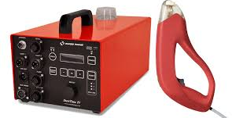
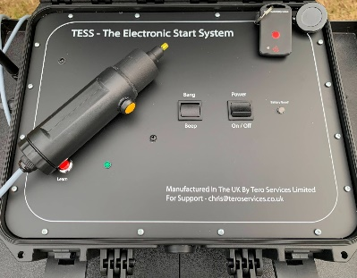

Duty Sheets

Duty sheets are prepared by the SC, CSA, and, when required, the LSA, prior to the event and circulated to their respective Start or SA Team either via email or in person at the briefing on the day of the event.

For events with an NTD and/or MM, a copy of the duty sheets must be sent to the NTD and/or MM prior to the event.

Starters Assistant Standard Duties
Where possible, the Starters and Starters Assistants' duty sheet should allocate duties by event. Ideally, 3 SA’s in addition to the CSA are required.
For example, the IC, A1 and A2 for the 1st round of the Men’s 100m should be replicated throughout subsequent rounds, where possible.
It is not essential for duty sheets to be elaborate with colour coding, etc. Although this does make quick reference easy during a hectic event.
The most important element is that the allocated duties are clear, fair, consistent and easy to follow.

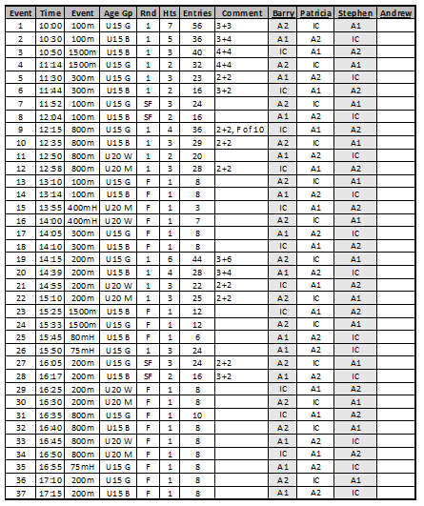

Starters’/ Recallers’ Standard Duties
- For Short Track, the Recall 1 position on the Straight is to the right of the Starter.
- If there is a FS allow the Starters time to recall. Provide information as necessary and be available to hear the Starter's intentions.
- Recall 2 on the Straight at Short Track events is for block slippage only and should be positioned to the left of the Starters.
- At Circular events, Recall 1 on a 400m Standard oval track is covering lanes 1 – 4 both for FS and block slippage. Recall 2 will cover lanes 5- 8 with the same duties. On Short Track, Recall 1 will cover lanes 1-3, whilst Recall 2 will cover lanes 4-6.
- The Duty Starter will have total control of the race and any decisions, as normal.
- The SC will, if required, also act as the SR to address any issues, protests or conduct warnings required to be awarded.
- If a Conduct Warning (CW) is necessary, then the Duty Starter will, after consulting with the SC, instruct the Starters’ Assistants to issue a 1st CW to the relevant athlete/s.
- If the Duty Starters are then informed that this will be the athlete’s second CW, or if the athlete/s have been given a 2nd CW at the start/during the start process, the SC will then instruct the Starters’ Assistants to issue a 2nd conduct warning to the relevant athlete/s.
- The SC will be at all starts.
- A named Starter will deputise for the SC in the SC's absence.
Note: The duties listed are generic. Specific guidance will be given by the SC as to duties/places to stand and to movement on/off FOP.

Start Team Actions Upon Arrival

- At Scottish Athletics Championship events report at least 1 hour before the first track event to the Meeting Manager (MM) or at non-Scottish Athletics events, the meeting organiser. Then report to the SC & CSA.
- In the Officials Room – sign in and pick-up lunch if provided.
- For National events attend briefings at the stated time and place as required.
- The CSA & SC will do a walk-about either individually or together, to check the track, surrounding areas, equipment required, podiums positions, etc.
- Ask the CSA if they require any help preparing for the first race.
- Check your wristwatch time against the stadium main clock to ensure accuracy.
- CSA & SC should advise each other of any relevant issues about the meeting.

400m Standard Oval Track – Starters Assistants Positioning
P1 = 1st position to take / P2 = 2nd position to take
When positioning yourself to check athletes on their start line, you should ideally position yourself in a place that lets you see what you need to with minimal movement.

Straight Line Races
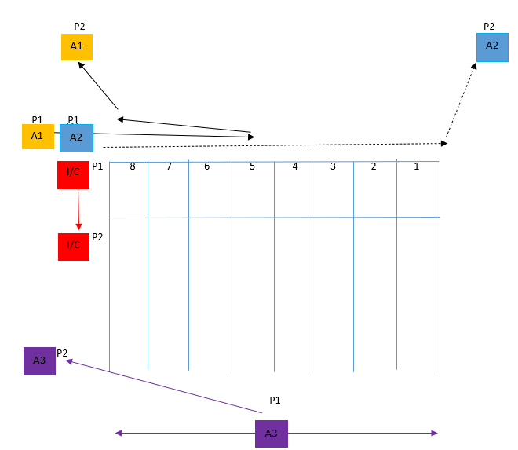
*dependant on track, A1/A2 may be positioned beside each other at the side of track prior to block check*
 | In Control (IC) | Ensures athletes are lined up in a straight line prior to the start, approximately. 2-3mtrs behind the start line, in preparation for the presentation, then the Starters’ instructions. Then proceeds to check that athletes in lanes 1-8 are settled for the race as per the duties given.
 | Assist 1 (A1) | Assists IC in preparing for the race as per assigned duties. Then proceeds to follow in A2 check feet are in contact with blocks for lanes 5-8, walks back and takes up relevant position dependent on the level of the meeting outside the track for the start of the race.
 | Assist 2 (A2) | Assists with preparation for the race as required per duties given. Then proceeds to lead, checking feet are in contact with blocks for lanes 4-1, then takes up a relevant position dependent on the level of the meeting for the start of the race.
 | Assist 3 (A3) | Takes up position 30m up the track to prevent excessive run-outs of athletes. Then makes way to the relevant position dependent on the level of the meeting outside the track.

Echelon Races
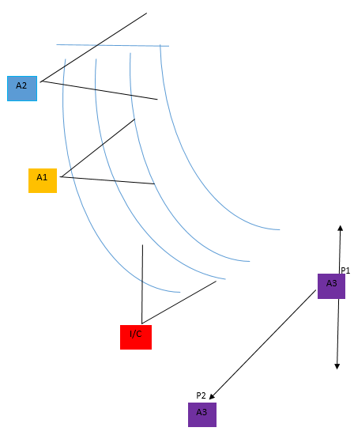
 | In Control (IC) | Ensures athletes are lined up in their lane prior to start, approx. 2-3mtrs behind the start line, in preparation for the presentation, then the Starters’ instructions. Then proceeds to check athletes in lanes 7-8, per duties, in a position that requires the least movement, preferably none, where possible.
 | Assist 1 (A1) | Assists IC in preparation for the race as per duties given. Then proceeds to check athletes in lanes 4-6 in a position that requires the least amount of movement (none), where possible.
 | Assist 2 (A2) | Assists with preparation for the race as required per duties given. Then proceeds to check athletes in lanes 1-3 in a position that requires the least amount of movement (none), where possible.
 | Assist 3 (A3) | Takes up position 30m up the track to prevent excessive run-outs of athletes. Then makes way to the relevant position dependent on the level of the meeting outside the track.

1500m, 3000m/5000m, 10000m

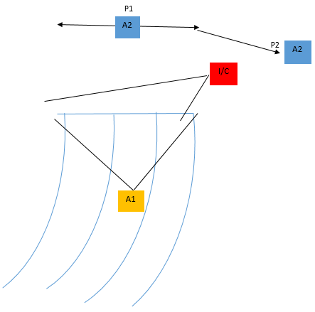

 | In Control (IC) | Ensures athletes are lined up in a straight line prior to the start, approximately. 2-3mtrs behind the start line, in preparation for the presentation, then the Starters’ instructions. Then proceeds to check that athletes are ready for the race as per duties given.
 | Assist 1 (A1) | Assists IC in preparation for the race as per duties given. Then proceeds to take up a position behind athletes so that any infringements may be spotted as per duties given.
 | Assist 2 (A2) | Takes up position 40-50m up the track to prevent excessive run-outs of athletes. Then makes way to the relevant position dependent on the level of the meeting outside the track.

Short Track – Starters Assistants Positioning
P1 = 1st position to take / P2 = 2nd position to take
When positioning yourself to check athletes on their start line, you should ideally position yourself in a place that lets you see what you need to with minimal movement.

Straight Line Races
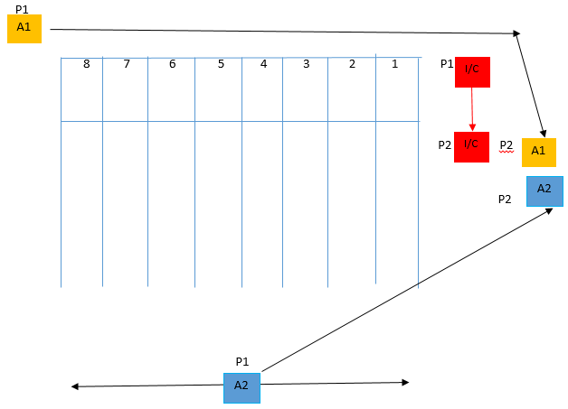

 | In Control (IC) | Ensures athletes are lined up in a straight line behind starting blocks prior to the start, in preparation for the presentation, then the Starters’ instructions. Then proceeds to check that athletes in lanes 1-8 are settled for the race as per the duties given.
 | Assist 1 (A1) | Assists IC in preparation for the race as per duties given. Then proceeds to lead, check feet are in contact with blocks for lanes 8-1, then takes up relevant position behind IC, ready for the start of the race.
 | Assist 2 (A2) | Takes up position 30m up the track to prevent excessive run-outs of athletes. Then makes way to the relevant position dependent on the level of the meeting outside the track.

Echelon Races

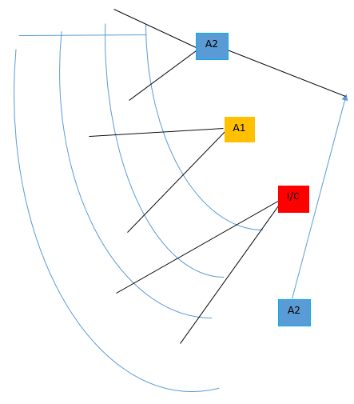
 | In Control (IC) | Ensures athletes are lined up in their lane prior to start, approx. 2-3mtrs behind the start line, in preparation for the presentation, then the Starters’ instructions. Then proceeds to check athletes in lanes 5-6, per duties, in a position that requires the least movement, preferably none, where possible.
 | Assist 1 (A1) | Assists IC in preparing for the race as per assigned duties. Then, proceeds to check athletes in lanes 3-4 in a position that requires the least amount of movement, preferably none, where possible.
 | Assist 2 (A2) | Assists with race preparation as required per assigned duties. Then proceeds to check athletes in lanes 1-2 in a position that requires the least amount of movement, preferably none, where possible.
 | Assist 3 (A3) | Takes up position 30m up the track to prevent excessive run-outs of athletes. Then makes way to the relevant position dependent on the level of the meeting outside the track.

Scottish Start Team - Generic Start Team Briefing Notes

This template is available to provide generic points for officiating at an event by a start team and will be adapted by each SC and/or CSA to reflect the specific event and the various elements they wish to cover in their briefings to their respective teams.

Welcome, everyone, to this event, and thank you for officiating today.
Meeting Management
National Technical Delegate |  | Meeting Manager
Track Referee |  | Chief Timekeeper
Technical Manager |  | Clerk of Course
Call Room/Assembly Mgr |  | Field Referee
Chief Photo Finish

Health and Safety
- In the event of any emergency, follow the instructions of the stadium staff.
- The nearest emergency exit may be the location of the incident, so please follow instructions.
- Keep the Start area clear.
- Be alert today for trip hazards, especially the plastic raised track, starting blocks, etc.
- Look before moving onto the track and be aware of what’s going on around you, especially during ‘run-outs’ by athletes.

Appearance
- Proceed smartly from one start area to another. Withdraw from FOP when not officiating.

Flow of athletes
- There will be one Call Room/Assembly located at ………………………………. and athletes will be required to report there at least …………… mins before the scheduled start time of their event.
- For other events, they will either be brought to the relevant start by volunteers or just turn up themselves. This should be 10 minutes before gun time.
- Athletes to be collected from the various field events by one of the SA Team.
- Bib numbers will be checked, and leg numbers will be issued in the Call Room/Assembly, but please have spare safety pins and spare leg numbers with you (dependent on meeting).
- Spikes – maximum dependent on track, these will be checked in the Call Room (if in operation).
- Stadium Blocks only. Will need to be moved as we go around the track.

Pre-race
- Photo finish will be in operation and be aware of front-on camera by the finish. Do not obscure.
- The Timetable is as available to me at the time of printing.
- Bib numbers not to be folded and secured firmly with 4 pins.
- Hip numbers to be visible and pinned. (Unless directed otherwise on the right hip).
- If HEATS are not required, track finals will be run at ……HEAT / FINAL (DELETE AS REQ)……. time.
- At Scottish Athletics events, tape measures are available for block placement. (Call Room box)
- Please remove unused blocks from empty lanes & lift blocks in 400 races swiftly.
- Blue Card Protocol will be used prior to the start of all Hurdle races.
- During hurdle races, blocks can be set, however NO RUNS OVER HURDLES until the Blue card is shown by the Clerk of Course and acknowledged by I/C SA. Ensure an SA is in front of the first flight.
- Please deploy a run-out blocker in front of the 4th flight, where possible.
- Allow athlete/s time to practice, ensuring athletes are lined up ready to race at least 1min prior to the allocated start time. Ensure the same process for all heats.
- Be aware of other officials performing their duties

Pre-race Starters Assistant information to Starters
- Inform Starters of the Number of heats and the status of the race, if different to TT.
- Provide updates on relevant issues to the Start Coordinator as required.
- IC to ensure athletes are lined up ready for the race, prior to showing a straight raised clipboard to the starter to confirm that the athletes are ready. Await acknowledgement.
- A coordinated ‘step back’ please after ‘On Your Marks’.

Rule/ Issuing of Warnings
- UKA rules, incorporating WA & WPA rules where appropriate.
- Safe Athletics, Track & Field Safety Guide for Competition.
- Please DO NOT anticipate any warning that may be given. Await instruction.
- SA taking the line in Straight track starts will issue cards.
- In Echelon Starts, if a Green Card is requested, this will be by the IC SA.
- If a Yellow/Black or Red/Black card is issued by the Starters, this will be by the SA responsible for that lane.
- Any athlete who receives a DQ will be escorted from the track by the CSA.
- If a CW is issued, it will be by the SC, who will perform the role of the SR, requesting the Starters’ Assistant to display a solid Yellow card to the athlete being warned, record it on the start list beside the athlete’s name with YC and then inform the CSA.
- If a second Conduct warning is issued by the SC performing the role of the SR, they will personally issue the 2nd Yellow card and then a solid Red card (supported by the CSA, if required) and record it this time on the start list as YRC.

General
- Please keep checking with the team members to see if anyone requires support or if you require help from others.
- Refer any problems immediately to your chief, the CSA or SC.
- The SC will make ANY decision on Conduct Warnings in the absence of a SR.
- Please exercise due caution when crossing the track.

Starters Generic Briefing

- A podium is available for the Duty Starters at all main start locations.
- R1 and R2. If you have any concerns about the race, please recall, but give the Duty Starter time to recall first. Then discuss your observations with the Duty Starter, who will decide on the appropriate action to take.
- If any false starts occur, the Duty Starter should discuss briefly with R1 and/or R2. Once agreed, the Duty Starter will issue a warning or a DQ in accordance with the rules for that age.
- If you have any concerns, please inform your SC.

Equipment
- At outdoor Scottish Athletics events, TESS will be used for starting and recalling.
- At Short Track events, 2 Electronic “Omega” Guns and control boxes are used. One will be situated at the 60m start, and one will be at the 200m start. When there are 300m & 1500m races, one of the boxes needs to be moved to the 300m start and the corresponding plugs swapped over at the main junction box by the 200m start.
- Transducer use - At outdoor events, as the start team move to a new start position and has disconnected and reconnected the transducer, a tap test will be required.
- At both indoor & outdoor events, if PF is in operation, a Zero Control Test (ZCT) will normally be held one hour before the first track or field event by the SC.

Chiefs' Technical Meeting

National Technical Delegate (NTD) / Meeting Manager (MM)
- Who is Assistant MM?
- Any specific info?

Track referee
- Confirm the use of the Blue card protocol.
- Confirm use of green card signal to SA for hurdles and steeplechase. Also, before another circular event and AFTER a 400mH race, to confirm the track is clear.

Clerk of Course
- Confirm the use of the Blue card protocol.

Technical Manager
- Number of sets of blocks available?

Chief Photo Finish
- When is the Zero control test and Radio contact channels?

Chief Timekeeper
- Signals. Yellow A4 / Whistle

Field Referee
- Confirm that the Starter will aim to start a race when no athletes are preparing for a throw or jump.
- If a field event is close to a start area, check with the Referee and agree on positioning and safety.

Chief Starters Assistant
- Info re: race and card procedures.
- Time changes and race reductions, inform as required
- Move speakers and listen for speaker test?

Call Room Manager
- Athletes brought or collected, by whom and to where?
- Hip numbers? Either or both hip/s. Double Pinned?

Meetings Check list for Start Coordinator

- Rules applicable?
- Sufficient start and start assistant officials? Y/N
- Chief Starters Assistant temporary replacement?
- Any other issues?

Section II – Endurance Guidance

Starter
- Comply with UKA Generic Risk Assessments for Starting.
- Check Starting Location prior to the start of the meeting to ensure that it is in a safe position within a sectioned off sterile Starters zone, and that the starter will have full visual control of the start area and timekeepers.
- Liaise with Referee/Timekeeper/Chip Timing Team/TV crew. Synchronise watch with Referee or Time signal.
- Issue 5min/3min/1min warnings or as agreed with the referee.
- Assemble athletes 2-3 meters behind the start line or in pens if appropriate.
- Allow Referee to address the assembled competitors prior to start if requested.
- In televised events Starter will synchronise with the Television Team.
- Ensure that the timekeepers are alerted.
- Call athletes forward to the start.
- Issue ‘on your marks’ command and start race as quickly as possible.
- It is strongly advised that the gun is not raised early so that the athletes are not alerted to the imminent start of the race.
- In the event of a FS, the Starter shall have the prerogative to recall the field.
- It may be necessary to deploy recall officials some distance in front of the start line to stop a race in the event of a FS.
Note: Starters and Referees should avoid being over-zealous in the application of Rule TR16.8

Starters Assistant
- Support the Starter.
- Assemble the competitors on the start line or pens, checking that athletes are in the correct order and “toes” are behind the line.
- In smaller events the Referee may ask for a “head count” to provide an indication of likely finishing numbers, to aid the officials at the finish.
- In the event of a False Start, re-assemble the athletes on the “assembly” line so the process can be repeated.

Starts for Off-Track Endurance

Introduction
- Competition Providers and Event Organisers may choose to have off-track endurance races started with an Electronic Start System, a Hooter or a Warning Horn.
- These are fully compliant with UKA Rules for Competition (Rule T56) and should still be carried out by a qualified starter, as they have the required experience regarding starting and recalling races under the UKA Rules of Competition.
- The agreed starting method should be noted in the pre-race athlete paperwork, so they are aware of the starting process and not caught unaware.
- The following protocol is a guide for those looking to use this method to provide a fair and clear start signal for all athletes, officials and spectators.

Start Protocol for “TESS” Starts
- The start process for TESS starts is an electronic gun sound and an LED flash emitted from the start actuator. A recall is sounded by a second actuator, which emits a multiple bleep sound as a recall warning.
- The FULL TESS system also uses a multiple-speaker system to enable start instructions and sounds to be clearly heard by the athletes, other officials and spectators.

Start Protocol for Hooter/Horn Starts
- In races which include large numbers of athletes, 5-minute, 3-minute and 1-minute warnings should be given, either by loudspeaker announcement or whistle.
- The Starter’s Assistant(s) assemble the athletes 2 -3 meters behind the start line.
- The Starter is in complete control of the race start, wearing a hi-viz armband and in possession of a plastic “warning horn” as used for athletics field events or a hooter.
- At the appointed time, the Starter checks that the timekeepers are ready for the race to start.
- The Starter calls the athletes to the start line by saying, “On your marks”
- At the same time, the Starter’s Assistant raises a white flag aloft, in clear view of the timekeepers.
- When the starter is satisfied the athletes are steady, but without delay to avoid a false start, the starter blows the horn/hooter.
- At the same moment, the Starter’s Assistant drops the white flag to provide a visual indication of the race start.
- In the event of a false start, a second Starters Assistant should be stationed 25yds from the start, in clear sight of the starter.
- If the starter notes a false start, they will signal to the 2nd Starters Assistant either by raising a red flag and blowing their horn/hooter repeatedly, or by radio message to the 2nd Starters Assistant.
- The 2nd Starters Assistant will stand in front of the lead athletes, waving their red flag to stop the race.

Section III – Protocols & Rules

Scottish Athletics - Blue Card Protocol

- The Clerk of Course is responsible for setting up the hurdles and will show a Blue Card to the IC Starters’ Assistant (IC SA) once…
- In sprint hurdles up to 110m, the first 4 flights have been made ready, and for ALL age groups, the 3rd hurdle has been lowered.
- In hurdle races beyond 110m, after the first 2 flights have been made ready.
The IC SA will acknowledge the Blue card by showing their Green Card.
- Trials may then be initiated by the I/C SA and be under their control.
- Once trials are concluded as decided by the I/C SA, they will proceed to tell athletes ‘Tracksuits off, Ready to Race Please’ and then ask the Clerk of Course to ‘Raise hurdles’. This could be via a ‘raise’ of both arms signal.
- Then, in ALL hurdle races, including steeplechase, the Clerk of Course will notify the Track Referee/Chief Track Judge that all is ready by raising their Blue card when ALL the relevant hurdles are in place. This signal will also confirm that personnel are available to remove any barriers not positioned on the track until after the race has started.
- The designated Track Referee/Chief Track Judge will then indicate to the I/C SA that all is ready by raising their Green card from the Track Judges’ Stand or on the Finish Line.
- The I/C SA will show their Green card to that official, acknowledging receipt of their ready signal. The Duty Starter should be alert for this signal from the Track Referee to prevent any delay by informing the I/C SA of it being displayed, if required.
- The I/C SA will signal to the starter by raising their board. The Starter will acknowledge the I/C SA ready signal by raising their yellow-sleeved arm before immediately showing it to the Chief Timekeeper ATOP their podium. The Chief Timekeeper then acknowledges the Timekeeping Team’s readiness to the Starter by raising a Yellow card.
- The Starter will then be free to commence the command sequence if safe to do so and after considering adjacent field events when appropriate.

- It is recommended that when hurdle heights are being altered, this process is commenced at the first flight to assist with timely starts by allowing athletes trials over the first two flights, while flights are adjusted further down the track.

**When any circular ‘Flat’ track event follows a circular hurdles or steeplechase event, the Clerk of Course will show the Blue card to the Track Referee after the circular track has been cleared of ALL barriers or steeplechase heights are adjusted, if necessary.

The Track Referee will then show the Green card to the I/C SA, who will then proceed with any further preparation and signal their White Board to the Duty Starter when ready. The Track Referee should be ATOP the Track Judges Stand or on the Finish Line, and this location should be agreed pre-event.

Scottish Athletics - Radio Training and Protocols

Some officials may be allocated a radio in order to carry out their role. Below are guidelines for using the radio and tips for correct radio protocol.

How do I use a radio?
- THINK – what do I need to say, is it relevant?
- LISTEN – check for any other conversations taking place (especially if you have swapped channels)
- PRESS – the Press-To-Talk (PTT) button on the side of the radio and hold down.
- SPEAK – talk slowly and clearly holding the radio about 5cm from your mouth.
- RELEASE – the PTT button in order that you can receive a response (no one else can talk while you hold this down)

Making a Call on the Radio: -
Example1: Track Referee communicating with Call Room.
TR: Track Referee to Call Room
CR: Call Room here, Go Ahead
TR: relay message, Over
CR: Acknowledged, Out

Example2: Photofinish communicating with Track Referee
PF: Photofinish to Track Referee TR: Track Referee here, Over
PF: Please reverse no. 107 and 435, Over
TR: Thank you, Out
Remember!
Do – stay on the correct channel
Do – follow the “Making a Call on the Radio Waves” guidelines
Do – be concise and to the point Do – speak slowly and clearly
Do – keep radio volume high enough to hear incoming calls
Do – remember that others can hear radio conversations
Do – sign out / sign in radio from the Officials Room
Don’t - leave the radio unattended
Don’t – turn the volume up so loud that it affects communication around you
Don’t – discuss sensitive matters on air
Don’t – interrupt other conversations
Don’t – swear – others can hear you!

REMEMBER:
- Ensure the Radio is turned on and set to the correct channel.
- Ensure the Earpiece if you have one is correctly installed.
- Use the words – Go Ahead, Over and Out during your message. Keep it relevant – Radios are not for conversation.
- TURN OFF the radio when returning it at the end of the day.

Warning / Disqualification (DQ) Cards

The following cards are used to inform the athlete of the Starter's decision. They also inform other relevant Officials and spectators/television audiences what is happening on the track. It is therefore important that the cards are the same on both front and back, and are shown raised high so that athletes and audiences are informed.
A Green card is used to indicate that no warning is being issued to any athlete. It can also be used to indicate that the recall did not warrant a warning because of an outside influence or a technical issue.
The Yellow and Black card is given for a 1st Warning if an athlete FS in a race. (Please refer to the DQ Guide for more details)

The Red/Black card is given to indicate a FS and that an athlete has been DQ’d from a race.

The Yellow card is used as a CW in both track and field events and follows an athlete through all events they are competing in during the competition (1 or more sessions) if shown. A second yellow CW card would result in a DQ.

A Red card is used as a CW in both track and field events. It indicates that a DQ has been issued for a second CW. It does not indicate a FS.

A Red/White card is used to indicate that an athlete, after having made an immediate oral protest against a FS, has been allowed to run, under protest, if the Start Referee is in any doubt. This is not allowed if a certified World Athletics SIS is in use (unless this information is deemed inaccurate).






UKA Rules of Competition 2026-2028 Rule TR16.9: -

It is recommended that the size of the diagonally halved cards be A5 and that they be doubled sided. Note that the corresponding indication on the lane marker(s) may remain yellow and red as previously, in order to avoid unnecessary expense in modifying existing equipment.

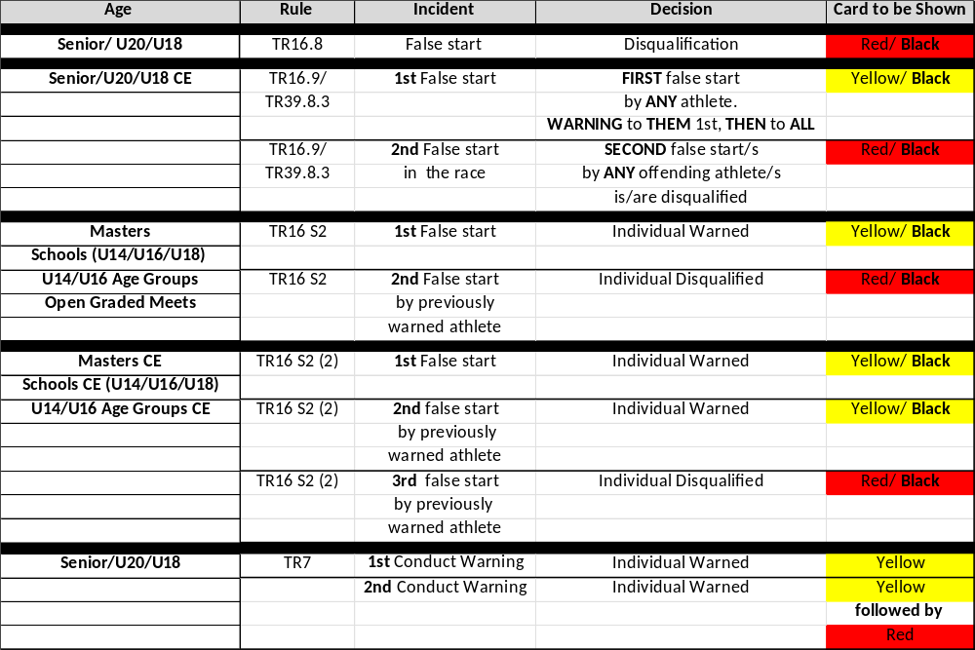

NOTES
* SENIOR: 'who is at least 20 years of age on the 31st December in the calendar year of competition.'
or others running in a Seniors race, including 'Masters', at least 35 on the day of competition.
* MASTERS: 'who are at least 35 years of age on the day of competition.'
* UNDER 20: 'who are aged 18 or 19 on 31st December within the *Competition Year
* UNDER 18: 'who are aged 16 or 17 on 31st December within the *Competition Year.
* UNDER 16: 'who are aged 14 or 15 on 31 December within the *Competition Year.
* UNDER 14: 'who are aged 12 or 13 on 31 December within the *Competition Year.
* The Competition Year - Rule 'T3 - S 1'
* OPEN GRADED MEETS (TR16 S2) (ALL ATHLETES, ANY AGE) - operate under Rule TR16 S2
*CONDUCT WARNINGS (TR7) - these 'follow' an athlete throughout the period of competition (event/multiple events,
round/multiple rounds, day/multiple days). Therefore, at the start line, we might only show an athlete/s their 1st or
2nd warning. If a Conduct Warning has been issued previously, the start sheet should be noted YC.

Key Rules and Regulations – Relating to the Start –

2026-2028

Black – Rule, Purple – UKA Domestic Ruling, Green – World Athletics Guidance
All taken directly from current UKA Rule book.
Full, in-depth rulings can be found and should be taken directly from the current Rule book.

World Para Athletics
UKA has accepted that World Para Athletics (WPA) Rules for Competition will apply to Disability competitions held in the UK. WPA Rules
are available on request from UKA and at https://www.paralympic.org/
athletics/rules-and-regulations/rules

Referees
One (or more) Referee(s), as appropriate, shall be appointed for the Call Room, for Running and Race Walking Events, for Field Events and for Combined Events. When appropriate, one (or more) Video Referee(s) shall also be appointed. A Referee appointed to oversee the starts is designated the Start Referee.

The Video Referee(s) shall operate from a Video Review Room, should consult and shall be in communication with the other Referees.

At meetings where sufficient officials are available so that more than one Referee is appointed for the races, it is strongly recommended that one of them is appointed as the Start Referee. To be clear, the Start Referee in such circumstances should exercise all the powers of the Referee in relation to the start and is not required to report to or act through any other Running and Race Walking Events Referee when doing so.

However, if only one Referee is appointed to oversee the races of a certain competition, and considering the powers they have, it is strongly recommended that the Referee be positioned in the start area, during each start (at least for those events using a crouch start) to witness any eventual problem that may occur and to take any decision needed to solve it. This will be easier when a World Athletics certified start information system is in use.

If not, and if the Referee will not have time to place themselves in line with the finish line after the start procedure (as in 100m, 100/110m hurdles, 200m and 300m hurdles), and foreseeing the possible need for the Referee to decide placings, a good solution may be to have the Start Coordinator (who should have an extensive experience as a starter) being appointed to also act as Start Referee.

Effort shall be made to reach consensus among the Referees. However, when no final consensus can be reached, the Video Referee shall have the final decision based on the available video images, except in cases concerning starts, where the final decision shall be made by the start referee.

(CR18.5)
The applicable Referee shall have authority to warn or exclude from competition, any athlete or relay team guilty of acting in an unsporting or improper manner in accordance with Rules 7.1 and TR7 S1(2) of the Technical Rules.

TR7 – Warnings and Disqualification
Athletes and relay teams shall participate in athletics competitions in a bona fide manner and shall not engage in unsporting or improper conduct. Any athlete or relay team failing to comply with this Rule may be warned or disqualified.
The applicable Referee shall have authority to warn or exclude from the competition, any athlete or relay team guilty of breaches of this Rule or Rule 6.1.
Note (ii) or (iv) of the Competition Rules or Rules 6, 16.5, 17.14, 17.15.4, 25.5, 25.19, 54.7.6, 54.10.8 or 55.8.8 of the Technical Rules. Warnings may be indicated to the athlete by showing a yellow card, exclusion by showing a red card. Warnings and exclusions shall be entered on the result card and communicated to the Competition Secretary and to other Referees.

In disciplinary matters, the Call Room Referee has authority starting from the Warm-up Area up to the competition area.
In all other instances, the Referee applicable to the event in which the athlete is or was competing, shall have authority. The applicable Referee (where practicable after consulting the Competition Director) may warn or remove any other person from the competition area (or other area related to the competition including the Warm-up Area, Call Room and coaches seating) who is acting in an unsporting or improper manner or who is providing assistance to athletes that is not permitted by the Rules.
Note (i): The Referee may, where the circumstances justify it, exclude an athlete or relay team without a warning having been given. (See also Note to Rule 6.2 of the Technical Rules)
Note (ii): The Referee for events outside the stadium shall, wherever practicable (e.g. under Rules 6, 54.10 or 55.8 of the Technical Rules), give a warning prior to disqualification. If the Referee’s action is contested, Rule 8 of the Technical Rules will apply.
Note (iii): When excluding an athlete or relay team from competition under this Rule, if the Referee is aware that a yellow card has already been given, they should show a second yellow card followed immediately by a red card.
Note (iv): If a yellow card is given and the Referee is not aware that there is a previous yellow card, it shall, once this is known, have the same consequence as if it was given in association with a red card. The relevant Referee shall take immediate action to inform the athlete or relay team or their team of their exclusion.

The below key points are made to provide guidance and clarity in relation to the way in which cards are shown and recorded:
a. Yellow and red cards can be given either for disciplinary reasons (refer mostly to Rule 18.5 of the Competition Rules and Rule 7.2 of the Technical Rules) or for technical infringements in case they are serious enough to be considered unsporting manners (e.g. a serious and clear deliberate obstruction in a race).
b. Whilst it is normal and usually expected that a yellow card would have been given before a red card, it is envisaged that in the cases of particularly bad unsporting or improper behaviour a red card can be given immediately. It should be noted that the athlete or relay team has in any case the opportunity to appeal such a decision to the Jury of Appeal.
c. There will be also some cases in which it is not practical or even logical for a yellow card to have been issued. For example the note to Rule 6.2 of the Technical Rules specifically allows for an immediate red card if justified in cases covered by Rule 6.3.1 of the Technical Rules such as pacing in races.
d. A similar situation might also follow when a Referee issues a yellow card and the athlete or relay team responds in such an inappropriate manner that it is justified to then immediately give a red card. It is not essential for there to be two completely different and distinct in time instances of inappropriate behaviour.
e. As per Note (iii), in cases where a Referee is aware that the athlete or relay team in question has already received a yellow card during the competition and they propose to issue a red card, the Referee should first show a second yellow card and then the red card. However if a referee does not show the second yellow card, it will not invalidate the issuing of the red card.
f. In cases where a Referee is not aware of a pre-existing yellow card, and he shows only a yellow card, once this becomes known, the appropriate steps should be taken to disqualify the athlete as soon as possible. Normally, this would be done by the Referee advising the athlete directly or through his team.
g. In cases of relay events, cards received by one or more members of the team during any round of the event shall count against the team. Therefore, if one athlete receives two cards or two different athletes receive a yellow card in any round of the particular event, the team shall be regarded as having received a red card and shall be disqualified. Cards received in relay events are only applicable to the team and never applicable to an individual athlete.

TR7 S1 – Misconduct
(2) Any competitor (or other person) interfering or attempting to interfere with the decision of an official, or indulging in unfair practices or misbehaviour, including the use of offensive or abusive language shall, at the discretion of the Referee, be disqualified from the competition and, if deemed necessary, reported to the appropriate National Association for further action. Performances achieves in the competition from which they were disqualified shall not stand.
NOTE: The use of offensive language audible to others should normally attract a warning from the Referee, but, if targeted at an official, should immediately attract disqualification.

TR7 S2 - Misconduct (SPITTING)
Spitting (or similar) in warm up, call room, competition or any other public area may be regarded as acting in an unsporting or improper manner and treated as a conduct offence and will be dealt with by a warning or disqualification (yellow card and/or red card offence). The Event Referee will determine whether a yellow or red card is shown. This determination may apply a red card where spitting directly towards an individual or persistent spitting but yellow for less serious offences. Athletes should be aware that different interpretations may apply from event to event. Warnings or disqualifications under this rule cannot be appealed as the Referee’s decision is final (Rule TR8 S1(2)(iii)). See also Rule CR18.5

Protests and Appeals (TR8.4.1/8.4.2/8.4.3)
TR8.4.1 In a Running or Race Walking Event, if an athlete makes an immediate oral protest against having been charged with a false start, the Start Referee (or if one is not appointed, the relevant Running and Race Walking Referee) may, if they are in any doubt, allow the athlete to compete “under protest” in order to preserve the rights of all concerned. Competing “under protest” shall not be allowed if the false start was indicated by a World Athletics certified Start Information System, unless for any reason the Referee determines that the information provided by the System is obviously inaccurate. If an athlete is allowed to compete under protest, a red and white (diagonally halved) card shall be raised in front of the athlete.

TR8.4.2 a protest may be based on the failure of the Starter to recall a false start or, under Rule 16.5 of the Technical Rules, to abort a start. The protest may be made only by, or on behalf of, an athlete who has completed the race. If the protest is upheld, any athlete who committed the false start or whose conduct should have led to the start being aborted, and who was subject to warning or disqualification according to Rules 16.5, 16.7, 16.8 or 39.8.3 of the Technical Rules, shall be warned or disqualified. Whether or not there may be any warning or disqualification, the Referee shall have the authority to declare the event or part of the event void and that it or part of it shall be held again if in their opinion justice demands it.
Note: The right of protest and appeal in Rule 8.4.2 of the Technical Rules shall apply whether or not a Start Information System is used.

TR8.4.3 if a protest or appeal is based on an athlete’s incorrect exclusion from an event due to a false start and it is upheld after the completion of the race, then the athlete should be afforded the opportunity to run on their own to record a time in the event and consequently, if applicable, to be advanced to subsequent rounds. No athlete should be advanced to a subsequent round without competing in all rounds unless the Referee or Jury of Appeal determines otherwise in the particular circumstances of the case, e.g. the shortness of time before the next round or the length of the race.
Note: This Rule may also be applied by the Referee, the Jury of Appeal in other circumstances where it is deemed appropriate (see Rule 17.2 of the Technical Rules)

When the Start Referee decides on an immediate oral protest made by an athlete for being charged with a false start, they have to consider all the available data and in case of only a reasonable possibility that the athlete’s protest may be valid, they should allow the athlete to compete under protest. After the race, a final decision must be taken by the Referee, a decision that may be subject of an appeal to the Jury. But to be clear, the Referee should not allow an athlete to compete under protest if the false start has been detected by a Start Information System that appears to be working properly or in cases where it is very clear by visual observation that the athlete has committed a false start and there is no valid reason to allow the protest.
These rules not only apply where a Starter failed to recall a false start but where also a Starter failed to correctly “abort” a start. In both cases the Referee must consider all factors involved in the particular case and must decide if the race (or part of it) has to be re-held.
Giving two examples of extreme situations, it will not be logical or necessary to re-run a Marathon race in a case where an athlete who finishes was responsible for a non-recalled false start. But the same will probably not be the case in a sprint event where an athlete was responsible for a non-recalled false start as this may have affected the start and subsequent race of other athletes.
On the other hand, if for example in a preliminary round, or perhaps even more so in a race within a Combined Event, it was clear that only one or some athletes were disadvantaged by a failure to recall a false start or to abort a start, a Referee could decide that only those athletes be given the opportunity to run again – and if so under what conditions. Rule 8.4.3 of the Technical Rules covers the situation in which an athlete is wrongly given a false start and excluded from a race.

RULE T8 S1 - PROTESTS AND APPEALS
For meetings where there is no Jury of Appeal and / or Technical Information Centre the following provisions shall apply:

(iv) Where protests are made in respect of the Start, the Starter’s decision is final.

Track Measurements (TR14.4)
In all races up to and including 400m, each athlete shall have a separate lane, with a width of 1.22m ± 0.01m, including the lane line on the right, marked by white lines 50mm in width.

RULE T24 S2 UKA SUPPLEMENT - RELAY RACES
(1) On completion of the final leg the baton is to be handed to an official by the last runner. It is not to be dropped or thrown from the hand. Failure to comply with this instruction may lead to disqualification. (See also Rule T7)
(2) The 4 x 300m Relay uses the 800m start line with the first leg being run in lanes until the break line described in Rule T17.5.1 (one bend in lanes).
The takeover zones for the 2nd, 3rd and 4th legs will be 30 metres, with no acceleration permitted (Rule T24.19).
Athletes for the 2nd, 3rd and 4th legs will be lined up by a designated official in the order (inside to out) of their respective team members as they enter the last bend (Rule T24.20).

Starting Blocks (TR15) (15.1)
Starting blocks shall be used for all races up to and including 400m (including the first leg of the 4 × 200m, the Medley Relay and 4 × 400m) and shall not be used for any other race. When in position on the track, no part of the starting block shall overlap the start line or extend into another lane, with the exception that, provided there is no obstruction to any other athlete, the rear part of the frame may extend beyond the outer lane line.

To be clear, the requirement that no part of the starting block shall overlap the start line includes the frame.

TR15 S1 UKA SUPPLEMENT - STARTING BLOCKS
The use of starting blocks is optional, except where blocks incorporating false start detection equipment are in use when all competitors shall be required to use only the starting blocks provided. If false start detection equipment is not in use, athletes may use their own starting blocks, but such starting blocks must be approved by the Starter.
For the avoidance of doubt in races up to and including 400m if the use of starting blocks is not compulsory (except as defined in Rule T15) then a crouch start does not have to be applied.

NOTE: On synthetic surfaced tracks the Competition Provider may insist that only starting blocks provided by them shall be used.

The Start (TR16) (16.1)
The start of a race shall be denoted by a white line 50mm wide. In all races not run in lanes, the start line shall be curved, so that all the athletes start the same distance from the finish. Starting positions in events at all distances shall be numbered from left to right, facing the direction of running.

Note (i): In the case of events starting outside the stadium, the start line may be up to 0.30m in width and may be of any colour contrasting distinctively with the surface of the start area.

Note (ii): The 1500m start line, or any other curved start line, may be extended out from the outside lane to the extent that the same synthetic surface is available.

It is anticipated that, in order to efficiently complete the start procedures and for larger meetings to appropriately introduce the competitors in the race, the athletes, when assembled, should be standing and facing in the direction of the race.

TR16.3
In all races using a crouch start, as soon as they are steady in their blocks, the Starter shall raise their arm in which they hold the gun, then they shall say “Set”. They shall wait then for all the athletes to be steady and shall then fire the gun.

The Starter must not raise their arm too early, especially when manual Timekeepers are being used. They are advised to raise their arm only when they feel they are about to give the command “Set”.

There is no rule that enables to determine the time that elapses between the commands “On your marks” and “Set” on one hand, and on the other hand, between the command “Set” and the gun shot. The Starter shall let the athletes go once they are all motionless in the correct starting position. Which means that they may have, for certain starts, to fire the gun quickly, but on the other hand, they may also have to wait longer in order to make sure that they are all steady in their starting position.

TR16.5.3
In case of Rules 16.5.1 or 16.5.2 of the Technical Rules, the Referee may warn the athlete for improper conduct (disqualify in case of a second infringement of the Rule during the same competition), according to Rules 7.1 and 7.3 of the Technical Rules. A green card shall not be shown.

In case of Rule 16.5.3 of the Technical Rules, if the movement or action by the athlete results in (an)other athlete(s) committing what would otherwise be a false start, the Referee may warn the offending athlete for improper conduct (disqualify in the case of a second infringement) according to Rules 7.1 and 7.3 of the Technical Rules. Otherwise, a green card shall be shown. However, in case of repeated movements by the same athlete at multiple aborted starts, even if they do not result in (an)other athlete(s) committing what would otherwise be a false start, the Referee may still warn the offending athlete for improper conduct (disqualify in the case of a second infringement) according to Rules 7.1 and 7.3 of the Technical Rules.

However, when an extraneous reason was considered to be the cause for aborting the start, or the Referee does not agree with the Starter’s decision, a green card shall be shown to all the athletes to indicate that a false start was not committed by any athlete. Alternate visual or audial indication may also be approved such as the use of widescreens or dedicated monitors, communication via speakers, use of light towers or similar devices, etc. The procedure shall first be coordinated between the Technical Delegate(s), the Start Referee and the Event Presentation Manager, and broadcaster should be informed.

The division of the start rules into disciplinary matters (under Rule 16.5 of the Technical Rules) and false starts (Rules 16.7 and 16.8 of the Technical Rules) ensures that the whole field was not penalised for the actions of a single athlete. It is important, in order to maintain the integrity of the intention of this division, that Starters and Referees are as diligent in the application of Rule 16.5 of the Technical Rules as in detecting false starts.

Such conduct, whether wilful or unintentional perhaps through nervousness, should cause Rule 16.5 of the Technical Rules to be applied although where the Starter is of the view that it was unintentional, the application of Rule 16.2.3 of the Technical Rules only may be appropriate.

Conversely, there will be instances in which an athlete is entitled to request a delay of the start for legitimate reasons. It is therefore vital that the Start Referee (in particular) pays attention to the environment and conditions surrounding the start, especially in relation to factors of which the Starter may not be aware because they are focussing on preparing themselves for the start and/or wearing headphones.

In all such cases, the Starter and Referee must act reasonably and efficiently and clearly indicate their decisions. If appropriate, the reasons for the decisions can be announced to the athletes in the race and, if possible or desirable, also to the announcers, television team etc. through the communication network. A green card shall not be shown in any case when a yellow or red card has been issued.

False Start (TR16.6)
When a World Athletics certified Start Information System is in use, the Starter and/or an assigned Recaller shall wear headphones in order to clearly hear the acoustic signal emitted when the System indicates a possible false start (i.e. when the reaction time is less than 0.100 second). As soon as the Starter and/or assigned Recaller hears the acoustic signal, and if the gun was fired, there shall be a recall and the Starter shall immediately examine the reaction times and other available information from the Start Information System in order to confirm which, if any, athlete(s) is/are responsible for the recall.

Note: When a World Athletics certified Start Information System is in operation, the evidence of this equipment shall be used as a resource by the relevant officials to assist in making a correct decision.

TR16.7
Generally, no false start should be charged if the athlete has not lost contact with the ground or foot plates. For example, if an athlete moves their hips up, but then moves them down without their hands or feet losing contact with the ground or foot plates at any time, it should not result in a false start. It may be a reason to warn (or disqualify if there has been a previous warning) the athlete for improper conduct under Rule 16.5 of the Technical Rules.

However, in cases of a “rolling start” where the Starter (or Recaller) is of the opinion that an athlete has effectively anticipated the start through some continuous movement even if they did not move their hands or feet before the gun sounded, the race should be recalled. This can be done by a Starter or Recaller but it will be the Starter who is in the best situation to judge such a case as only they will know the position of their finger on the gun trigger when the athlete began their movement. In these cases where the Starter is sure that the athlete’s movement began before the report of the gun, a false start should be awarded.

In accordance with Note (ii) Starters and Referees should avoid being over-zealous in the application of Rule 16.7 of the Technical Rules to those events started from a standing position. Such instances are rare and usually occur unintentionally as it is easier to overbalance from a two-point start. It is not intended that same should be unduly penalised.

If such a movement was considered to be accidental, Starters and Referees are encouraged to first consider calling the start “unsteady” and proceed according to Rule 16.2.3 of the Technical Rules. However, repeat practices during the same event may entitle the Starter and/ or Referee to consider applying either the false start or disciplinary procedures, as might best be applicable in the situation.

TR16.10
The Starter or any Recaller, who is of the opinion that the start was not a fair one, shall recall the athletes by firing a gun or activating a suitable audible signal.

The reference to a fair start does not relate solely to cases of a false start. This rule should also be interpreted as applying to other situations such as blocks slipping, a foreign object interfering with one or more athletes during a start etc.

TR16 S1 - THE START
NOTE: If an athlete has a hearing impairment the Starter or his Assistant may use a flay, a strobe light, or other visual device as well as a pistol to signal the start. In some circumstances, for athletes with both a vision and hearing impairment, and Official may touch an athlete to signal the start.

TR44.6.3 (200M Standard oval track competitions)
For the start of races of 800m, each athlete may be assigned a separate lane, or up to two athletes may be assigned per lane, or a group start, as in Rule 17.5.2 of the Technical Rules preferably commencing in lanes 1 and 4, may be used. In races started in lanes, athletes may leave their lane only after the breakline marked at the end of the second bend. For group starts, athletes running in the outer group may join the inner group, only after the breakline marked at the end of the first bend, or if the race is run with two bends in groups, at the end of the second bend. A single curved start line may also be used.

Note (i): In competitions under paragraphs 1. (e) and 2. (e) of the World Rankings Competition definition, the participating teams may agree not to use lanes for the 800m event.

Note (ii): On tracks with less than six lanes, a group start may be used to allow six athletes to compete.

Section IV – Starting Equipment

TESS (The Electronic Start System)

The TESS Electronic Start System is designed to provide the correct signals to start and, if necessary, recall athletics track events.
The system will provide: -
- A flash which should be clearly visible to timekeepers.
- Audible start signals from the sounder units for the athletes.
- A “beep” recall signal from the sounder units to be used in the event of a false start.
- Connectivity to other technology, e.g. Photo Finish and SIS.

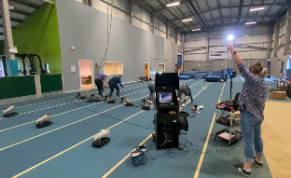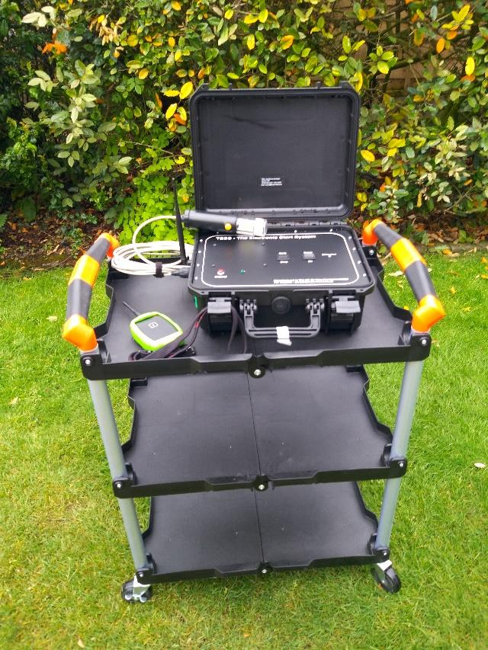
The Electronic Start System -
Start Team Training with TESS at Grangemouth Indoor Track -

The system uses a radio microphone to convey the starter’s voice commands to the speakers through the TESS Sounder Units or a connected public address (PA) system. The “start” and “recall” sounds are triggered using a wireless link to remote units. The Sounder Units can be appropriately placed to facilitate the best experience for the athletes and officials.
Additional Sounder Units may be placed to ensure that spectators can also hear the signals for events at the far side of the arena.
The system is easy to set up and use by a single person, but has connectivity to allow an additional two "recall starters” to use additional recall actuators.
The main elements of the system are: -
- A TESS Control Unit – this is located next to the starter and provides the “flash”, the connectivity to other technology (Photofinish and SIS), the wireless link to the remote Sounder Units and the wireless link to the recall actuators.
- One or several TESS Sounder Units – these receive commands from the Control Unit and output a “start” or “recall” tone. If used with a radio microphone, the starter's commands are also available. They provide an output to trigger a remote flash if required.
- An optional PA (Public Address) system can pair with a control unit using a Link Box to output start/recall sounds. A wireless microphone can also be connected to improve the effectiveness of the starter’s commands.
- Optionally, a Remote Flash unit can be placed close to the timekeepers to provide an alternative to the starter’s flash – this can be useful on a bright or sunny day.
There are several accessories: -
- Start Actuator and Flash Wand.
- Wireless recall actuators
- Battery Chargers
- The system comes in a soft pull-along carry bag. Also provided is a trolley to place the control unit on, for ease of movement around the stadium.
- The system also features connectivity to associated technology with connections to trigger both electronic timing/photo finish and start information systems (SIS).
- The latency between the “flash” and the Photofinish (and SIS) switch operating is bench set to 250μS, which is well within the WA horizon of 1mS for a ZCT.
- Use is made of wireless technology to transmit instruction signals to the Sounder Units and the recall signals sent to the control unit from the recall actuators. Avoiding cables where possible adds to the system's flexibility and facilitates setup and movement.
- Additional Sounder Units can be employed to provide signals at all start points, thus removing the need to move equipment during the programme of events. Being trolley-mounted, the Control Unit is easily moved between start positions.

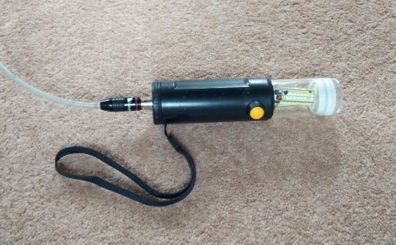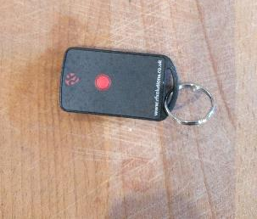
Recall Button-
-Start Actuator
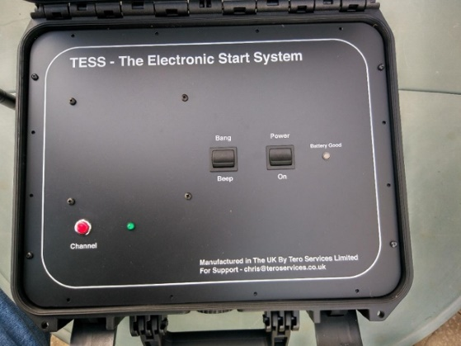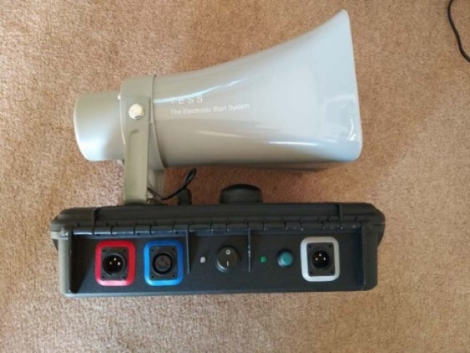
-Control Box
-Speaker Unit
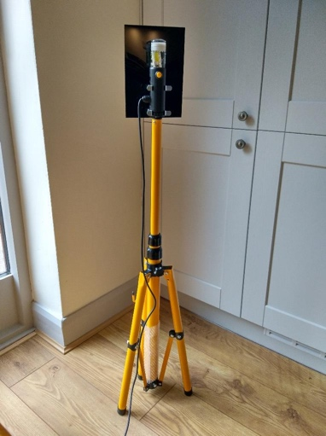
Timekeepers Remote Flash-

SIS (Start Information System)

The Alge Start Judge SJ2 is a SIS for track & field to monitor the start of running competitions up to 400m. It consists of the Start Judge transport cart SJT2 with an integrated controller and battery. The transport cart can store the complete system. The sensors SJS2 are mounted on each starting block. The integrated loudspeaker system enables the starter to give commands to the athletes. The start tone (simulated start shot) is released through the speaker integrated into the start sensor, and the BANG is heard. By this, all runners can hear the start tone at the same time. With a radio push button, WTN-PB, one can move around and still trigger a false start at any time.

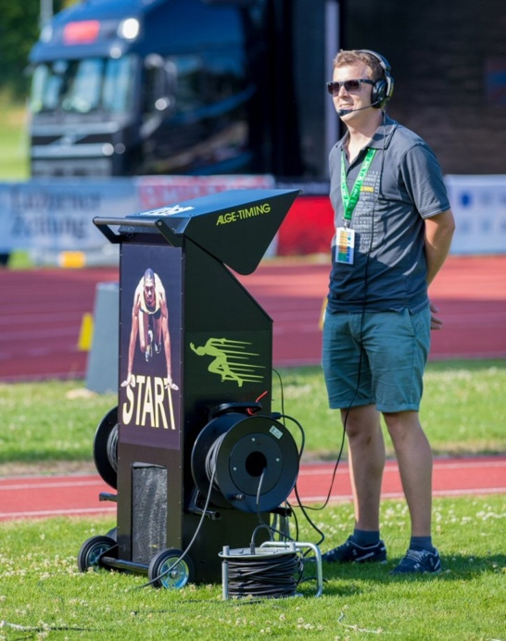

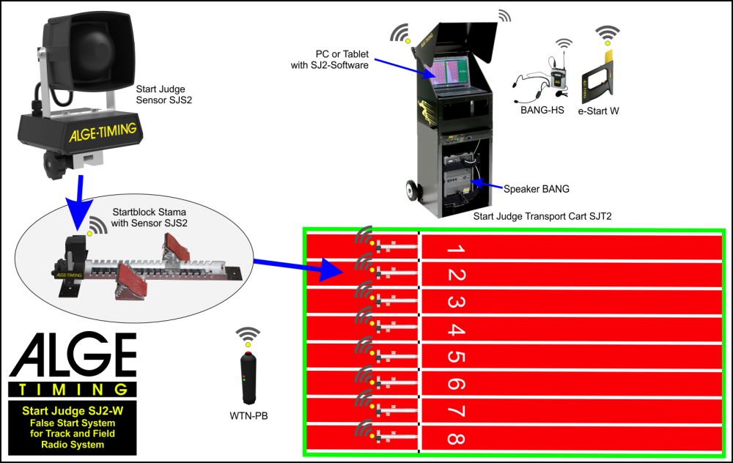

The ZCT

The Zero Control Test (ZCT) is conducted prior to the start of a session to ensure that cameras positioned at the finish line are properly aligned.

A Fully Automatic Timing and Photo Finish System must have been tested and have a certificate of accuracy issued within 4 years of the competition.
UKA Rules of Competition 2026-2028 Rule TR19.19: -
The Chief Photo Finish Judge shall be responsible for the functioning of the System. Before the start of the competition, they will meet the technical staff involved and familiarise themselves with the equipment, checking all applicable settings.

In cooperation with the Track Referee and the Starter, they shall initiate a zero control test, before the beginning of each session, to ensure that the equipment is started automatically by the Starter’s signal within the limit identified in Rule 19.13.2 of the Technical Rules (i.e. equal to or less than 0.001 second).

They shall supervise the testing of the equipment and ensure that the camera(s) is (are) correctly aligned.
UKA Rules of Competition 2026-2028 Rule TR19.13.2: -
The System shall be started automatically by the Starter’s signal, so that the overall delay between the report from the muzzle or its equivalent visual indication and the start of the timing system is constant and equal to or less than 0.001 second.

Example of a typical TESS alignment on the Start line, ready for a ZCT test.
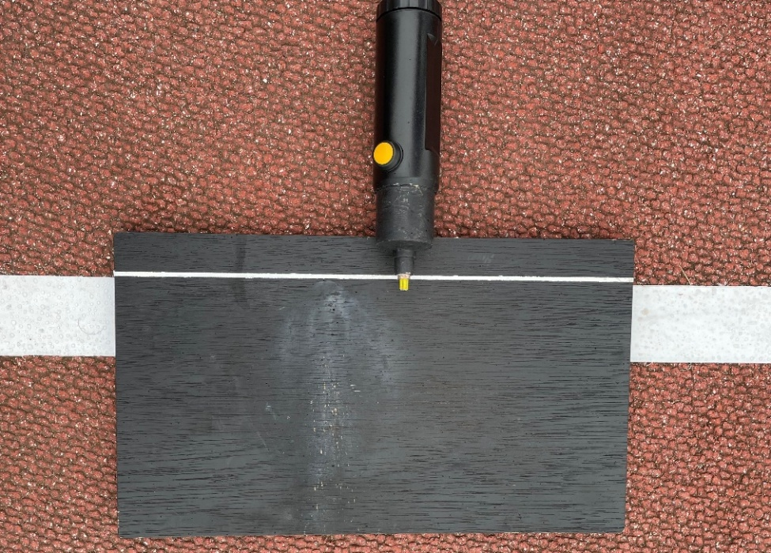

Image – ZCT conducted with TESS (0.001) – SAIL Final 2026.

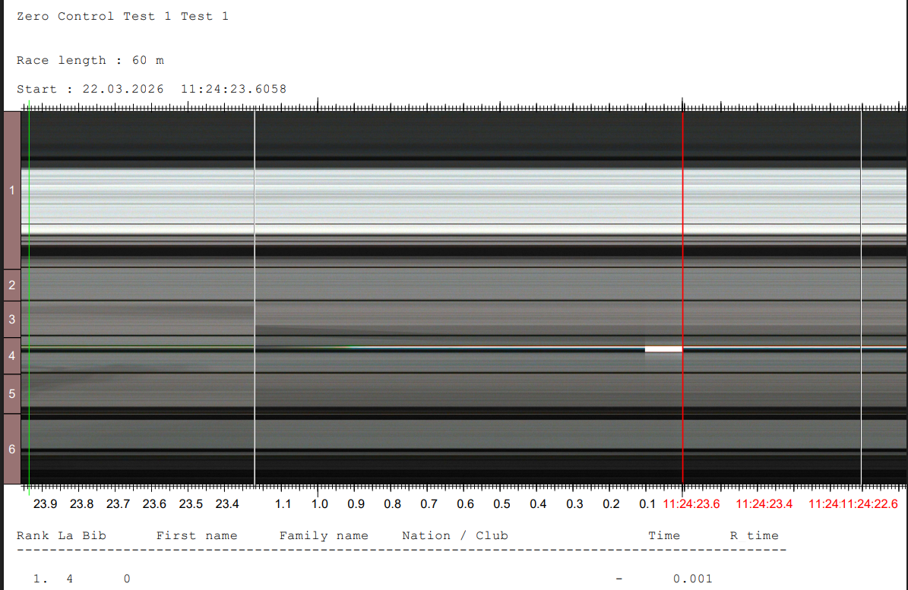

Section V - Scottish Start Team Peer Group

All Technical Official Disciplines (Track, Field, Start, Timekeeping, Photo Finish Endurance) have a body of officials from within their respective disciplines who coordinate the work of that discipline, known as a Peer Group.

The scottishathletics Start Team Discipline is all the active Scottish Starters and Starters Assistants.

Start Team Discipline
    - The Scottish Athletics Start Team Discipline is composed of all active Scottish Starters and Starters Assistants, and throughout this document, all references to the Start Team include these officials.
    - The Peer Group’s role is to oversee and coordinate the work of the discipline in a fair, unbiased and, where possible, evidence-based manner.

Composition of the Start Team Peer Group
- The Start Team Peer Group is made up of a Head of Discipline (HoD) and one lead official from each of the three coordinating Sub-groups: Mentoring, Upgrading and Allocations.
- Each Sub-group will consist of at least one, up to a maximum of two active start team officials (L2 or above), who have an appropriate skill set or experience in the work of the Sub-group.
- One official from each Sub-group will be identified by the HoD as the lead co-ordinator for that Sub-group and sit on the main Start Team Peer Group.
- The HoD will be an ex officio member of each Sub-group.
- The HoD will lead and coordinate the work of the Discipline.
- The HoD will represent the Start Team at Scottish Athletics Officials Commission meetings or delegate a lead from one of the Sub-groups to attend in their absence.
- The HoD and Sub-group Member’s term of office is 4 years, at which time either a new HoD or Sub-group Member is appointed, or the previous HoD or Sub-group Member continues for a further 4 years.
- A HoD or Sub-group Member can only do two consecutive terms of office, after which time they must stand down for at least one term of office.

Aim
Involving more of the team in the work of the Peer Group will:
- De-mystify the role, providing a better understanding.
- Encourage a more united and better-informed team of officials
- Establish a broader support base for the Peer Group structure.
- Provide an opportunity for officials to develop skills and experience, enabling them to take on leading roles in the future.

Method
To ensure this structure is fair and equitable, the following procedures will be put into place:
- A HoD replacement is initially identified either through succession planning by the outgoing HoD or, if the position is vacant, by the Scottish Athletics Officials Commission.
  - The Start Team is then notified of the selection and asked if they support the nomination via a poll.
  - Once agreed and the HoD is in post, letters of interest are requested from interested start team members for the vacant Sub-group positions.
  - Each Sub-group must be representative of the Start Discipline in its entirety, to ensure openness and fairness.
  - To be eligible for selection onto any of the Sub-groups, each person must be an active start team member of level 2 or above and have the relevant skills, strengths or experience they feel they can bring to one of the Sub-groups. This needs to be reflected in their note of interest when applying.
  - Sub-group members must work with the HoD to coordinate and manage the Start discipline. It is therefore essential that the composition of the Sub-groups, and ultimately the Peer Group, reflects the opinions of all active Start Discipline members.
  - The HoD will appoint a Sub-group lead.
  - The Lead will ensure that all matters forwarded to that Sub-group are dealt with appropriately, and the Lead will represent that Sub-group on the Peer Group. This person is not necessarily the most senior official in the Sub-group, but the most appropriate person.
  - The contact details of each official appointed to the Sub-groups will be notified to the whole discipline.
  - Relevant matters will be circulated to all active members of the Start Discipline by the HoD, noting which Sub-group will be leading.
  - Any comments or suggestions from any active Start Team member are to be sent in the first instance to the coordinator of the Sub-group dealing with the issue under consideration. This will permit the Sub-group to make preliminary decisions informed by all active Start Team members.
  - Start Team Peer Group meetings will be restricted to HoD plus one representative of each Sub-group, preferably the co-ordinator. The co-ordinator may delegate a member of their Sub-group to attend in his/her absence.
  - Agendas will be circulated to all active Start Team members prior to the meeting, noting which Sub-group will be leading on item(s).
  - The HoD will be responsible for circulating the minutes of the Start Team Peer Group meeting to all members as soon after the meeting as possible.
  - Matters of a personal or confidential nature should be sent directly to the HoD.

Sub-Group Remits
Depending on the requirements and work being undertaken by Sub Groups, their remits may intertwine. Subgroup members may therefore be asked to work in an additional area or crossover with their experience.
Allocations
- To allocate active Start Team Officials to Scottish Athletics Championship events, both indoors and outdoors, and also SIS operators when possible.
- Upon request from the TRNG Secretary (Scottish Officials Commission Convenor), to nominate officials for UKA Level 5 events.
- To allocate active Start Team Officials to any other events as necessary.
- To allocate any adjustments to the original teams as necessary.
Upgrading
- To provide a fair, unbiased and evidence-based assessment of an official's upgrade opportunities.
- To encourage officials to progress, but only to the level they are comfortable with.
- Gather Record of Experience info from annual submissions to provide an evidence base of each official's officiating skills and suitable development and progression.
  - Inform the Peer Group of any recommendations.
- For Level 2 and up, the Record of Experience form will also be used to show what an official has done as part of their application to progress to a higher level.
  - It will be important for the official to show a variety of roles undertaken at a range of meetings. Whilst time will not be a primary factor, this diversity may take a minimum of 1 year to complete, with increasing timescales for the higher Levels.
- To identify and monitor level 1, 2 & 3 officials for upgrading to the next level and arrange for reports to be completed on them. In discussion with the Allocations sub-group, allocate reporters for these officials.
- Identify reporters for each upgrade level (1 to 2, 2 to 3); where possible, recruit and train* new reporters as part of the overall skills enhancement of the Start Team. For example, as an official moves from level 2 to level 3, they could be trained in reporting on officials moving from level 1 to level 2.
  - As an addition to this point, it may be worthwhile to liaise with the Mentoring sub-group so that ‘practice reporting’ can take place, whereby throughout the season, trainee reporters can do ‘dummy’ reports on officials.
- When reporting, take account of UKA report forms and recommendations, i.e. a Level 2 report to be done by a Level 2 official with at least 2 years’ experience; and a Level 3 report to be done by a Level 3 official with at least 2 years’ experience, or higher graded.
Mentoring
(Please note this will vary depending on the needs of the mentee)
- To ensure that any official who wishes to have a mentor can do so.
- In discussion with the Allocations and Upgrading Groups, enable all officials to have opportunities to further their development and competencies within the officiating pathway.
- Provide information to officials on development and mentoring opportunities appropriate to their experience and level.
- Allocate mentors to developing officials according to the mentee’s level and needs, ensuring any official who wishes to have a mentor can do so, in line with the mentoring framework.
- Record, monitor and track all mentees and mentors to ensure progress.
- Provide support and guidance to mentors:
    - Enable mentors to have the opportunity to learn and develop, and to contribute to the growth and development of aspiring officials.
    - Help mentors to understand their mentee’s goals and aspirations, and to create and agree a plan that meets the mentee’s needs
    - Help mentors to listen to and be supportive of their mentee and their thoughts and ideas
- Ensure that developing officials receive appropriate feedback from mentors as and when required
- In discussion with the Allocations Group, when and where possible, ensure that a mentor and mentee have the opportunity to work with each other during events

Allocations - Key factors in the allocation process:
- The official’s availability.
- The status of the event and level of competition.
- The present level of the official.
- Their allocations during the current season, both at Scottish and UK events.
- The need for maintenance and development opportunities, reports and/or performance assessments.
- Their recent performance or performances.
- The availability of reporters.
- Any other relevant factors.

Upgrading - Pathway:
The most recent version of the UKA Officials Pathway can be found here:
Upgrading - Scottish Athletics

Mentoring Pathway
Requirements and support measures at each stage of the officials’ pathway: -

Assistant Official / Trainee - Requirements | Support | Feedback | Reports
No requirement for 1:1 mentoring  Support provided during meetings by Chief officials and other members of the team  Course tutor(s) and scottishathletics Officials Development Officer can also be contacted to offer additional support with finding suitable meetings in the local area, contacting local clubs and getting started with officiating | Initial support provided by course tutors: assistance with identifying meetings to attend, useful contacts and where to seek support.  Supported by Chief Starter’s Assistant (CSA) or Start Co-Ordinator (SC), as appropriate to the discipline of the official, during events  Where possible, the official should be matched with a more experienced member of the team (typically L2+) for 1:1 support on the day of an event | Feedback provided via e-mail by CSA or SC, as appropriate to the discipline of the official, post-event. Feedback should be positive and constructive, building on feedback discussed during the meeting. Where another official provides 1:1 support on the day, the CSA/SC should consult with them before sending feedback to the official or ask the supporting official to provide feedback directly. *  CSA/SC providing feedback will preferably be L2+ and have sufficient experience to act in a Chief role | A written report is not required for officials working towards level 1
LEVEL 1 - Requirements | Support | Feedback | Reports/Feedback
No requirement for 1:1 mentoring  Support provided during meetings by Chief officials and other members of the team | Supported by CSA/SC during events as/when required. This would include encouraging feedback and helpful reminders, but not 1:1 support throughout a whole meeting. | Feedback provided via e-mail by CSA/SC post-event in a positive and constructive tone, building on feedback discussed during the meeting. *  When nearing L2 upgrade, the mentee can submit questions to the course tutor or mentoring sub-group or ask for advice from a higher-level official before submitting to DH (who will distribute to relevant subgroup) for marking, comments & feedback. | Level 2 questions can be submitted to the mentoring sub-group; course tutor or another official for feedback and advice. Once the mentee is happy with their work, they may then submit to the DH for marking.  Report/Feedback to be arranged by upgrading sub-group once the official has completed the knowledge/question portion of the upgrading process.  Report to be written, where possible (according to level and relevant experience of reporter required), by an official who has worked with the candidate as their CSA/SC previously.

LEVEL 2 - Requirements | Support | Feedback | Reports
Support provided to all L2 officials by Chief officials and other members of the team during meetings  A request for 1:1 mentoring support can be made to the mentoring sub-group; the official can approach a potential mentor directly; or the official can continue without mentor for as long as wanted, if preferred.  A mentor (at L3+) is required if considering upgrading to L3 within the next 12 months.  Officials can have one mentor for both SA and Starting, or a separate one for each if preferred and dependent on the mentor’s experience in each discipline | Supported by CSA/SC during events as/when required. This would include encouraging feedback and helpful reminders, but not 1:1 support throughout a whole meeting. | L2 officials without a mentor will continue to receive support from the CSA/SC during meetings as/when required, and they can request formal feedback (verbal or written) following a particular meeting if they wish. *  L2 officials with a mentor are encouraged to discuss their progress with their mentor on a regular basis, in a format agreed with the mentor. Suggestions include phone/video calls, e-mail or meeting in person. They can also receive feedback from their Chief/team during meetings if desired. ** | The mentee should discuss with their mentor to check if they are ready or should be encouraged to begin the upgrading process. Once they have both came to a decision, the mentee should ask the upgrading sub-group to arrange any feedback report(s) required.  It is recommended that the official’s report towards upgrading to L3 is not written by their mentor. However, the official could have a ‘practice report’ written by the mentor to provide feedback only if desired.  Report to be written, where possible (according to Level and relevant experience of reporter required), by an official who has worked with the candidate as their CSA/SC previously.

LEVEL 3 - Requirements | Support | Feedback | Reports
No requirement for 1:1 mentoring unless the official is working towards L4.  The official can opt not to have a mentor (for any period of time) if not considering upgrading within the next 2 years.  Mentors for L3 officials will be L4+  An official’s mentor could be the same person they worked with at L2 (provided the mentor is L4+) or they can change.  Officials can have one mentor for both SA and Starting, or a separate one for each if preferred and dependent on the mentor’s experience in each discipline. | Supported by CSA/SC during events as/when required. This would include encouraging feedback and helpful reminders, but not 1:1 support throughout a whole meeting.  The DH, mentors, senior Start officials and the scottishathletics Officials Development Officer can be contacted to offer additional support with finding useful contacts/ meetings outwith the local area, to help the official seeking L4 to broaden their knowledge and experience. | L3 officials without a mentor will continue to receive support from the CSA/SC during meetings as/when required, and they can request formal feedback (verbal or written) following a particular meeting if they wish. *  L3 officials with a mentor are encouraged to discuss their progress with their mentor on a regular basis, in a format agreed with the mentor. Suggestions include phone/video calls, e-mail or meeting in person. **  Mentoring evidence must be documented for the official to progress to L4. Evidence to be shown must include self-reflection and feedback given by a mentor. | The mentee should discuss with their mentor to check if they are ready or should be encouraged to begin the upgrading process. Once they have both came to a decision the mentee should confer with the upgrading sub-group to arrange any report(s) required.  Reports to be written by an official who has been L4 for at least 2 years.  An official seeking progression to L4 may have gained useful contacts from outwith their own region. If the official wishes to seek an out-of-area report from their contact in another region, they may arrange this themselves whilst keeping the upgrading sub-group informed.  All relevant L4 paperwork including questions, reports and RoE, can be submitted to the upgrading sub-group for assessing prior to submission to the National Peer Group. All evidence and application forms must be submitted on time (preferably before deadline) to be considered for upgrading.

LEVEL 4 - Requirements | Support | Feedback | Reports
Currently, there are no Scottish Start officials above L4 to provide mentoring to L4 officials. Experienced L4s could mentor on request.  Mentoring may be available at UK level. However, this is beyond the remit of the Scottish peer group. | 4Ps receive the opportunity to officiate at National/International events via selection by the National Peer Group. During these, they will be supported by CSA/SC as/when required. This should include encouraging feedback and helpful reminders, but not 1:1 support throughout a whole meeting. | The National Peer Group will ‘Consider the competency of appropriate officials to ‘‘chief’’ at National meetings having regard to the need to introduce new officials to this role, possibly with mentoring built in. To monitor the progress of those officials used in this role’. **
* Please refer to ‘Feedback Template L0-1’
** Please refer to ‘Feedback Template L2-4’

Section VI - Conduct

UKA Code of Conduct for Technical Officials

Officials play a vital role in the preparation and delivery of safe and high-quality athletics events.
The code of conduct for officials reflects the required standards of personal and professional conduct in that role.

The most recent version of the British Athletics code of conduct for Technical Officials can be found here: https://www.uka.org.uk/governance/safegarding/codes-of-conduct/

Notes

