[ ] July 2025

Dear Coach,

UKA Members Nomination
Senior Coach Representative

UKA Members (the Members) are the formal members of UK Athletics Limited (UKA) and undertake the powers and duties as set out in the Articles of Association.

Members of UKA are normally elected or nominated – dependent on the sector of the sport they represent. Elected members serve a four-year term of office and are eligible to serve a maximum of two terms of four years of office.

A new Senior Coach Representative will be appointed at the AGM in December 2025. Nominations are therefore invited for one representative Member for Senior Coaches. Coaches who meet the nomination conditions and wish to put themselves forward to stand can do so. The closing date for receipt of nominations is 29 September 2025 at 17:00. A nomination form and details of the role are attached.

You may choose to nominate yourself or another individual. To make a nomination please return the nomination form duly completed and signed, along with a personal resume of the nominee, to a maximum of 250 words, by email to elections@uka.org.uk by the nomination deadline. Please address any queries in the interim to companysecretary@uka.org.uk.

If there is only one nomination and assuming all conditions are met, then that individual will be appointed. If there is more than one nomination, then a selection process will be held. The name of the successful nominee will be announced and appointed at the AGM in December 2025 and will take up their post immediately following that appointment.

At the end of the initial four-year term the nominee will be eligible to stand for a further four-year term.

Nomination Conditions

- Nominations must be in writing on the provided form and received by the deadline.
- Candidates must hold a full and valid coach licence, in accordance with the licence terms and conditions, at Athletics Coach Level (former Level 2) or above with current DBS certificate. The Candidates’ licence must not be suspended and must not have expired.
- Coaches supporting a nomination must be in possession of a full and valid licence, in accordance with the licence terms and conditions, at Athletics Coach Level (former Level 2) with current DBS certificate. The Coaches’ licence must not be suspended and must not have expired.
- The nomination may be made by either the candidate and supported by 4 other Coaches or another Coach and supported by at least 3 other Coaches.
- Experience coaching athletes at GB level is desirable.

Nominations breaching any of these conditions will be excluded from the process.

Yours sincerely
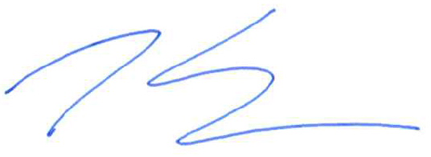
Tom Solesbury
Company Secretary

