[ ] July 2025

Dear Chair/Secretary

UKA Member Nomination
Representative of Affiliated Clubs

UKA Members (the Members) are the formal members of UK Athletics Limited (UKA) and undertake the powers and duties as set out in the UKA Articles of Association.

Members of UKA are normally elected or nominated – dependent on the sector of the sport they represent. Elected members serve a four-year term of office and are eligible to serve a maximum of two terms of four years of office.

A new Representative of Affiliated Clubs will be appointed at the AGM in December 2025. Nominations are therefore invited for one representative Member from Affiliated Clubs. The closing date for receipt of nominations is 29 September 2025 at 17:00. A nomination form and details of the role are attached.

If you choose to nominate a representative, please return the nomination form duly completed and signed, along with a personal resume of the nominee, to a maximum of 250 words, by email to elections@uka.org.uk. Please address any queries to companysecretary@uka.org.uk

Nomination Conditions
- Nominations must be in writing and received by the closing date to the email address set out above.
- Each club is entitled to nominate or second one individual only.
- A nomination must be signed by the person nominated.
- A nomination must be signed by either the Chair or Secretary of the Affiliated Club making the nomination.
- A nomination must be seconded by the Chair or Secretary of at least 4 other Affiliated Clubs.
- The Affiliated Club making the nomination and those supporting it must together be entitled to cast at least 15 votes – see paragraph 2.1 of the UKA Election and Appointment Regulations which sets out that each Affiliated Club has weighted voting rights depending on the number of registered athletes (as at 1 August 2024) in the membership of a HCAF as follows:

1-100 1 vote
101-200 2 votes
201-300 3 votes
301-400 4 votes
over 400 5 votes

Nominations breaching any of these conditions will be excluded from the process.

Yours sincerely
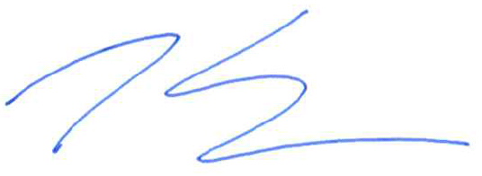
Tom Solesbury
Company Secretary

