Instructions for using the ‘Lynx Startlist.xlsm’ Spreadsheet

The Workbook name for assisting in writing start list and ppl files is Lynx Startlist.xlsm
This is a Macro enabled workbook so when you open it if you are asked if you want to enable Macros or Editing – say yes.
Within this workbook there are three Worksheets: Lynx Startlist, ppl, PPL File
Let’s start with the athlete’s information and convert it into a Lynx.ppl file.

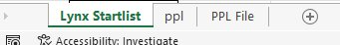

Let’s start by opening up the workbook and then go to the ‘PPL File’ Worksheet.
Leaving the headers visible in Row 1, highlight all the populated Bib, Surname, Firstname, and Nation(Club) cells and delete the information in them.
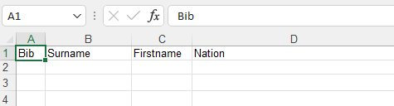
Open up the Worksheet ‘ppl’. This is where you would paste all your athletes Bib, Firstname, Surname and Nation(Club) for the event you are preparing for. Leaving the headers visible in Row 1, you can delete the existing populated cells first so as not to cause confusion. Paste in your athletes’ information making sure that it is in the correct order and there are no extra fields eg age group.
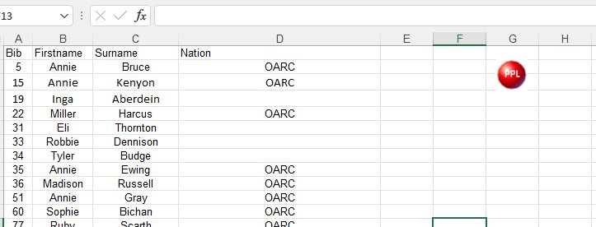
Click on the red PPL button and the Macro will take you to the PPL File Worksheet where you will notice that the cells have been populated and that the position of the Firstname and Surname columns have been swapped.
This is now in the correct order that the Lynx Software is looking for.
The Worksheet is now ready to create the file required by converting the PPL File Worksheet to a *.csv but we will now continue and work on the Event and Startlist information.
Now we will continue and create the Lynx.evt file which contains all the event information

- With the file still open, Go to the ‘Lynx Startlist’ Worksheet. You can save this workbook as many times as you like after importing or changing any data as it is not very productive typing the same data twice and it is a good safe practice.
- Here you will see the header row which is two lines high. The top line is the description of the event header line within the Worksheet. The first three columns make up the file number made up of Event Number, Round Number, Heat Number. The fourth column is the Event Name
The second row describes all the lines that will be seen before you reach the next event header containing the athletes Bib Number and Lane Number. The Athlete Surname, Athlete Firstname and Club columns will be automatically populated by means of embedded formula. I suggest that you leave the first three events Test, Zero Control Test 1 and Zero Control Test 2 as they do not need to be populated and will save you typing in when you need them at the track.

- Using your timetable and startlist sheets that have been prepared by the event organiser / seeder, you can populate the headers for each event with the information you need, taking into account the number of heats within that event. e.g. Event 2 has 5 heats so the headers will start with 2-1-1, 2-1-2, 2-1-3, 2-1-4, 2-1-5 – the last number being the heat number
The event name information that you put into Column ‘D’ will appear in the Lynx Software. Best to include the Heat number in this as it will be easier for anyone reading the printed result to understand which heat they are looking at. I like to included the expected start time as well as it gives you a good indication if the meeting is running to time or not.

- Now we need to have the correct number of lanes available for each race within this spreadsheet. If there are too many, then delete the rows that you don’t need. If there are too few then copy any row that has a lane number within it and insert selected rows pushing rows down to accommodate. This means that the formulae have also been copied. You need to resolve the correct lane numbers as you may have pasted in numbers that already exist. These cells only contain numbers and do not contain formulae so just renumber them starting at 1 or whichever the lowest number is on the seeding sheet.

- After you have created all the headers and lanes for each event/heat then we can populate the spreadsheet with the athletes. Copy only the bib numbers from each event on to the spreadsheet pasting in the correct event in Column ‘B’. The athletes name and club will automatically appear. Continue until you have populated the whole event. Check your spreadsheet against the Seeding sheets confirming that all the athletes are there matched to the correct lane.

- Now we can do a final save of the Workbook then proceed to save both the event information and athlete information in separate files but in *.csv format.
You can now create the files required firstly by converting the PPL File Worksheet.
- Save the Lynx Startlist.xlsm Workbook(always good practice to regularly save changes)
- Go to the PPL File Worksheet and go to File, Save As and select CSV UTF-8(Comma delimited) (*.csv) (other csv options should also work)
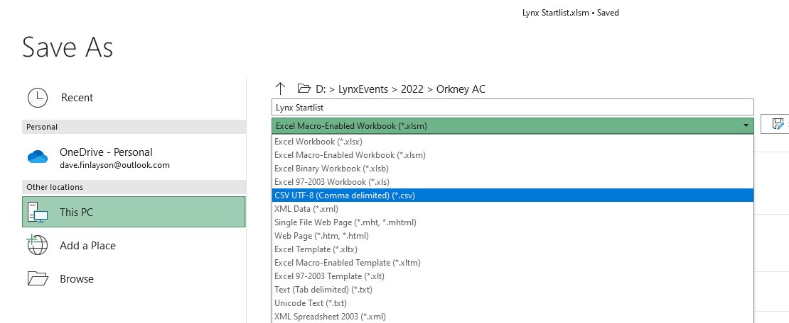
This will save the file as Lynx Startlist.csv so you should change the name, you could call it Lynx ppl.csv which is more meaningful.

You will get a Message Box like this telling you that the selected file type does not support workbooks that contain multiple sheets and that is ok because we are only saving one worksheet at a time. Click ok
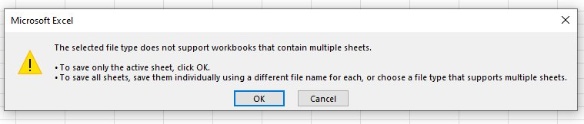

- Now go to the ‘Lynx Startlist’ tab and click to open it. You can now save the event information in *.csv format.
- Go to File, Save As and select CSV UTF-8(Comma delimited) (*.csv) (other csv options should also work)
- Save the file as ‘Lynx Startlist.csv’ giving more meaning to the content.
- You will get a Message Box like this telling you that the selected file type does not support workbooks that contain multiple sheets and that is ok because we are only saving one worksheet at a time. Click ok
After you have saved this *.csv file, close the document. You will get this or a similar warning:
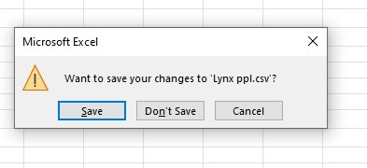
Click ‘Don’t Save’ as this is asking you to save the whole workbook and we have already saved the *.xlsm Workbook in 1. above.
- Now open the folder in which you saved the Lynx ppl.csv, right click on that file and select Rename in the dropdown menu
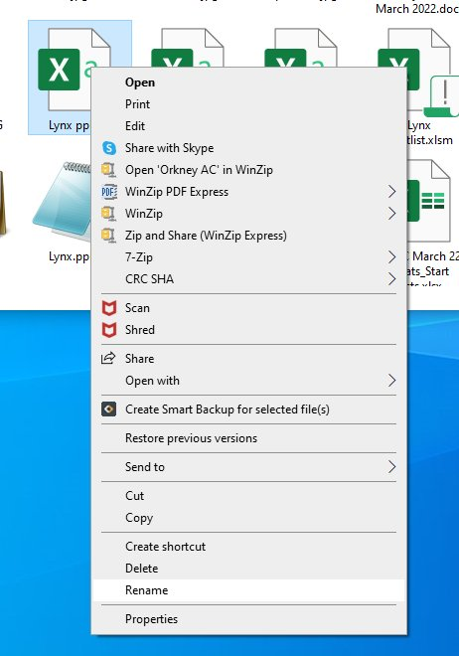

Rename the file from Lynx ppl.csv to Lynx.ppl .
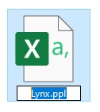
That will give you a warning:

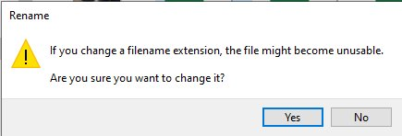

Click Yes.
- Go to the file that you have just created and open it by right clicking and selecting open with:
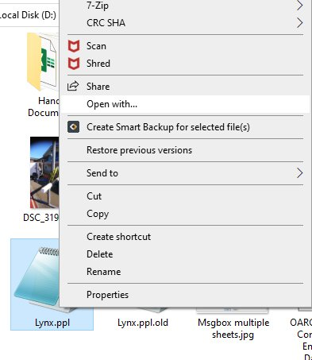
Select Notepad:
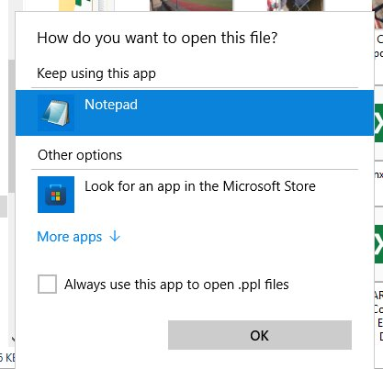

- Once opened, scroll to the bottom and if there are any lines that contain three consecutive commas delete them:
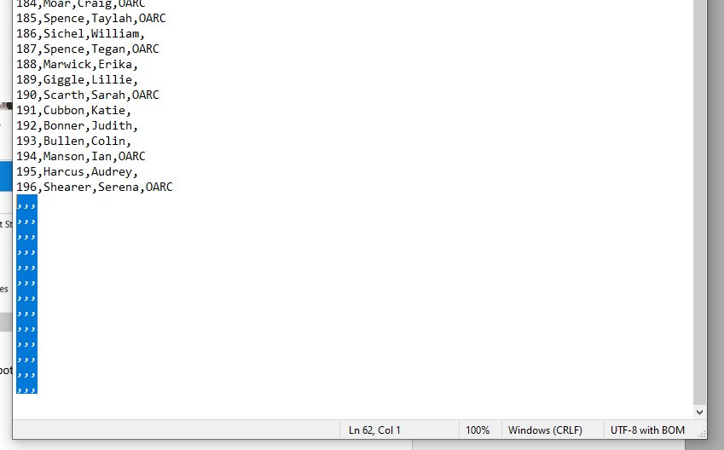
- Go to File, Save and save this file. It is now ready to be used by Lynx. You could copy it on to a USB stick to transfer onto the Capture Laptop when you get to the track.
- Do the same for the ‘Lynx Startlist.csv’ file renaming it to ‘Lynx.evt’ you will get similar warnings.
- You now have the two files required for the event and the original ‘Lynx Startlist.xlsm’ Workbook
- It is always worth checking the startlist information in the Lynx Software using the newly created files before you get to the event. It would be useful, if you have the Lynx Software on the computer where you have been working on the files, to put them in the folder that you would identify with the event and check them by opening the Lynx Software and using ‘options’ – ‘events’, browse to the correct folder and do the same for the Database tab. You can now load the races without the camera being attached so that you can check that they contain all the information that you would expect.

