Outdoor – Ideal Starters’ Assistant Positioning

Straight line races

P2 P2
A2
A1

P1 P1
A1
A2

P1 8 7 6 5 4 3 2 1
I/C

P2
I/C

A3
P2

P1
A3
I/C
In Control (I/C) – Ensures athletes are lined up in a straight line prior to start, approx. 2-3mtrs behind start line, in preparation for presentation then Starters’ instructions. Then proceeds to check athletes in lanes 1-8 are settled for race as per duties given.
Assist 1(A1) – Assists I/C in preparation for race as per duties given. Then proceeds to follow in A2 check feet are in contact with blocks for lanes 5-8, then takes up relevant position dependant on level of meeting on outside of track in for start of race.
A1
Assist 2 (A2) – Assists with preparation for race as required per duties given. Then proceeds to lead, checking feet are in contact with blocks for lanes 4-1, then takes up relevant position dependant on level of meeting for the start of the race.
A2
Assist 3 (A3) – Takes up position 30m up track to prevent excessive run-outs of athletes. Then makes way to relevant position dependant on level of meeting on outside of track.
A3

Echelon races
I/C
In Control (I/C) – Ensures athletes are lined up in their lane prior to start, approx. 2-3mtrs behind start line, in preparation for presentation then Starters’ instructions. Then proceeds to check athletes in lanes 7-8 as per duties given.
Assist 1(A1) – Assists I/C in preparation for race as per duties given. Then proceeds to check athletes in lanes 4-6 in a position that requires the least amount of movement (none) where possible.
A1
Assist 2 (A2) – Assists with preparation for race as required per duties given. Then proceeds to check athletes in lanes 1-3 in a position that requires the least amount of movement (none) where possible.
A2
Assist 3 (A3) – Takes up position 30m up track to prevent excessive run-outs of athletes. Then makes way to relevant position dependant on level of meeting on outside of track.
A3

A2

A1

P1
A3

I/C

P2
A3

1500m, 3000m/5000m, 10000m
I/C
In Control (I/C) – Ensures athletes are lined up in a straight line prior to start, approx. 2-3mtrs behind start line, in preparation for presentation then Starters’ instructions. Then proceeds to check athletes are ready for the race as per duties given.
Assist 1(A1) – Assists I/C in preparation for race as per duties given. Then proceeds to take up a position at the side of track behind athletes so that any infringements may be spotted as per duties given.
A1
Assist 2 (A2) – Takes up position 40-50m up track to prevent excessive run-outs of athletes. Then makes way to relevant position dependant on level of meeting on outside of track.
A2

P1
A2

P2
I/C
A1
A2

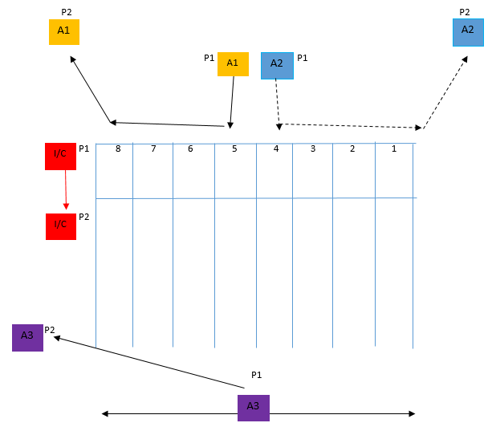
*Alternative for Straight Starts (CSA will advise on the day)*

