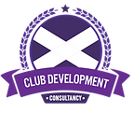
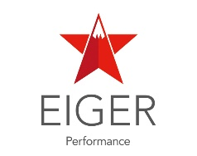

Club Leaders Academy - Cohort 4 (2023-2024)
Introduction
scottishathletics is committed to ensuring that club leaders, staff, and volunteers are supported to assist them navigate the demands of running a modern, sector-leading sports club. We believe that investing in the development and education of people is essential to support clubs on their journey.
Since 2016, and over 3 cohorts, nearly 40 leaders from athletics and running clubs across Scotland have completed the Club Leaders Academy programme, combining their personal development as leaders with the practical knowledge and skills required to play a leadership role in an athletics or running club. This has proven to be a great personal development opportunity for those individuals.
We are delighted to announce that the Club Leaders Academy programme is re-launching following a break due to the COVID-19 pandemic.
Over the coming weeks, scottishathletics will be recruiting another cohort of club leaders to be part of the 2023/24 Club Leaders Academy. This will be an opportunity for up to 16 individuals to undertake a 12-month commitment to develop themselves as an effective and skilled club leader.

What is the Club Leaders Academy?
This innovative programme will support up to 16 current and aspiring club leaders to develop a broader understanding of business development within a club context, hone their skills as leaders, and provide a strong emphasis on practice-based learning.
Particular emphasis will be placed on creating, managing, and enhancing, effective working relationships with management boards/committees, whilst developing and leading the club workforce (paid staff and/or volunteers). There will also be a focus on developing the strategic and business plans of the club.
New to the programme curriculum for cohort 4, is a third strand of educational learning which focusses on the community impact and social responsibility of a modern-day sport club, and the role they play as an anchor organisation in their local community.
Not only does the Club Leaders Academy present a great opportunity to learn from hugely experienced and knowledgeable subject matter experts, but it is also the perfect forum to share experiences with, and learn from, peers within other athletics clubs in Scotland.

Programme Overview
The Club Leaders Academy programme is to be delivered in collaboration with two long-standing partners of scottishathletics.
EIGER Performance, led by Guy Richardson, will deliver a ‘Leadership Development’ module that develops effective leadership, culture, management, and relationship-building skills, through seven workshops.
Club Development Consultancy, led by Dr. Andrew Jenkin, will deliver a module on club and business development. Over six workshops, Club Leaders will learn about key areas of business development in the context of a modern-day sports club.
A series of champions from underrepresented communities and diversity partners, alongside scottishathletics staff, will deliver a module on ‘Community Impact and Responsibility’. This module will equip leaders with understanding of barriers and challenges faced by those from underrepresented and diverse communities.
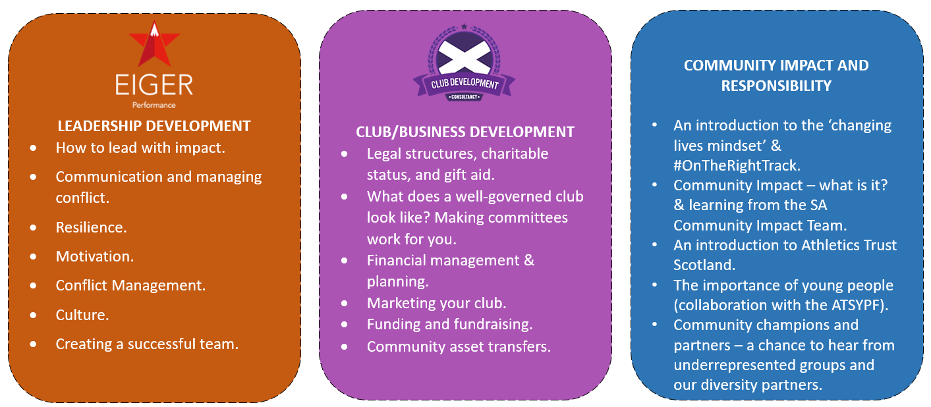
The Club Leader Route Map
Club Leaders will embark on a 12-month leadership and education journey, kicking off with a residential launch at Glenmore Lodge, Aviemore, from Friday 24th to Saturday 25th November 2023. They’ll then be invited to several in-person and online workshops throughout the year that will help review and develop their leadership, skills, and knowledge, across a number of core club and business competency areas.

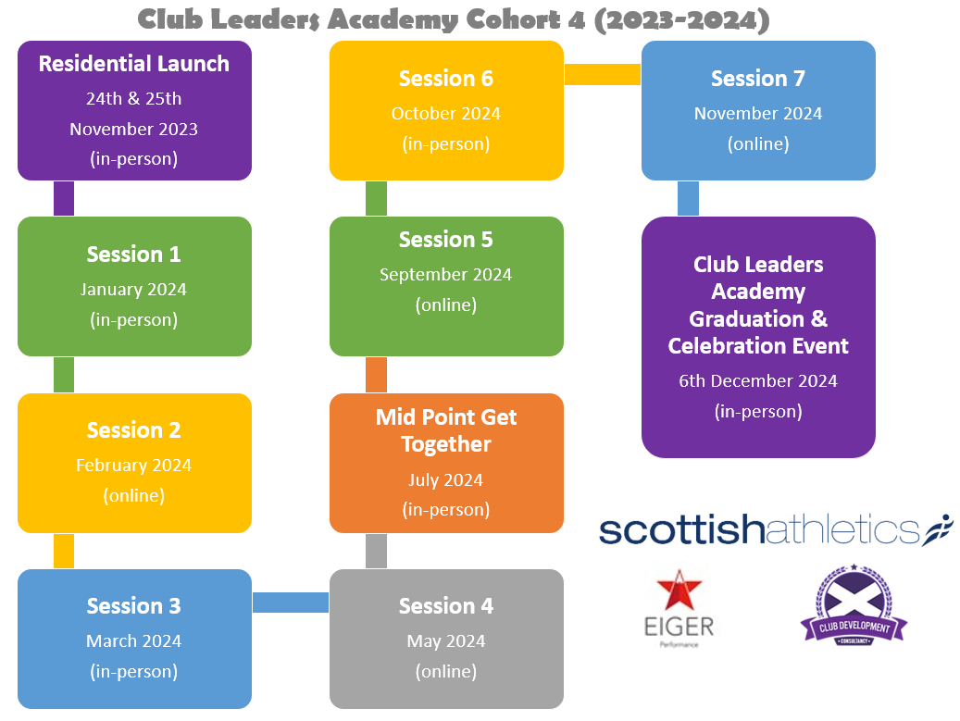

Selection Criteria
We are seeking applications from people who:
- Have current responsibility for influencing and leading within a club
- Are committed to continuous professional development
- Aspire/show potential to be a great club leader
- Want to further develop and refine their leadership competencies and behaviours

Commitment and attendance
Due to the limited spaces on the programme, which we expect to be highly contested, there is a requirement for leaders to commit to 100% attendance at all dates.
There is a further commitment that each leader will be fully supported by their club committee, and that a club representative will attend the celebration event at the end of the programme.

Programme Cost
The Club Leaders Academy programme is heavily subsidised by scottishathletics, with education, resource, travel, and accommodation costs of over £1,000 being invested into each successful applicant.
Clubs of successful applicants are asked to contribute £200 per-leader towards the programme. This is payable prior to the commencement of the programme.
To repay this investment, Club Leaders are expected a fulfil a role in their club for at least 12 months after the conclusion of the programme.

Information Session
If you’d like to know more about the programme, ask some questions, and meet some of the external delivery consultants, then register for our information session being held on Zoom at 7pm on Wednesday 18th October 2023.
Registration link: https://us06web.zoom.us/meeting/register/tZAuf-qpqT8rEtCXjnFcn-ftJtEqjC-lJYzz

Applications
Applications for cohort 4 of the Club Leaders Academy programme will be open from Wednesday 4th October 2023 to 11:59pm on Wednesday 1st November 2023.
Online application form: https://forms.office.com/e/VAMraSGTTx
Please speak to your club committee prior to applying, you will require their support as part of the application process.

