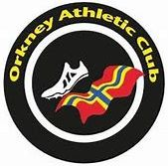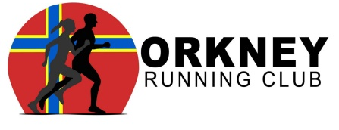

Orkney Athletic and Running Club (SCIO SC051316)
Club Manager

Contract Length: 3 years
Hours: 10 hours per week
Salary: £7,800 per annum (£15 per hour)

Orkney Athletic and Running Club is a well-established, ambitious and successful athletics club based on the Orkney Islands. Orkney Athletic and Running Club have a membership of over 160 members.

An exciting opportunity has arisen for a new role within Orkney Athletic and Running Club for a Club Manager as part of the scottishathletics Club Together programme.

Club Together is a fundamental project within Scotland’s National Strategy for athletics, Building a Culture of Success, placing a key focus on supporting the development of athletics clubs in the country. The role will have a significant impact in the further development of the club.
This part time post (10 hours per week) is funded through a partnership between Orkney Athletic and Running Club and scottishathletics.

Conditions of Employment
The successful candidate will work from home for the most part, but will engage with the board, coaching team, athletes and parents regularly at The Pickaquoy Centre, Muddisdale Road, Kirkwall, Orkney, KW15 1LR. In addition to this, there is likely to be a requirement to attend various locations throughout Orkney, as well as travel throughout Scotland and further afield.

Salary
The starting salary offered for the post will be £7,800. Annual pay awards will be made in accordance with the salary review procedures agreed by the scottishathletics Board of Directors.

Hours of work
The person appointed will be expected to work 10 hours per week. Due to the nature of the post, there will be a requirement to work flexibly, which will include evenings and weekends. There may be future opportunities for these hours to increase.

Pension
scottishathletics operates a qualifying group pension scheme for auto-enrolment purposes and will match the successful candidates’ contribution up to a maximum of 6% of salary, including the legal minimum contributions required.

Annual Leave and Public Holidays
The annual leave entitlement for this post is 25 days pro rata. In addition, the public holiday entitlement is 10.5 days pro rata. Annual leave may be taken by prior arrangement with the line manager.

Probationary Period
All new members of staff will serve a six month probationary period before their appointment is confirmed.

Notice
This post carries a one month period to terminate employment after the satisfactory completion of the probationary period.

Application Process
Applications should be made by submitting the application form, covering letter (addressing how the applicant’s skills and expertise fit with the job roles and person specification) and equal opportunities form, marked “private and confidential”, to Jennifer Goodwin, HR Administrator, email, hr@scottishathletics.org.uk

The closing date for applications is 12 noon on Friday 22nd September 2023 with interviews taking place on week commencing 25th September online.

Incomplete applications and those received after the closing date will not be considered.

Any offer of employment would be subject to a satisfactory background check and references.

scottishathletics is an equal opportunities organisation.

Downloads: 1. Application Form 2. Job Description & Person Specification 3. Equal Opportunities Form
4. Privacy Notice for Scottish Athletics Potential Employees

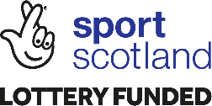

Scottish Athletics Limited, Caledonia House, South Gyle, Edinburgh, EH12 9DQ
t. 0131 539 7320 w. www.scottishathletics.org.uk e. admin@scottishathletics.org.uk
Registered Company SC217377 VAT reg no 596971174

