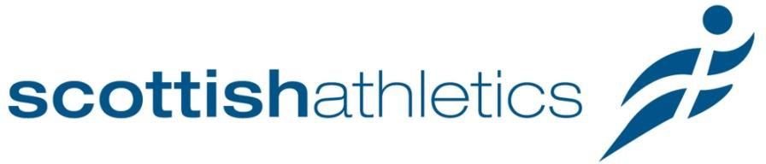

Scottish Athletics Limited

Information for applicants for the position of
National Community Impact Manager

Salary £33,000

(37 hours per week)

2-year Fixed Term

About Us
scottishathletics is the national governing body for athletics in Scotland. Our vision is to give everyone in Scotland the opportunity to participate in athletics and running and to achieve their personal ambitions.

Our mission is to deliver an integrated, inclusive and adaptable model of athletics and running provision that inspires everyone in Scotland to enjoy the sport and experience personal success. Equality, diversity, and inclusion are at the heart of the work that scottishathletics leads, and the organisation works closely with all stakeholders in athletics across Scotland, to continue improving diversity and create an inclusive culture in the sport, and to be reflective of Scottish society.

Our strategy, Building a Culture of Success (2023-2027), captures the breadth of work that scottishathletics facilitates, from supporting performance athletes on the world stage to providing opportunities for people to participate in the sport within their local community. The member clubs play a crucial role in growing and developing the sport and, along with the volunteer workforce, they are integral to the sport’s future success.

Everyone in Scotland can participate in athletics and scottishathletics strives to continuously evolve to deliver on our vision for the sport.

About the Role
One of the biggest changes to our newly launched stratgey is to the fifth key pillar - ‘Community Impact & Health’. The vision and ambition of this strategic pillar has significantly increased as we strive to widen access to athletics across Scotland, to improve diversity in the sport and contribute towards health and wellbeing nationally.

Through our annual collection of diversity data across the sport, we know that the membership of scottishathletics exhibits significant underrepresentation from certain communities when compared with the representation of these communities in the Scottish population. Our three main areas of underrepresentation are:
- People who live in poverty and have a low income
- People from ethnically and culturally diverse communities
- People living with a disability
The role of National Community Impact Manager will be to identify potential participants from these communities, understand and remove any real or perceived barriers to participation, and offer a range of participation opportunities to increase their mental and physical health and wellbeing.
The National Community Impact Manager will recruit National Community Impact Officers and Local Community Impact Leaders. This Community Impact Team will strive to widen access to physical activity to our underrepresented communities, increasing their physical and mental health and wellbeing, and ultimately empowering everyone to achieve their own personal success in the athletics and recreational running in Scotland.

About You
We are looking for a motivated, proactive National Community Impact Manager to lead on scottishathletics’ ambitions to challenge the main areas of underrepresentation in our sport and widen access and opportunities to participate in atheltics and running.
You will have a strong understanding of community engagement and activation, and have evidence of developing and sustaining positive and meaningful relationships with underrepresented communities, internal teams and external partners.
You will have a passion and strong understanding of the role that sport and physical activity play in improving people’s physical and mental health and wellbeing, and the role they can play in creating an environment where everyone can feel welcome, safe, valued, and included, whatever their background.
You will have experience of leading on the successful planning, delivery, and review of national projects and programmes and display excellent organisation, monitoring, and evaluation skills.
With a forward-thinking and hard-working approach, you will bring self-discipline and enthusiasm to the role using your skills and experience to innovate and continuously evolve our offering of education, support, and development to diverse communities and leaders.

Staff
scottishathletics employs 31 members of staff and 16 Club Together Officers.

Place of Work
Hybrid working. The scottishathletics office is based at Caledonia House, South Gyle, Edinburgh EH12 9DQ.

Salary
The salary offered for the post will be £33,000. Annual pay awards will be made in accordance with the salary review procedures agreed by the scottishathletics Board of Directors.

Hours of work
The person appointed will be expected to work for 37 hours per-week. Due to the nature of the post, there will be a requirement to work in the evenings and at weekends. The organisation encourages a flexible working approach from all staff, consistent with meeting the needs of the business.

Pension
scottishathletics operates a qualifying group pension scheme for auto-enrolment purposes and will match the successful candidates’ contribution up to a maximum of 6% of salary, including the legal minimum contributions required.

Annual Leave and Public Holidays
The annual leave entitlement for this post is 25 days, increasing to 30 days after five years’ service. In addition, the public holiday entitlement is 10.5 days.

Travel and Subsistence
The post holder will be required to travel to meetings within Scotland. Travel and subsistence will be reimbursed in accordance with the scottishathletics policy.

Probationary Period
All new members of staff will serve a six-month probationary period before their appointment is confirmed.

Notice
This post carries a three-month period to terminate employment after the satisfactory completion of the probationary period.

