Outdoor – Ideal Starters’ Assistant Positioning
P1 = 1st position to take / P2 = 2nd position to take
When positioning yourself to check athletes on their start line, you should ideally position yourself in a place to see what you need to with the minimal amount of movement possible.

Straight line races
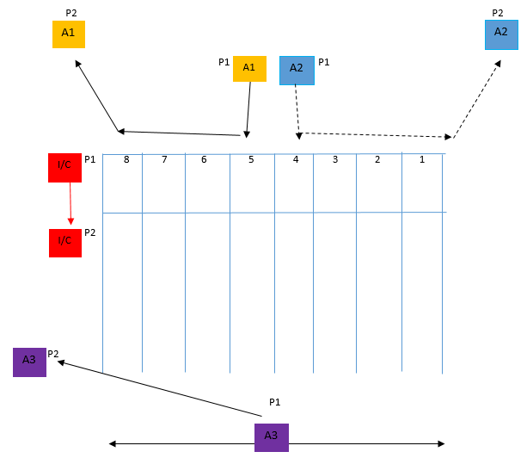

 | In Control (I/C) | Ensures athletes are lined up in a straight line prior to start, approx. 2-3mtrs behind start line, in preparation for presentation then Starters’ instructions. Then proceeds to check athletes in lanes 1-8 are settled for race as per duties given.
 | Assist 1 (A1) | Assists I/C in preparation for race as per duties given. Then proceeds to follow in A2 check feet are in contact with blocks for lanes 5-8, then takes up relevant position dependant on level of meeting on outside of track in for start of race.
 | Assist 2 (A2) | Assists with preparation for race as required per duties given. Then proceeds to lead, checking feet are in contact with blocks for lanes 1-4, then takes up relevant position dependant on level of meeting for the start of the race.
 | Assist 3 (A3) | Takes up position 30m up track to prevent excessive run-outs of athletes. Then makes way to relevant position dependant on level of meeting on outside of track.

Echelon race

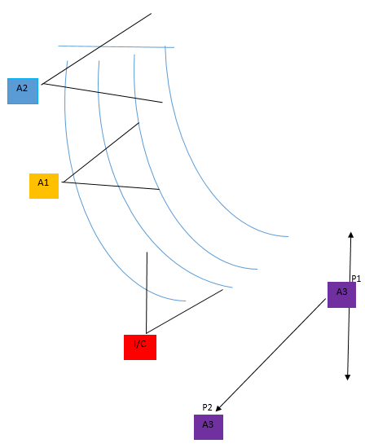
 | In Control (I/C) | Ensures athletes are lined up in their lane prior to start, approx. 2-3mtrs behind start line, in preparation for presentation then Starters’ instructions. Then proceeds to check athletes in lanes 7-8 as per duties given in a position that requires the least amount of movement, preferably none, where possible.
 | Assist 1 (A1) | Assists I/C in preparation for race as per duties given. Then proceeds to check athletes in lanes 4-6 in a position that requires the least amount of movement (none) where possible.
 | Assist 2 (A2) | Assists with preparation for race as required per duties given. Then proceeds to check athletes in lanes 1-3 in a position that requires the least amount of movement (none) where possible.
 | Assist 3 (A3) | Takes up position 30m up track to prevent excessive run-outs of athletes. Then makes way to relevant position dependant on level of meeting on outside of track.

1500m, 3000m/5000m, 10000m

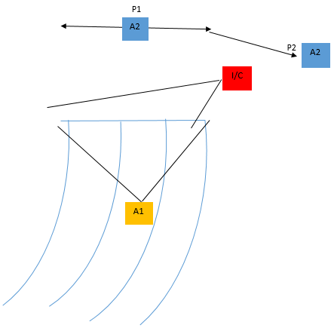
 | In Control (I/C) | Ensures athletes are lined up in a straight line prior to start, approx. 2-3mtrs behind start line, in preparation for presentation then Starters’ instructions. Then proceeds to check athletes are ready for the race as per duties given.
 | Assist 1 (A1) | Assists I/C in preparation for race as per duties given. Then proceeds to take up a position behind athletes so that any infringements may be spotted as per duties given.
 | Assist 2 (A2) | Takes up position 40-50m up the track to prevent excessive run-outs of athletes. Then makes way to relevant position dependant on level of meeting on outside of track.

