Scottish Athletics Officials’ Commission
Minute of meeting
Via Zoom 17/11/21
Present: Margaret Brown-MB (Convener) Margaret McInally-MM (Admin/Secretary)
Andy Law-ALa (Track) Dave Finlayson – DF (Photo Finish)
Dave Cairns-DC (Endurance) Jason Pender-JP (Time Keepers)
Richard O’Grady-RO (Start Team) Moira Nisbet - MN (Field)
Ally Love-ALo (Events Team) Leslie Roy-LR (Track & Field Commission)
Davie Hanlon-DH(Health & Safety) Colin Hutchison-CH (CEO)
1 Convener’s opening remarks:
MB thanked everyone for attending. Zoom meeting are good, but you can have too many of them! Things are looking positive for the Indoor Championships, and we are in a far better place than this time last year. Thanks must go to Scottish Athletics and particularly ALo and his team. It has been a busy time gathering information but it is complete and passed on as appropriate.
* Active lists complied and sent to UKA
* Allocation & selections for Indoor Championships completed
* UKA Indoor allocations compiled and submitted.
* Lists for Officials’ Rewards passed to DA with SM copied in
* L4 R of E to UKA – MN commented in report timing was tight, but MB confirmed there was nothing we could do but meet the deadlines. Reminders out earlier next time from SM as well as H of D
Thanks to everyone for their input in all of this.
3 upgrades – Track, Field & Time Keeping – all successful. Those concerned are now aware but it would be appropriate if UKA was acknowledged by candidates. MB to pass on this info
2 Apologies: Rob Dalziel(RD), Shona Malcolm(SM), Joyce Wighton(JW). Nice to see cover for Track with ALa
3 Matters arising from Minute of 8/09/21:
Everyone happy with accuracy of previous Minute. MM arrange to have it added to web pages.
Appreciation Certificates out. Not to everyone though. ALo reminded the meeting SM had to arrange for 450 of these to be put in envelopes and stamped. CH praised RRR group for this idea and organising it.
4 Convener’s Report update:
* Newsletter to go out by end of year. MB asked that articles were submitted to her ASAP, serious or fun.
* There had been mention of a Training Day evaluation. ALo didn’t know, but it would be helpful as it would give suggestions for the next one due in the spring. Discuss later in meeting.
5 Discipline Report updates:
- Track: ALa – Delighted with the Track upgrade, thoroughly deserved, the reports were outstanding. Well done to the candidate and Mentor. Allocations are complete and will be with RD by end of week.
MB commented at this stage that all 3 candidates had excellent reports put forward.
- Field: MN – No update, just congratulations on upgrade for excellent paperwork & presentation, thanks to Mentor too. 3 upgrades to L4 expected next year and they will be reminded to acknowledge UKA communication of success. R of E was a huge task, so many not in till November. Will remind earlier next year. Overlap with other disciplines also hard to fathom. Make it clearer to L1what is required. MB plan to include this in the Newsletter too. DC commented that Endurance receives hardly any.
- Timekeeper: JP – Upgraded candidate is one of the good guys. Enthusiastic about the sport and getting family involved too. Joined Endurance for Training Day, then covered track lap charts. Recruitment needs to be looked at as no one interested in L1 training.
- Photo Finish: DF –2 Scots did the UKA L4 course and were the only folk on it. No flood of officials from England, very weird, much more interest in Timekeeping. Perhaps it demonstrates the difference between us and south of the border. We have numerous photo finish units and qualified officials to operate them. Very limited in England.
- Start Team: RO – 17 officials available for the Indoor season, 5 of them new. Hope to use opportunity to shadow and mentor. Allocations completed.
- Administration: MM – Names need for those that can be released for admin duties, only 1 received. Track & Field promised this week. Discussion around number limitations for indoors. Agreed that everyone available should be used, also allowing opportunities for shadowing. MB stressed the importance of changing attitudes to who could officiate at championships, too many newer officials think you must be L4. DC endorsed this too and it must be seen as a pathway of development.
- Endurance: DC - New availability form is up and running though disappointing response. 47/698! DC had attended Tutor Training in England unsuccessfully. Discussion followed about need to be able to tutor to suit situation and not be subscriptive. More than one way of doing something well even within set standards. CH suggests situation needs investigated, linking through SM & ALo. He would take it up. MB thanked him. UKA looking for universal level to ensure consistency, therefore becomes prescriptive.
Thanks to RO for developing the ‘box’ to replace gun starts. Still being further developed but has had success to date.
6 Track & Field Coordinator:
Mail chimp Trinity Officials List, statistics (11/11/20)
- 668 subscribers
- 183 Unsubscribed
- 168 Cleaned
Winter Availability 2021/22 (as of 4th November)
- 165 Responses received (30 indicated they did not wish to officiate this winter)
  - 5 Admin
  - 69 Field
  - 13 Photo-Finish
  - 17 Starters/Starters Assistant
  - 11 Timekeepers
  - 31 Track
  - 19 Blank (All from the list of those not wishing to officiate this winter)

Now awaiting returns from Discipline Heads for their allocations, as well as notice of those appointed to Management roles, before being able to share with all officials.
RD not present but MB highlighted the lack of returns in relation to the number sent out.

7 Events & Facilities: ALo –
Summer 2021 Debrief Session – Wednesday 6th October 2021
Communication of Duty Sheets
Confirmed that these can be published on the Officials section of the scottishathletics website – must be received by 12noon the Thursday prior to the event and cannot be changed thereafter.
Any other changes will need to be communicated on the day.
Staffing of Admin Roles
A number of admin roles are being staffed by scottishathletics staff team.
Question: What is the commissions view of this and where does the remit of staff end and officials begin?
- Admissions
- Declarations
- Call Room Stewards
- Presentations
scottishathletics Staff are attending in a voluntary role only as it is not covered in their normal working remits / role descriptions.
Accommodation for Winter 2022
Will continue with officials booking their own accommodation and claiming back for Winter season. This will be reviewed at the end of the winter with the aim of block bookings beginning again for summer 2022 dependent on pandemic issues. When block bookings return officials will again be expected to accept twin rooms.
Timetabling
Hurdles events
Identified as a regular area where time is lost against the timetable.
Potential solutions
- Timetable group to allocate additional time between heats.
- Preparation by Technical Team / Clerk of Course to provide clear written instructions to on the day helpers can make a big difference in the efficient movement of hurdles.
Seated Throws
This is a specialist area where a recruitment push is needed to upskill officials to speed up process. Canvass officials to identify those with an interest.
Allocation of duties within teams
Play to the teams strengths and seek advice on strengths and weaknesses from others – confidentially and sympathetically.
Covid Protocols to keep
Pre registration for Coaches and Spectators
Less paper – no results in paper format
Extended Call Room and assembly times – refine process. Forthcoming indoor season will present challenges with allocation of roles key.
Refreshments – investigate process to pre order lunches as per Aberdeen Sports Village.
UK Athletics Officials Strategy
Will be launched by UKA in the coming weeks – Roadshows on 19th, 23rd and 26th November
Perhaps Scottish launch at March training day?
Will be available to review and feedback on soon – nothing involved that we aren’t already addressing.

Emirates proposed track layout

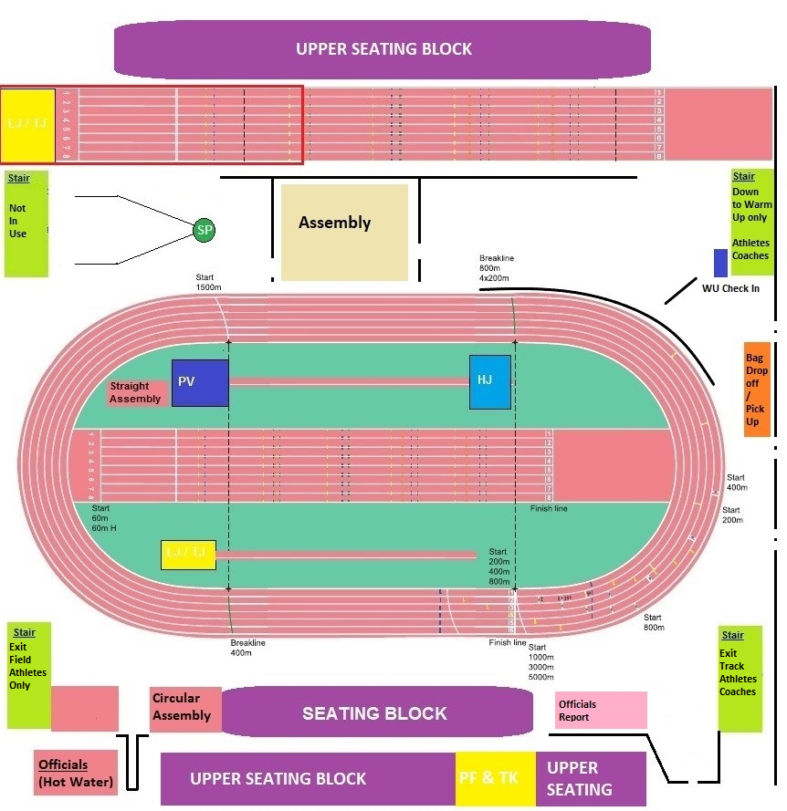
Plan to catch up with Technical group and look at a programme for maintenance of equipment at facilities.
Question from report, where does the office responsibility end and officials take over? Entry can be seen as an office role but not Declarations & Call Room. Appreciate this summer was different and the number of staff helping was much appreciated & needed. Discussion around lack of license for Admin only. Need to look at an education pathway, a booklet, MB agreed this was the way to go and MM agreed to take it forward with the offers of assistance. CH commented that SM needs involved too.
Officials’ Strategy launch email now out to all, date changes though. Need to look at Scottish launch. Training day in spring a long way away but busy early in the year.
DNA event at Emirates to go ahead. Walk round this week with UKA. Scottish Officials will be offered certain roles, use those who committed to indoors season first.
8 Health & Safety: DH – has been no issues so nothing to report. Will submit something for Newsletter though.

9 Track & Field Commission: LR
- Fixtures 2021 – Dates are now in place for Indoor Championship season with reduced numbers and different Emirates’ layout to help ensure everyone feels safe.
- Entries for Indoor Championships are now live with a good response to date
- A new European Athletics event – Dynamic New Athletics – will be held at Emirates on 5th February. This is a 2-hour team based event comprising 10 events with 6 teams competing – Scotland, England, Wales, Ireland, Spain and Turkey. This will be an opportunity for some officials in Technical and non-Technical roles.

ALo has touched on DNA. European Athletics will have a big say in selection, looking for multi discipline officials.
Entries are live for indoors, some already full and many getting near. Great to see so many athletes signing up especially after high XC numbers.

10 Officials’ Development Officer: SM
Training Courses – We have been delivering on-line training course and some face to face at the Emirates with Covid restrictions.
Level 1 Courses – Level 1 Virtual Course delivered – thanks to all the tutors for their continued support.
9 – September – Starters Virtual Course – 10 Attended
25 – September – Endurance Face to Face – 10 Attended
13 – November – Timekeeping – 8 Attended

A virtual Risk Awareness & Level 1 Endurance course will be delivered later this month via Zoom, as well as an Assistant officials Course on 7th December. There will be face to face Level 1 Field & Track Courses delivered in December & January at the Emirates.

National Officials Training Day – Was held at Grangemouth Stadium on the 16th October with 52 attendees. Many thanks to the Discipline heads and some Peer Group members for delivering the workshops. We are hoping to plan another training day in March time or look at the possibility of holding some Regional Training Days.
Website – Updating of Officials pages is ongoing. There have been some updated forms from UKA which have gone up on the upgrading page. Thanks to Jason for sending through some updates for the timekeeping page. Could the other Discipline heads please check the toolkit of their discipline and send me any additions or deletion by the end of January please. If anyone has any other changes then please pass then on to me for updating.
UKA Education Sub-Group Update. – Last meeting was held on 22 September via Teams the main point discussed were-
- Looking at putting a toolbox on the UKA website.
- Putting together examples for report writing on officials both positive and negative for all disciplines.
- The first pilot of the Level 1 Virtual Timekeeping course was help on 10 November with Mike Forrest and myself in attendance.
- There is a working group been put together to look at a new online resource on Introduction to Officiating, I am part of the working group.
- The Licence application forms for Level 1 &2 have been updated and the other levels will be worked on next. The wording on the form has changed from “Application for Accreditation” to “APPLICATION FOR LICENCE AS LEVEL 1 OFFICIAL”.
- Call Room Module still being built and looking for some video content.
- The CMA courses will be delivered virtually between January & March.
- A virtual Conference took place on the 31st October.
Home Countries Forum –
- The group is working with UKA to look at all the current resources that are online for new and current officials. We will be working through them to update and simplify.
Recruitment, Retention, Reward Sub-Group –
- The group met on 8th November. The action plan is attached to this report and some key points listed below.
- The Appreciation Certificate has been posted to 450 officials that have supported athletics in Scotland over the past 2-3 years.
- The group are looking at putting a Welcome pamphlet together, once we have a draft we will circulate for some feedback.
- Question from group - Would the commission support the April Training Day being a Regional Day or Days where we go North, South and Central belt? Possible date Sunday 20 or 27 March or 9/10 April. Can you let me know your preferred date and thoughts please?
- Can Discipline group produce best practise material for the toolkit on the website and send back to me by end of January.
- Can all discipline heads please encourage as many new officials as possible at events over this Indoor season? There is no restriction on numbers of officials selected for SA Championships, so shadowing is highly recommended.

MB asked H of D to get back to SM with preferences asap.

11 AOCB:
1 - Clarification of who should submit Record of Experiences & to whom – MN
Already covered and MB will add to Newsletter. Encourage to complete as they go along and to use Trinity. CH will ask SM to pick up on how to help Officials.
2 - SSAA arrangements update – MM. Plan outlined for Pentathlon International, reducing numbers of adults, preregistering coaches etc, masks. Officials’ info attached at end of reports.
3 - Technical Manager’s Book – MN. Big thank you to MS and team, amazing what they have put together. A big help to anyone in technical role. MB agreed and appreciated hard copy. MM had checked with MS progress for sharing and could confirm it will go onto the Toolkit pages under Management roles.
4 - Trinity Reports – support for inexperienced Referees, NTD or Discipline – MN. Many newer referees don’t appreciate what is involved in an after-event Referee’s report. Little chance to see one. Support definitely needed from both Discipline as well as the NTD on the day. DC intimated UKA weren’t interested in L4 endurance RofE, but still to go to MB.

12 Date of next meeting: Zoom proposed at this stage. 9 or 16th March 2022.

Meeting closed : 7.45 with MB thanking everyone for their time.

Reports submitted:
1.Convener – Margaret Brown

Enormous thanks go to the Officials’ Commission members for their continued hard work, and enthusiasm during very difficult times in 2021. The commitment and resilience shown by all is nothing short of amazing.

Annual Awards 2021
Our Commission meeting takes place this year after the Annual Dinner & Awards and am delighted to note the following winners announced:

Technical Official(s) of the Year – went to the 4 members of the Rose Family (Kevin, Carol, Rebeka & David)
Raymond Hutcheson Trophy for Services to Officiating – Richard O’Grady
HLM – Alistair Aitchison, Janice Hendry and Bob Masson

It was a very good evening and, whilst things were not quite normal – no ceilidh! – very enjoyable otherwise.

All winners were hugely deserving of their award.

UKA Peer Group – 2021/22
Appointees to UKA Peer Groups for the next year are as follows:

Field Julie Dew, Shona Malcolm, Paul Smith
Photofinish Mark Delgado, Cameron Lindsay, Alison Jordan
Starting Sara Fletcher, Alan Bell, Mark Purser
Timekeeping John Vickers, Jason Pender, John Barwick
Track Alistair Aitchison, Noel McKakly, Steve Snodden

Well done to our Scottish officials who are included in four of the UKA PGs.

Officials’ Training Day 2021
An officials’ training day was set up in preference to a face-to-face conference for 2021. The workshops offered by Start, Photo Finish, Track, Field (Technical & EDM) & Timekeeping proved to be very popular. An evaluation questionnaire is being set up in order to gain feedback from all officials who attended.

If evaluations are positive, we may look to set up another Training Day towards the end of March 2022. Discipline groups would be advised to start considering useful topics now.

Officials’ Upgrading
Applications for upgrading to Level 4 from three Scottish officials have been submitted. As the UKA Peer Group meeting takes place at the end of November details of successful Upgrades are not yet available. Further details will be made available as soon as these are confirmed.

Officials’ Indoor Availability
Selections for Management Roles for the 2022 Indoor season took place virtually on Monday 8th November. The Discipline Heads are now working towards the finalised lists for all Scottish Championships and details will be made known to all as soon as these are finalised.

Indications from availabilities received are positive for Technical, Call Room/Assembly and Admin roles and we will definitely be calling on those who have shown an interest in developing skills in these areas.

Heads of Discipline were asked to ensure that where newer officials are included a commitment by all experienced officials should make certain that everyone is provided with a valuable and worthwhile experience. In addition Discipline Heads were tasked with ensuring that no one is turned away on any specific day, even if there are more officials available than perhaps would normally be required.

It is acknowledged that this is always an on-going process which needs to be constantly reviewed as officials’ commitments change. Many thanks go to all Discipline Heads and members of their Peer Groups for their commitment and time in discussing, agreeing and providing the necessary information to allow Rob Dalziel to complete the task.

Officials’ Rewards
Once again we are fortunate to be supported by scottishathletics in being able to offer a reward, in the form of a kit voucher, to those officials who have actively supported our championship events (or equivalent of) during the past year. These lists, produced by the Discipline Groups, are presently being finalised to be sent on to Dawn Allan, SA Operations Manager, for processing. It will require a bit of time for this to happen. Heads of Discipline are asked to ensure that their officials are aware of who has qualified for the Reward.

Details will, once again, be included in an Officials’ Newsletter.

Newsletter
It is hoped that an officials’ newsletter can be produced by the end of November or early December. However, this requires an input/article from all Disciplines and ‘others’ who are so inclined. Please try to find something to say, entertain, challenge etc very soon.

Indoor Season 2021/2022
It is looking much more positive for scottishathletic indoor championships during the coming months. While things may be a little different than they were in 2019 it is great to be able to have some active involvement for everyone.

To ensure officials are comfortable and confident in attending indoor athletics in 2022 an Officials’ Catch-up took place virtually towards the end of October where plans and processes were shared with those who attended.

Huge thanks must go to the Events’ Team and the whole of scottishathletics for working so hard to ensure that one-way plans and different processes will allow our indoor championships to happen.

2.Track - Joyce Wighton
Track Peer Group:

It was good to be able to hold our first in-person meeting for two years on 10 November 2021.

Training Day:

For track this was about quality rather than quantity. There were only three of us so we took the opportunity to use the session to provide detailed training for a young official. We agreed topics with him in advance. On the day we did a practical session on preparing Duty Sheets and had detailed discussions on the Para rules and progression to level 2. The young official enjoyed the session and left with an armful of useful resources and documents.

Officials Progression:

All planned reports from the outdoor season, for progressing officials, were completed.
One very good quality application for level 4 has been submitted to UKA.

Current position:
1 official progressing from level 2 to level 3
8 officials progressing from level 1 to level 2
4 Assistant officials progressing to level 1

It has been a difficult year and a half, with reduced opportunities for new officials to gain the required experiences so we may have ‘lost’ a number of these officials. We hope to re-engage as clubs and leagues gradually normalise.

Picking up on Mark Munro’s comments, on the UK Officials Conference, about new level 4’s being thrown in to televised meetings, I plan to have a meeting with any new level 4’s, along with their mentor, to talk through what they can expect at televised meetings and provide them with advice. I also plan to produce an associated information sheet on this, as part of a general mentoring document (to include what can be expected of a mentor and providing guidance for mentors and mentees).

Allocations

The outdoor season went well, considering the restraints, with most events having sufficient track officials. There were no call offs from those given major roles but there were a number of call offs from those given Track Judge/Umpire duties. The published spreadsheet was constantly changing with removal and addition of officials so it was difficult for our Allocations Lead to keep track as he wasn’t informed of withdrawals.

There has been quite a good response to the indoor availability by track officials, on a par with previous years. The zoom meeting to explain plans and procedures was appreciated and some, who had felt uncomfortable about indoor officiating, were reassured by what they heard.
However, there is a problem with the number of people making themselves available for Clerk of Course duties. This will have to be addressed. Some people will be given this duty even though they did not tick the box!

UK Indoors:

Track has been allocated 3 places at the Indoor Grand Prix (which clashes with our own Age Group Championships) and 2 places at the British Championships.
3. Field – Moira Nisbet
Since our September meeting, it has been a busy time with all the Record of Experiences being returned. In total 69 returns, and lot coming late in October. The cut off at the 1 October seems quite tight especially if officials are still doing events at the end of September, or taking a short holiday after a busy season. I was still working through these reports at the end of October/beg Nov. Submitted report to Margaret Brown to allow me to contact each person to confirm success - being very generous this year due to restricted number of competitions people were able to attend.
The training day at Grangemouth in September gave the opportunity to provide some training on EDM use, Technical Manager and how to check implements and summary of Field levels, reports required and summary of what reports for each grade required. Grangemouth staff also provided some training in the use of using the new Hammer/Discus cage doors. I think most people who attended missed the getting together at beginning and end of the day but understood the need to have restrictions in place under current Covid-19 guidelines.
Good meeting with Scottish Athletics and Margaret Brown on Tuesday 26 October. It is good to learn that the field duties allocation and briefing can be placed on the Scottish Athletics web page under the event. Once we have completed the indoor allocations I plan to have a zoom call with the allocated referees to go over what it is they need to do and when by – we need to be clear that Scottish Athletics require these forms on their event site by the Thursday prior to the match. There was some concern about changes etc, but this meeting after allocations should alleviate any concerns for allocated field referees.
Scottish Athletics officials development officer has recruited quite a number of new level 1 officials over the year and this has worked well with her online training, it is encouraging to see these new officials coming through. Development officer now copies me in when sending out the confirmation of upgrade to level 1. An update on Scottish Athletics webpage for “Become an official and support our sport” with training dates noted. As officials we need to encourage new blood and be welcoming to all.
The UK officials conference reflected on “lasting memories” and our own Mark Munro did comment on people not remembering what was said but would remember how they were treated. We need to encourage our officials remember this and that we all take on this on board when we are attending events and challenge behaviour not acceptable, as a Commission Group we need to be setting the example, leading the way.
Upgrades: I have submitted the following requests for upgrading during the year:
- 1 level 3 to level 4 – awaiting confirmation
- 1 level 2 to level 3 – successfully updated
- 5 level 1 to level 2 – successfully updated
We have a number of upgrades in the pipeline and need to ensure reports etc are provided but for most this will be outdoors as always need to have a long throws included in the report. I will ensure the officials in the pipeline are made aware of what is required after I have the reporting group have met. Feedback on reports completed this year is that guidance is required to ensure:
1. Officials allocated to do the report understand who they are reporting on and what needs to be covered for them to return a positive report or if negative what needs to be reported
2. Officials being reported on need guidance to confirm what they are required to do on the day – feedback given to the reporting team and they are working on a template to issue which would include as a level 4 the requirement to complete a field referees report on trinity and the importance of this being done within 14 days after the event.

The Field discipline peer sub-groups have worked well this year. Meeting held on 3rd November to consider lessons learned this year and how we take forward for next year for both indoors and outdoors.
- Mentoring - Pam Auckland, lead, has worked with her team and set up everyone that wishes a mentor with a mentor. Good feedback so far, but still a way to go to ensure consistency of approach and information. Pam will consider sending out another email to invite more mentors. Training for mentors is the way forward.
- Technical Group - Mark Stringer, lead, confirmed the technical sub-group has worked really well, making sure that all technical roles are covered when allocating and looking at the requests when availability is provided. We have also been able to work together to complete the technical guide.

- Reporting – Joyce Rammell, lead, worked with her team to identify those requiring reports and this has been successful during 2021 considering the limited number of events we have done well to have a few people put forward for upgrade. The pipeline list is in place to ensure others are considered when requests for upgrade received. Contact will be made with all officials in this pipeline list to ensure everyone is aware of the plans for the year ahead.

- Allocations – George Sneddon, lead, ready to receive the indoor allocations list and meeting set up for 11 November to work through the list. Lessons learned from this year for allocations where some officials did not receive allocation even although they submitted a return and were not aware of the process that they will get something through to confirm allocations from Scottish Athletics. Moira will ensure a communication is cascaded after the next allocations meeting once the indoor list is on the Scottish Athletics website.
I have had difficulties with the officials email and will contact Scottish Athletics office to sort. In the meantime I have managed to access to get all the ROEs (without a password) but prefer at present to use my personal email. I will update once the email is working as expected.
I have been grateful for the support Joyce has given me during my first term in office, lots of learnings gained and lots more to learn as different topics crop up. Communication is definitely key.
4. Time Keeper – Jason Pender
Training Day 16th October
This day albeit low numbers was an excellent cross collaboration between Endurance and Time Keeping disciplines. It covered timing and recording at endurance events, a practical exercise in setting up and operating a finish funnel and follow by track and field time keeper lap charts as a final topic.
Training Course 13th November
Level 1 Time keeper course provided by tutor Mike Forrest supported by Jason Pender.
The number of track and field time keepers involved at the Scottish Athletic Track and Field Indoor events is as follows
Number of Active Officials Listed/Number of Officials Volunteered for Indoor 2022 SA Organised events
Level 1
36/1
Level 2
15/3
Level 3
20/1
Level 4
15/8
Total
86/13
Upgradings
One level 3 submitted for upgrading to level 4

5.Photo Finish – Dave Finlayson

As of this month’s UKA Affiliated Officials Report we have the following active PF Officials:
Trainee : 11
Level 1 : 12
Level 2 : 6
Level 3 : 3
Level 4 : 9
Inactive : 5
We have :
2 x Level 3s progressing to Level 4 Attended the L4 course last Saturday 13th November
1 x Level 2 progressed to Level 3
2 x Level 1 progressing to Level 2
We welcome Mark Stringer to Level 3.

6. Start Team – Richard O’Grady

The Start Disciplines’ outdoor season went well, with all requests to supply Start Officials met and no issues reported. Sometimes, there had to be some tweaks to team lists, due to last minute changes in work or family commitments, but as always, the team rallied to the call.
We’ve run a L1 Online Start Course with Alan Bell and now have 10 new officials. Several of them have already started their officiating pathway, attending local open grades and the recent Scottish Universities Freshers OG at Glasgow Emirates Arena. I’ve included all of them into all the team emails and sent them all the latest version 5 copy of the Scottish Athletics Starters & Starters Assistant Handbook.
At the recent Officials Training Day, we ran 3 workshops for the Start Team on TESS (The Electronic Start System, the new Algae SIS (false start) system and for the first time a Gun handling & maintenance workshop.
The Peer group are currently looking at our “Active” & “Non-Active” officials list in preparation for submitting to the Officials’ Commission Convenor as requested. We’re using recent Records of Experience and our Allocations spreadsheet, which covers all Start Team allocations from 2017 to the present day.
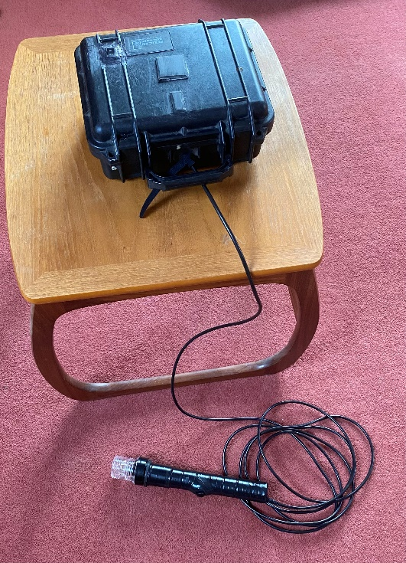
Following the decision by the Scottish Athletics Road & Cross Country Commission to stop using gun starts at their events, I’ve been looking at various non gun options for our endurance starters. Although there are several alternatives, they all come with some drawbacks. For example, the athletics field warning horn is very good but doesn’t provide a visible indication for timekeepers, chip operators, etc. Therefore a flag system would need to be used along with the field horn. It also requires considerable puff to provide a prolonged start signal for larger events.
Looking for a more suitable option I made this 12v start system out of odds and ends from my garage, similar to the TESS system but a lot less technical (coffee table not included).
A waterproof case containing 1 12v sealed battery, an on/off switch and 2 motorcycle horns. This is connected via 5m cabling to a wand with an LED light on the top and a push button on the side. As long as the push button is pressed the horns will sound and the light will shine. We tested it at the recent National Short Course XC event in very bad conditions and it worked well.
Here is a link to a very short You Tube video demonstration >>> https://youtu.be/jrErRTIdjA0
I have asked the R&CC Commission for permission to purchase the materials and make a further 3 units and issue them to each RR&CC District.

7. Administration – Margaret McInally
Since the last meeting there has been a limited number of opportunities for those Admin officials with no other discipline, but with Indoors fast approaching commitment will once again be imperative. There are a number of previous ‘regulars’ still not making themselves available, which makes it more important than ever that we get input from other disciplines. Without physically being able to visit and encourage, I’m limited to email/phone contact which isn’t necessarily acknowledged. Scottish Athletics will continue to encourage staff to be involved in Admin and this is greatly appreciated.
8. Endurance – Dave Cairns
- UKA Endurance Education Sub-Group:
- Question raised regarding Endurance Officials material posted on British athletics website. Advice was that Training course current updated material was available to delegates who had attended training courses, through their Trinity Athletics Hub. However, this does not address existing officials who would remain unaware of changes. UKA agreed that a link should be added on the website (NB Awaiting minutes of the meeting for confirmation).
- Next meeting: 25/01/2022.
- Endurance Officials Action Plan:
- Ongoing.
- Endurance Officials Discipline (Peer) Group:
- Still just DC (East) and M-AM (West), but I’m sure there must be issues from the North worthy of sharing.
- Endurance Officials Availability Google Form:
- Completed and circulated to all officials irrespective of whether T&F or Endurance, together with our “unqualified” officials (who have now applied for PVG disclosure).
- 698 Officials were on the mailing list of which I have had 47 returns. Nobody advised that they did not wish to do Endurance, they are therefore still on the mailing list.
- Only Scottish Championships organised by the RR&CCC included.
- In order to clarify issue of availability being oversubscribed for an event I prepared guidance to conveners on UNALLOCATED ENDURANCE OFFICIALS POLICY.
- This is a work in progress, constructive feedback would be welcomed.
- Endurance Officials Training:
- There were 12 delegates signed up for the Endurance Officials training course on 25/09/2021 at the Emirates but only 9 attended.
- Following a request from Aberdeen AAC a Virtual L1-L3 Endurance Officials training course is being planned for 21st & 28th November 2021 (RA & L1-L3 modules on respective dates). These will be led by a senior UKA Tutor assisted by DC.
- Accreditation Upgrade:
- Three delegates from 25/09/2021 training course have applied for Level 1 Accreditation.
- Endurance Officials L1 Course Tutor Training on 4th/5th October 2021:
- M-AM was advised that as she had already done the new “interactive methodology” training for Track, she did not require to attend the course at Birmingham. DC was therefore the sole Scot.
- At the end of the course candidates completed a self-assessment on how they felt they had performed and had individual meetings with the Trainer/Assessor. DC was assessed at level 2 and advised that further mentoring on delivery skills was required.
- I understand that the next step with respect to M-AM becoming a qualified Endurance Tutor will require her familiarisation with the Endurance Matrix, which will be discussed directly with her.
- I have advised SM of the Tutor Training outcome and that, for the time being I am not qualified to deliver face-to-face training. As things stand, Scotland do not have a qualified tutor for delivery of the new interactive face to face endurance training course.
- There were a number of issues highlighted through the Tutor Training course deliveries which are now under review.
- Start Procedures for Endurance Events:
- Additional guidance on false start recall protocol has been incorporated into “Alternative Start Procedures for Endurance Events”.
- Officials Training Day at Grangemouth 16/10/2021:
- DC Co-hosted an Endurance Timekeeping Session with JP (Timekeeping Discipline Head).
- RO’G (Starters’ Discipline Head) incorporated the “Alternative Start Procedures for Endurance Events” in his Start Team presentation.

Schools’ Pentathlon International:

Officials info from SSAA – as at 16/11/21
Officials can enter by the lower door (or outer stair after 8.45)
Plan arrival & departure to minimise time indoors
Officials Only seating area on upper section of finish straight side
Masks to be worn when moving around & seated.
If distancing possible when officiating, no mask needed
Access to track via stair at warm up area, departure from stair at shop end
Track athletes will be collected at finish and escorted to UP stair where they will be issued with a mask & advised to return to designated seating area
Field athletes will be escorted to stair by an Official from the team.
Urn, tea, coffee etc will be provided at Admin area near finish. Do not congregate in this area
Own food, drink, cup & spoon required
£5 lunch allowance will be available from Chief/Referee
Café should be open till 3pm with limited menu

