Promoting inclusive practice in sports clubs
The purpose of this paper is to promote inclusive practice by encouraging and supporting mainstream clubs to offer opportunities to participants with disabilities. Clubs may also wish to consider the needs of all protected characteristic groups when promoting inclusive practice. Scottish Governing Body staff may use this as a resource to support clubs.
INTRODUCTION

A short video and further information on the underpinning principles of inclusive practice can be viewed on the Activity Inclusion Model and Step Framework
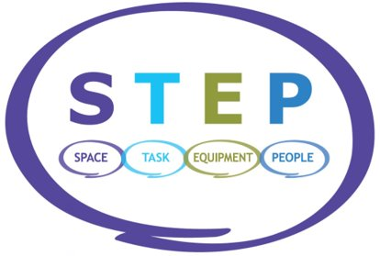
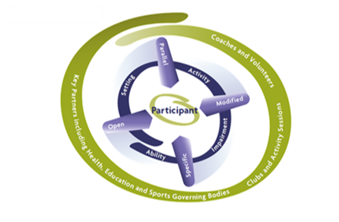
Inclusive sport offers ALL participants with disabilities the opportunity to reach their full potential in physical activity and sport

Clubs may consider:
- Plans and procedures meet group and individual needs.
- Offer coaches, officials and volunteers appropriate training (CPD) opportunities to upskill, improve confidence and increase knowledge of disability sport.
- Inclusive and disability specific training and competition pathway.
- Full access to club facilities and any adapted equipment required.

Club committees may consider the following to promote inclusive practice:
- Club constitution may require to be updated to reflect the Equality Act 2010.
- Committee members, volunteers, coaches, officials, and all participants will create a welcoming and positive environment for every member (inclusive culture)
- Committee members, volunteers, coaches, officials, and all participants will contribute to the promotion of inclusive practice
- Communications to be accessible to meet the needs of all participants with disabilities e.g. accessible formats

Club considerations for the inclusion of participants with disabilities.
Planning
1 | Is the club vision inclusive? | - Does the club’s vision ensure the club will provide opportunities for participants, coaches, officials and committee members with disabilities?
2 | Does the club plan consider the inclusion of participants with disabilities? | - Does the plan take in to account how you would offer training and competition opportunities for participants with disabilities?  - Does the club consider disability inclusion and sport specific inclusion training for coaches, volunteers, officials, and committee members?  - Is disability sport explicitly referred to in the club’s plan?  - Are there targets within the plan explicitly referencing participants with disabilities?
3 | Is the culture of the club inclusive? | - Are the club’s facilities and equipment fully accessible to participants with a disability and have considerations been given to improving this access?  - Does the club have a welcoming and supportive attitude towards participants with disabilities?  - Does the club have an inclusion ambassador/champion who is the advocate for participants with disabilities?  - Does your club recognise and celebrate the successes of participants, coaches, and volunteers with disabilities or those who work with participants with disabilities?  - Does the promotional imagery used by the club reflect participants with disabilities?
4 | Club Profile – data gathering | - Does the club have key baseline figures with reference to participants, coaches, committee members with disabilities?  - Are the following five key areas used to gather information on members with disabilities?  - physical impairment – wheelchair user for sport  - physical impairment – ambulant  - learning disability  - sensory impairment – hearing  - sensory impairment – visual
Delivery Outcomes
5 | Are club programmes and competitions inclusive? | - Can the club confirm the number of participants with disabilities participating in competitions and programmes?  - Where appropriate and relating to the Activity Inclusion Model is there signposting to mainstream and disability specific competitions? For example, SDS Branch, Regional and National competition  - Does the club provide education and CPD opportunities to upskill coaches, volunteers and officials?  - Does the club know where to access further information and support for participants with disabilities, for example, performance development and classification support?
Review
6 | Review of club plan | - Is the club plan reviewed on an annual basis to demonstrate success and identify gaps to progress the following year?
If your club would like further support and information on any of the guidance notes, please contact admin@scottishdisabilitysport.com or telephone Head Office on 0131 317 1130.

