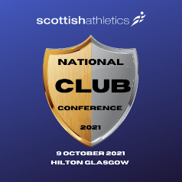
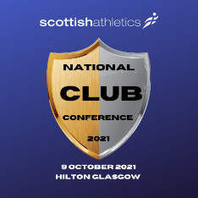
National Club Conference
Draft Agenda

Time
8:45am – 9:25am | Networking exhibition area open
9:30am – 9:40am | Introduction – David Fallon, Head of Development of scottishathletics
9:40am – 10:20am | Keynote Presentation – Leadership/Energise/coaching – Paula Dunn
10:30am – 11:10am | Workshops – Session One
 | Coaching | Springburn | Aberdeen | Equality
11:10am – 11:30am | Refreshment Break
11:35pm – 12:15pm | Workshops – Session Two
 | Coaching | Springburn | Aberdeen | Equality
12:25pm -1:00pm | Future Vison – Colin Hutchison, Chief Executive Officer and David Ovens, Chair of scottishathletics
1:00pm – 1:45pm | Lunch
1:50pm – 2:35pm | Development Team – Key Priorities Round Table  Facilities  #OnTheRightTrack(changing lives)  Youth Forum  Board Myth Busting  Welfare/Coaching  Para Sport
2:35pm – 2:45pm | Refreshment Break
2:50pm – 3:35pm | Workshops – Session Three
 | Coaching | Springburn | Aberdeen | Equality
3:40pm – 4:00pm | Guest Speaker – Presentation and Q&A – Erin (All about youth)
4:00pm | Summary & Close

