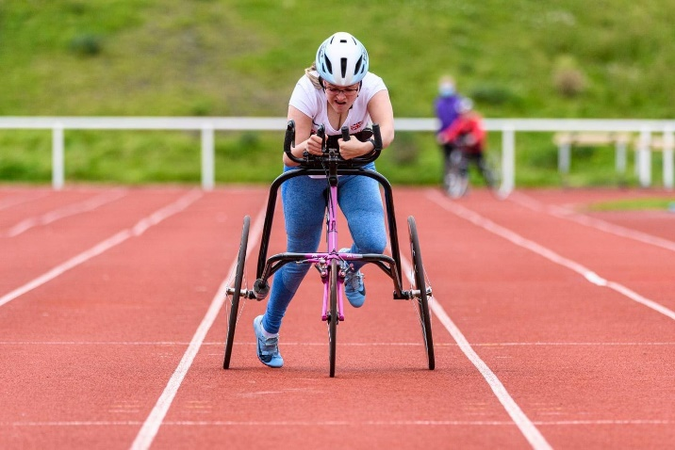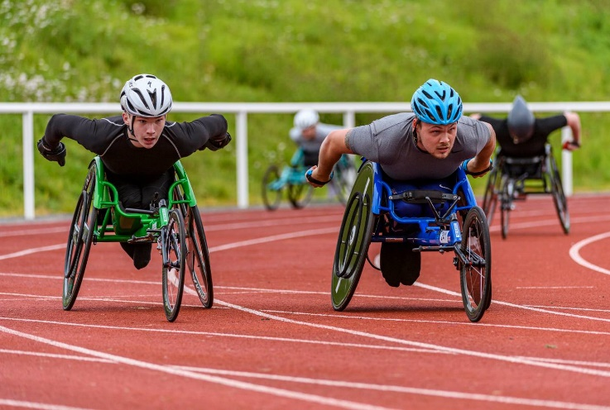

General Safety Reminders:

* Athletes should always wear a helmet.
* Use correct gloves for pushing.
* Check helmet and gloves for wear and tear.
* Be aware of time in the chair, build up gradually.
* Have tools, pump, and puncture repair kit handy.

**Minimise Risks**

It’s possible that the equipment has been unused for quite a period, some basic checks are needed:

* Check tyre pressure and tread.
* Check the frame for loose parts or obvious damage.
* Listen for any rattling / catching noises.
* Check that it fits as it did before and adjust if needed.
* Make sure brakes are in working order.

For any advice or additional information please contact Pamela Robson:

Email: [pamela.robson@scottishathletics.org.uk](mailto:pamela.robson@scottishathletics.org.uk) Mobile: 07827 343410

Training Safely on the Track

Reminders for safe training on the road:

* Use a flag to improve visibility or train with someone on a bike / in a car.
* Carry basic tools and puncture repair kit.
* Have knowledge of how to do simple repairs.
* Inform someone of your route and timings.
* Carry a phone where possible.

Reminders for safe use of track:

* Remove hazards where possible e.g. hurdles, cones, water bottles or highlight them when unable to be moved.
* Allocate lanes or faster athletes use inside lanes.
* Check behind before moving and communicate when overtaking.

Training Safely on the Road

**Is the Wheelchair or Frame Safe?**

With athletics training returning across the country, now is a good time to take a moment and remind ourselves of the extra safety considerations for **wheelchair** and **frame running** athletes.

Here are some points for consideration to ensure a safe and enjoyable return to training:

**Safe Return to Training**