Welcome back to the club
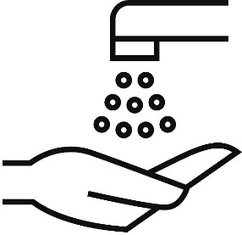
Follow physical distancing at all times
Follow venue rules
at all times
Wash your hands before and after and sanitise during the sessions
<2m>

Before you train  In this phase you must stay at home if you:  - Have been in contact with someone with COVID-19 in the last 14 days.  - Have been overseas or exposed to someone with COVID-19 in the last 14 days.  - Have COVID-19 symptoms (self-isolate for 7 days) or are feeling unwell.  - Have been told to self-isolate as part of the contact tracing measures in place.  - You may be subject to a symptom check by your facility provider or club prior to training.  Physical distancing & good hygiene  - Refrain from handshakes and high fives.  - Keep 2 metres away from other people at all times.  - Do not share food, towels, and drinks.  - Clean your hands and equipment frequently.  - Cover your coughs and sneezes and dispose of any used tissue in your own bag and take it home with you. Wash your hands for 20 seconds or sanitise afterwards.  - Avoid spitting unless into a tissue which you should take home and dispose of.  - Avoid touching your face.  Welfare (safeguarding for U18s – state who welfare officer is and any additional procedures)  - In line with our child wellbeing & protection policy, athletes under 18 years of age should always be accompanied by a parent/carer throughout the training session where it takes place in an outdoor and public space. | Booking process  Insert your club booking procedures  Procedures at training (include arriving, departing and any relevant event specific information)  Training information (what groups on what nights and at what times? Will it be staggered)  After training advice  - Once training has finished leave promptly and maintain physical distancing.  - Hands should be washed and/or sanitised as soon as possible.  - Ensure personal kit and equipment is cleaned thoroughly after use.  - If you become unwell after training, you should first contact your GP/NHS 24 and then inform your club/scottishathletics welfare team.  Facility procedures (for each venue you use)

Scottish Government guidance - https://www.gov.scot/coronavirus-covid-19/
scottishathletics guidance - https://www.scottishathletics.org.uk/clubs/club-support/coronavirus/

