WELCOME BACK TO THE CLUB

**Please adhere to the following measures at all times.**

**You must also follow Scottish Government Guidance.**

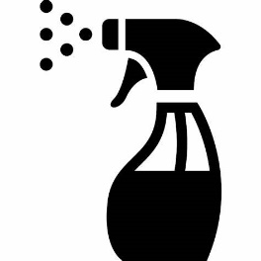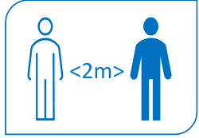

Use the toilet before you leave home

Always maintain physical distancing

Outdoor exercise only

Stay with your own group during a session

Implements should not be shared and should be cleaned after each use

**Further information and resources can be found in the Covid-19 section of the scottishathletics website** [**https://www.scottishathletics.org.uk/clubs/club-support/coronavirus/**](https://www.scottishathletics.org.uk/clubs/club-support/coronavirus/)

Club Contact Details

Always follow the coach’s instructions