
Organising a

VIRTUAL RACE
Pre-Event
  - Licensing
  - First Aid
  - Courses/Facilities
  - Entries
  - Insurance
  - Risk Assessment

During the Event
  - Rules
  - Results
  - Emergencies

Post-Event
  - Debrief
  - Reports and Returns


Tap here to add a caption

This document provides an overview of the main steps involved in hosting a virtual race. Further guidance is also available from our website.

Pre-Event

Licensing
All athletics events taking place in Scotland should apply for a scottishathletics licence: virtual races included. To apply for a licence from scottishathletics, your organisation must be a member (either a registered club, associate member or event organisation member) and complete a licence application form online. Virtual races should apply for a Road/Multi-terrain licence, and confirm within the application that the race will take place virtually.

First Aid
Event Organisers are not expected to provide first aid cover for their virtual event but must ensure that pre-race information contains guidance for runners in case of accident or injury. This could include reminding athletes to inform someone of where they are going and to check in with them on their return; to carry an ICE (in case of emergency) card with their details; or advice on any other appropriate arrangements they should make. Event Organisers must confirm that they have issued first aid instructions to their runners when applying for their race licence in the first aid section.

Courses/Facilities
At conventional events, it is the responsibility of the Event Organiser to ensure the facilities used for their event are suitable. In the case of virtual events, however, the Event Organiser’s influence over the course could be limited. Where the Event Organiser sets the route for the virtual run (eg. a well-known loop in the local area, a Strava segment, etc.), they should ensure that the exact route is communicated clearly, and is accessible to all participants. Where participants should choose their own route, guidance should be offered to participants on planning an appropriate route for their run, as well as any other factors runners should consider (elevation, access restrictions, etc.). When applying for a licence for a virtual event, the Event Organiser will be able to select ‘Virtual Race’ in the address box when asked for the race’s location.

Entries
As in all licensed events, organisers must collect a £2 unaffiliated runners’ levy from all entrants who are not current athlete members of scottishathletics. This levy applies to jogscotland members (number beginning JS) and anyone else who cannot provide a valid SA membership number on their entry: remember to ask for scottishathletics numbers on your entry form. These levies must be paid to scottishathletics within 28 days after the event takes place. Events with an entry fee of £2 or below will not be required to pay levies.

Insurance
A licence from scottishathletics ensures your event receives public liability insurance under the UKA master policy. Policy documents can be found here.

Risk Assessment
You should carry out a risk assessment ahead of your event, and ensure this can be made available to scottishathletics upon request. Participants should conduct their own assessment of their own route, but Event Organisers are still expected to have measures in place to ensure that participants in their event can take part safely, including guidance on planning a suitable route and procedures to follow in case of accident or injury. These should be outlined in your event plan and rick assessment. Guidance on conducting a risk assessment can be found on our website here

During the Event

Rules
Events issued a licence by scottishathletics must be held under UKA rules, and this should be advertised with the words “Under UK Athletics Rules” and “scottishathletics Licensed Event” on all event materials. Copies of the UKA rulebook can be found here. Any additional rules set out by the Event Organiser must be communicated clearly to all participants at the point of entry.

Results
Pre-event, consider how you will compile the results of your event. There are a number of electronic systems available commercially to assist you with compiling results, or you can compile results manually. Determine how much information you require from participants (times, distances, elevation, detailed routes, route maps, etc.) and ensure this is communicated in advance to runners. If runners should use a specific method of tracking their performance (eg. a certain app), ensure this is readily available and provide support with its use if required.
There is no need for qualified officials to be involved in your event, but you may wish to contact officials at your local athletics club for assistance with race planning and/or results.

Emergencies
In planning your event, you should have identified potential issues through your risk assessment. Your event plan should also identify and describe procedures that should be followed in the event of an emergency, and communicated to all relevant parties. Should any major accidents occur, they should be reported directly to UK Athletics using this form.

Post-Event

Debrief
Following your event, it is good practice to hold a de-brief with your team. This will make you aware of any issues, feedback or incidents; reflect on the event itself; and to begin planning for next time. It is also beneficial to seek feedback from participants if you plan to hold a similar event again.

Reports and Returns
After your event, ensure you return to scottishathletics:
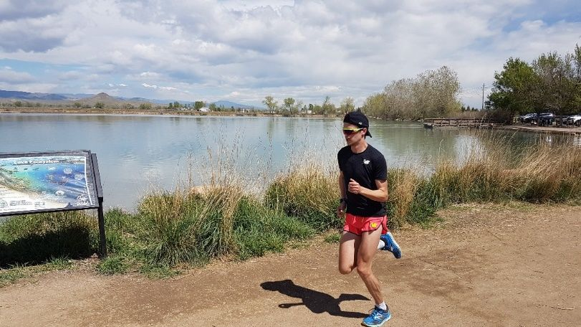

Contact Us
scottishathletics
Caledonia HouseSouth GyleEdinburghEH12 9DQ
Telephone: 0131 476 7335
events@scottishathletics.org.uk
www.scottishathletics.org.uk/events

- your completed event return form (found online, in your licensing portal)
- any levies due from your event, as detailed in your event return form

If your event is part of a series, the above should be returned for each individual event in the series within 28 days of each. Levies should be paid after each individual race/competition, NOT at the end of the complete series, nor annually.

