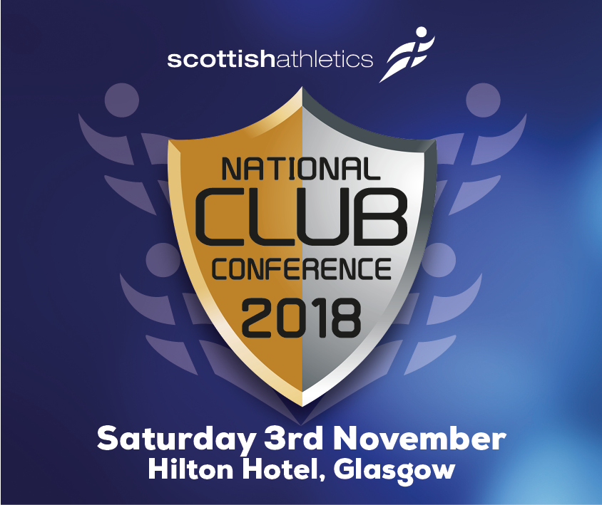

**National Club Conference - Timetable**

|  |  |  |  |
| --- | --- | --- | --- |
| **Time** |  | | |
| 9:30am – 9:40am | **Welcome** – Mark Munro, Chief Executive Officer of **scottish**athletics | | |
| 9:40am – 10:00am | **scottishathletics Club Development and Welfare Update – scottish**athletics **Development Team and Welfare Officer** | | |
| 10:00am – 10:30am | **Gavin Oattes –** keynote – Leadership Development | | |
| 10:30am – 10:45am | **Refreshment Break** | | |
| 10:45am -11:30 am | **Workshops – Session One** | | |
| Governance in Practice - Bellahouston Harriers | Officials recruitment and retention – Shona Malcolm, **scottish**athletics | Community Engagement -Spartans Football Community Academy |
| 11:30-12:15 | **Workshops – Session Two** | | |
| ClubServe – Mike Lynch, GB Sport | Delivering club development across multiple training bases and providing a club open to all - Fife AC | Community Engagement -Spartans Football Community Academy |
| 12:15pm – 1:00pm | **Lunch** | | |
| 1:00pm-2:15pm | **Round table – Gavin Oattes – Three topics** | | |
| Your clubs’ vision – thinking differently; thinking outside the box | Volunteer recruitment and retention | Communicating effectively with your membership |
| 2:15pm-2:30pm | **Refreshment Break** | | |
| 2:30-3:15pm | **Workshops – Session Three** | | |
| ClubServe – Mike Lynch, GB Sport | Coaching Structures -Kilmarnock Harriers and AC | Our evolving business model -Livingston AC |
| 3:15 pm -3:30 pm | **Guest Speaker**   |  | | --- | | Olympic, World, European and Commonwealth medallist - Eilidh Doyle | | | |
| 3:30 pm – 3:45 pm | **Summary & Close** | | |