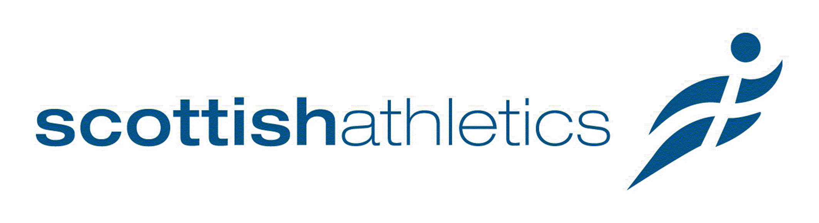

National Officials’ Conference

Booking & Data Form

Title | Mr  Mrs  Miss  Ms  Dr  Other 
Name
Licence Number
E-mail
Phone (mobile)
Workshop 1 (√) |  | Workshop 2 (√)
Workshop 3 (√) |  | Workshop 4 (√)
How many Years have you been Officiating

PAYMENT DETAILS

Officials’ Conference - £10

Please tick the appropriate box(s):-

Switch |  | Visa Debit |  |  |  | Visa |  |  |  |  |  |  | Mastercard |  |  |  |  |  |  |  |  |  |  |  | Solo
Card No
Issue No |  | Valid From |  |  |  |  |  | Valid To
Name on Card |  |  |  |  |  |  |  |  |  |  |  |  |  |  |  |  |  | Security No

Please return to Shona Malcolm at: scottishathletics, Caledonia House, Redheughs Rigg, South Gyle, Edinburgh EH12 9DQ or shonamalcolm@scottishathletics.org.uk



