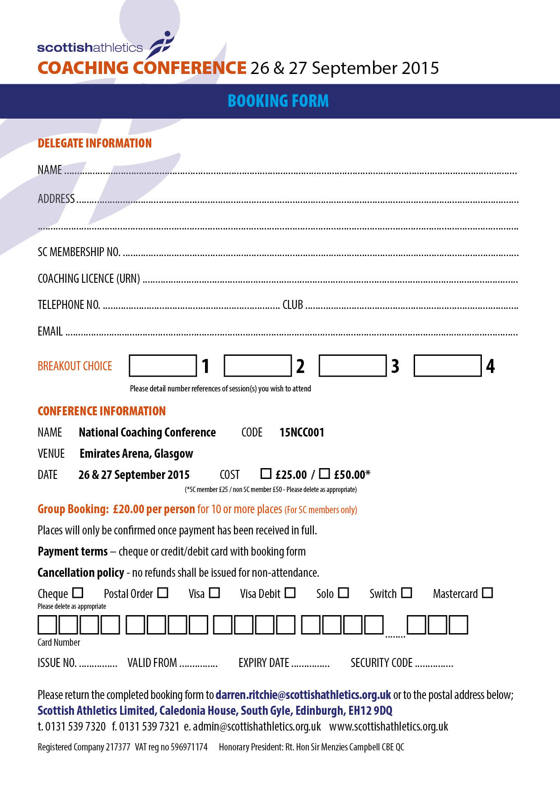

?

?

?

?

?

?

?

?

?

?

000

00/00

00

00/00

?

?

?

?

?

?

?

?

?

•

•

•

•

•

•

•

Email Here

•

•

00-00

00-00

00-00

00-00

Club Here

Telephone Here

Membership No Here

Name Here

Address Here

Address Line 2 Here

URN Here