Athletes Information
Scottish National Senior Championships
15th and 16^{h} August 2015
Aberdeen Sports Village,
Linksfield Road, Aberdeen, AB24 5RU

Getting There & Parking
The will be limited car parking available at the area. If this area becomes full the over spill car park will be available. Please see the Map attached to this email for help with directions.

Declarations
On arrival, athletes please report to declarations which will be situated in the Sports Studio next to the indoor warm up area. Declarations will open from approx. 10:00 until 14:00 both days. Athletes must declare no later than one hour before their scheduled event.

Competition Numbers: These will be issued on declaration for your event(s), one number per athlete. Only competitors wearing the correct number will be permitted to enter the competition area. Numbers must not be folded, mutilated or concealed in any way. The same number must be worn on front and back. It will be used for both competition days.

Please inform the Referee if you are not fit to continue in an event for which you have declared.

If any athlete is in a field and track event at the same time, it is extremely important that you please notify the Call Room when reporting in.

Call Room
There will be one call room in operation for these championships.

Track athletes should be advised that they should report to Call Room for no later than 20 minutes before their scheduled event. For throws and horizontal jumps 40 minutes, high jump 50 minutes and pole vault 60 minutes. All athletes are reminded that coaches and/or parents are not permitted in Call Room.

Leg numbers: will be issued in Call Room.

Timetable
Timetables are available online and are sent out along with the athlete’s information. They will also be posted at the event. If not enough athletes declare for heats then the event will take place as a final at the timetabled final time. If semi-finals are not required finals will be contested at final time.

Track Events
Athletes are reminded of the False Start Rule 111.

Track Events - Relays
Athletes, Team Managers and Coaches should be aware of Rule 118 Relay Races.

Field Events
Qualification conditions are - three trials and thereafter the leading eight competitors will be allowed a further three trials (If there are less than eight athletes then all will get six trials)

ATHLETES MUST OBEY ALL STADIUM RULES

Equipment
Own Equipment Check in: Must be 75 minutes before start of your event
Use of own blocks: Athletes are NOT allowed to use their own blocks. Stadium blocks will be available at both Competition and Warm Up areas.
Length of Spikes: 9mm for track and 12mm for High jump and Javelin

Spectators
Spectators all are welcome. There will be a small admission charge of £3 per person.

Catering
There are two Café’s within Aberdeen Sports Village, situated at both the entrance to the Sports Centre and Aquatics Centre. In Addition a Catering Van will be on site.

Advertising
Athletes are reminded of UKA Rule 116 which limits sponsorship advertising on competition clothing.

Medals
Medals will be awarded for all Championship events. Medal ceremonies for field events will take place immediately following the conclusion of each competition. Medal ceremonies for track events will take place immediately after kit collection.

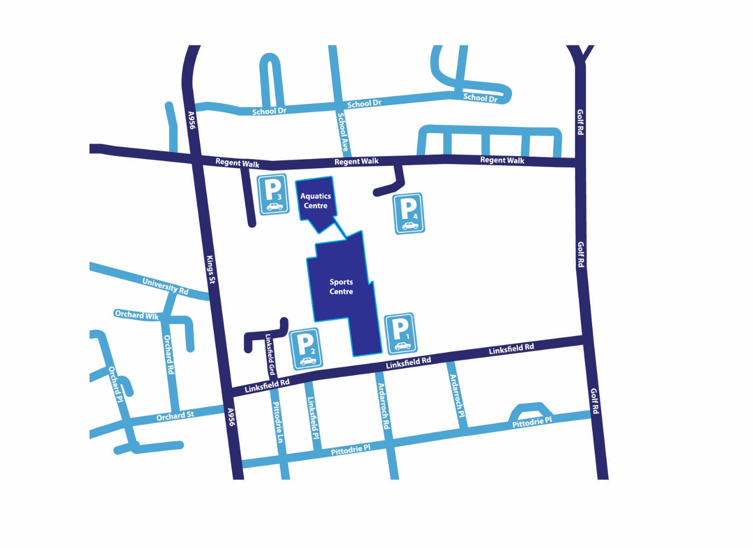
Aberdeen Sports Village Parking

