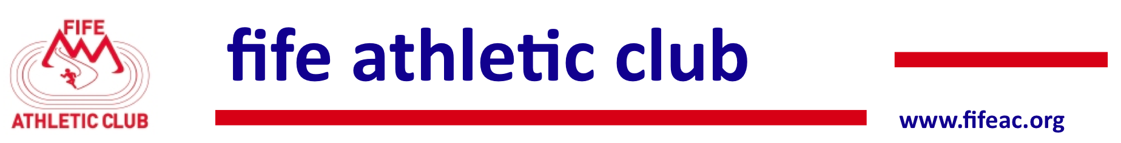

Fife Athletic Club
Festival of Trail Running
Incorporating the Scottish Athletics Mid–Trail Championships
Under UKA Rules

Falkland Estate, Fife KY15 7AF
5/9/2015

The Fife Athletic Club Festival of Trail Running caters for all standards of athletes from beginners to Scottish Internationalists. The races are open to all and will take place in the beautiful Falkland Estate in Fife. For members of Scottish Athletics the events incorporate the Scottish Mid–Trail Championships and for all competitors there is an extensive prize list. This is your chance to meet and run with the champions.

Entries
http://www.entrycentral.com/FAC-Festival-of-Trail-Running

Declarations and Parking
Declarations and parking for all events will take place at the Village Hall, Back Wynd, Falkland KY15 7BX. Due to parking restrictions please do not take cars into the Estate.

The Race Programme – Medals, Prizes and Entry Fees
- Race Timetable & Entry Fees
Race | Declarations  Close | Race  Starts | Distance | Entry  Fee
U11 Boys and Girls | 11.30am | 12.00 noon | 3K | £3
U13 Boys and Girls | 12.00 noon | 12.30pm | 3K | £3
U15 Boys and Girls | 12.30pm | 1.00pm | 5K | £7/£5*
U17 Men and Women | 1.00pm | 1.30pm | 5K | £7/£5*
U20/Senior/Masters  Men and Women | 1.30pm | 2pm | 15K | £12/£10*
* SAL Members
  - The Championships will be held within the U15, U17 and U20/Senior/Masters mixed gender races
  - The U11 and U13 races are open but non championship events
- SAL Championships & medals
  - 1st 3 individuals both male and female for U15, U17, U20, Senior, O40, O50, O60, O70
  - 1st 3 teams both male and female in U15 race (3 to count)
  - 1st 3 teams both male and female in U17 race (3 to count)
  - 1st 3 teams both male and female in U20/Senior/Masters race (4 to count)
  - All eligible athletes (U20/Senior/Masters) may count in the Senior championship race as well as their own age category
  - Masters and U20s compete in the Senior team race
- In all events the age is determined on the day of the race 5th September 2015.

Prize List
- There will be prizes both male and female for the 1st 3 individuals in all races and for the teams in the medal races.

Course Maps – Preliminary Versions
- 3K route
- 5K route
- 15K route

Declarations & Presentations
- Declarations for all event will take place in the Village Hall, Back Wynd, Falkland KY15 7BX
- Presentations for U11, U13, U15 and U17 races will take place at the finish area
- Presentations for all other races will take place in the Village Hall asap after the last runner has finished

Refreshments
- Soup, sandwiches, tea, coffee will be available at the Village Hall. For those familiar with the Devil’s Burden Relay, Tour of Fife, Norman’s Law, Cupar 5, Ceres 8, Giffordtown 5K, Chariots of Fire etc you will know what to expect. For others it is a treat in store.

