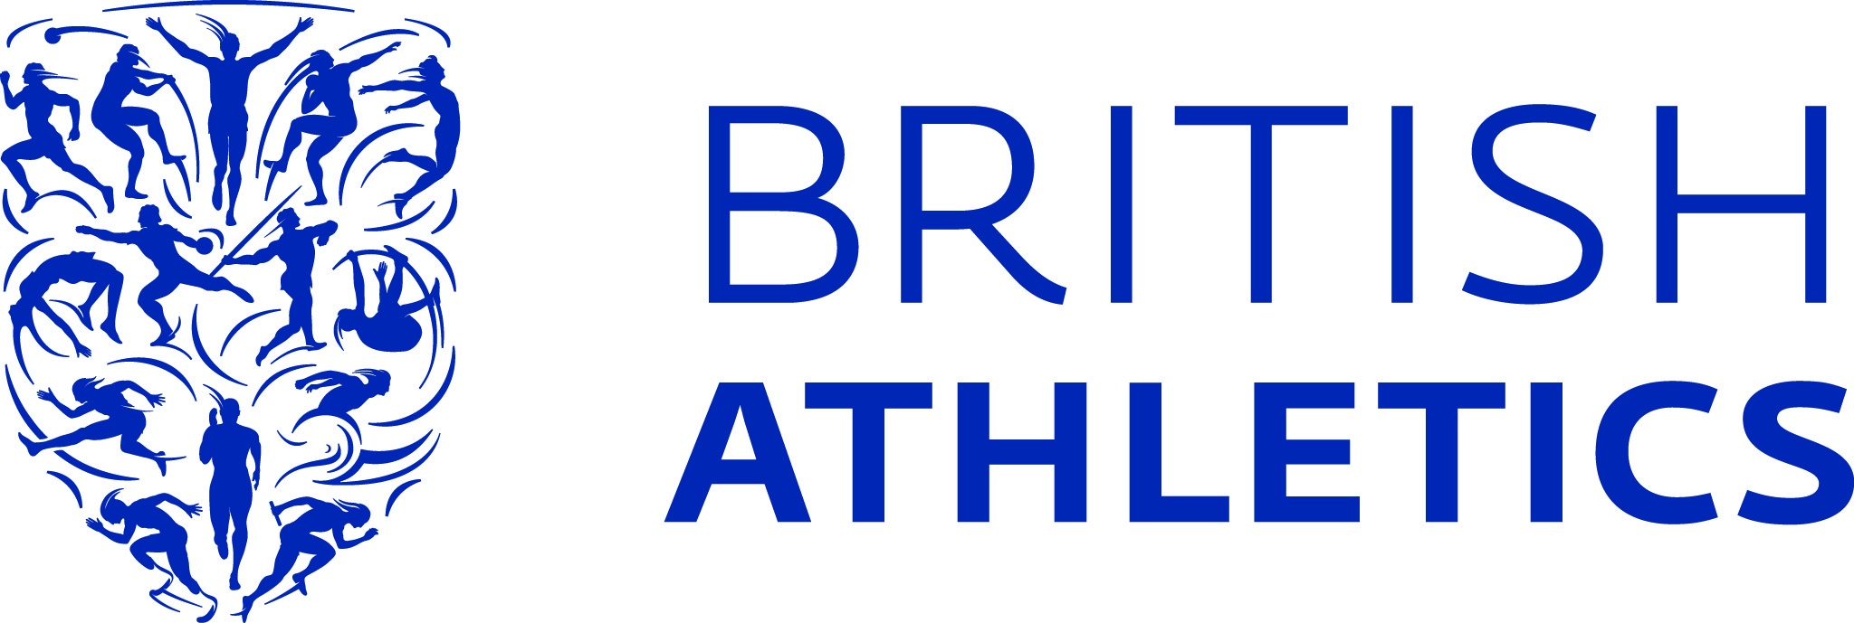
23/06/15

PRESS RELEASE DDRAFT

ESS RELEASE

BAR SET HIGH FOR GB & NI TEAM HEADING TO SWEDEN

European Junior number ones Morgan Lake (coach: Eldon Lake), Ojie Edoburun (Jonas Tawiah-Dodoo), Shannon Hylton (John Blackie) and Bobby Clay (Peter Mullervy) are among 32 athletes announced in the first wave of selections for the European Junior Championships in Eskilstuna, Sweden on 16-19 July. A 22-strong team has also been confirmed for the Mannheim Bauhaus Juniorengala this weekend.
Double World Junior champion Lake leads the European junior high jump standings courtesy of a 1.94m clearance at the England Athletics U20/23 Championships in Bedford on Sunday and will look to follow her gold medal winning performances from Eugene last summer.
Edoburun, the 2013 World Youth silver medallist came through the rounds convincingly before winning the 100m in 10.33 at the Bedford International Stadium adding to his growing stature as one of the world’s best junior sprinters.
Hylton meanwhile was also an impressive winner in the 200m recording a time of 23.53 (+2.7) and will be joined on the team by twin sister Cheriece (John Blackie), who won the 400m title in a new personal best of 53.54.
After leading from start to finish in the women’s 1500m, Clay booked an automatic spot on the team heading for Sweden with a 4:16.29 clocking, while Taylor Campbell (Paul Dickenson) will lead the way in the hammer after extending his British Junior record to 78.74m on Saturday.
Kyle Langford (George Harrison) will also be in positive mood ahead of the forthcoming championships after regaining his 800m title on the weekend cruising to victory in 1:50.8.
GB & NI team leader Jo Summers said: “We have had some fantastic performances over the last few months and collectively as a team, we are heading to Sweden in really good shape.
“We saw that despite challenging conditions at times in Bedford, the athletes as a whole were able to show the sort of maturity that will hopefully put them into medal contention in a few weeks’ time. Mannheim is a key competition ahead of the trip to Eskilstuna and will give the athletes a chance to complete their preparations before flying out to the European Juniors.”
Campbell, Edoburun and Shannon Hylton are among the athletes also selected for the event in Germany which will provide preparation ahead of the European Junior Championships and offer an opportunity to earn the qualifying standard before the second wave of selection.
GB & NI team for the European Junior Championships after the first wave of selection (second wave to be released on Tuesday 7 July):
MEN
100m: Ojie Edoburun (Jonas Tawiah-Dodoo), Joseph Dewar (Gladys Bird)
200m: Elliot Powell (Glenys Morton)
800m: Kyle Langford (George Harrison)
1500m: Josh Kerr (Mark Pollard), Liam Dee (Ricardo Santos)
5000m: Alex George (Paul de-Camps), Gus Cockle (Mick Woods)
10,000m: Jack Rowe (Mick Woods)
10,000m race walk: Callum Wilkinson (Mick Graham)
110m hurdles: Jack Hatton (Malcolm Arnold)
3000m steeplechase: Jack Jibb (Jim Glover)
Long jump: Jacob Fincham-Dukes (Matt Barton)
Triple jump: Montel Nevers (Nigel Kesteven)
Hammer: Taylor Campbell (Paul Dickenson)
Javelin: Harry Hughes (Mike McNeill)
Pole vault: Harry Coppell (John Mitchell), Charlie Myers (Chris Boundy)
Decathlon: Tim Duckworth (Toby Stevenson)

WOMEN
100m: Daryll Neita (Jonas Tawiah-Dodoo)
200m: Shannon Hylton (John Blackie), Charlotte McLennaghan (David Hourd)
400m: Cheriece Hylton (John Blackie)
800m: Molly Long (John Knowles)
1500m: Bobby Clay (Peter Mullervy), Amy Griffiths (Mick Woods)
5000m: Grace Baker (Mick Woods), Bronwen Owen (Andrew Henderson)
10,000m race walk: Emma Achurch (Steve Arnold)
High jump: Morgan Lake (Eldon Lake)
Shot put: Adele Nicoll (Vladimir Zinchenko)
Discus: Amy Holder (Neville Thompson)

GB & NI Team for the Mannheim Bauhaus Juniorengala on 27-28 June in Germany:
MEN:

100m: Reuben Arthur (Ryan Freckleton), Joseph Dewar (Gladys Bird)

200m: Elliot Powell (Glenys Morton), Freddie Owsley

Triple Jump: Montel Nevers (Nigel Kesteven)

Pole Vault: Harry Coppell (John Mitchell), Adam Hague (Trevor Fox), Charlie Myers (Chris Boundy)

Hammer: Taylor Campbell (Paul Dickenson/Chris Black)

110m hurdles: Jack Hatton (Malcolm Arnold), Jack Kirby (Laura Turner-Alleyne)

400m hurdles: Jack Lawrie (John Macdonald)

4x100m relay: Reuben Arthur (Freckleton), Joseph Dewar (Bird), Ojie Edoburun (Jonas Tawiah-Dodoo), Theo Etienne (Ryan Freckleton), Freddie Owsley, Elliot Powell (Morton)

WOMEN:

200m: Shannon Hylton (John Blackie), Charlotte McLennaghan (David Hourd)

400m: Cheriece Hylton (John Blackie), Lina Nielsen (Frank Adams)

Discus: Amy Holder (Neville Thompson)

4x100m relay: Shannon Hylton (Blackie), Imani Lansiquot (Joseph Felix), Shannon Malone (Richard Sayer), Charlotte McLennahan (Hourd), Daryll Neita (Jonas Tawiah-Dodoo),

***ENDS***

For more information, please contact:
Alex Ferguson
Senior Media Officer
T: +44 (0) 7702 849 276
E: aferguson@britishathletics.org.uk

Notes to Editors:
UK Athletics
UK Athletics is the national governing body of the leading Olympic and Paralympic sport in Britain. British Athletics is the sport we represent, the people, the athletes, the fans, the team.
We work closely with the home countries to develop and grow all areas of the sport including elite performance, coaching, major international events, competition and grassroots programmes within schools and clubs.
For more information visit www.britishathletics.org.uk
Follow us on:
Facebook – http://www.facebook.com/britishathletics
Twitter – @britathletics
Youtube – youtube.com/britishathleticstv

