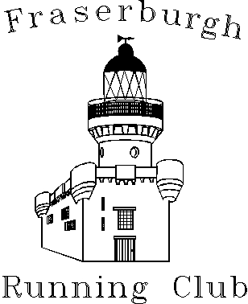

Club Together Officer – Fraserburgh Running Club
33 month contract

Salary - £5368.42 (12hrs per week)

An exciting opportunity has arisen within Fraserburgh Running Club for a Club Together Officer, in partnership with scottishathletics and sportscotland. Club Together is a fundamental project within Scotland’s National Club Development programme for athletics, Club Legacy 2014 that places a key focus on supporting the development of athletics clubs in the country.

The role will have a significant impact in the growth and development of the club and the twin aspects of our vision of increasing participation and performance sit at the heart of everything we do - neither however is possible without athletics clubs playing their part.

This part time post (12 hours per week) is funded through a partnership between Fraserburgh Running Club and scottishathletics. Club Together is exactly that – clubs, scottishathletics and others coming together to deliver once and for all a programme that will make the athletics vision happen.

Application Process
Applications should be made by submitting the application form, equal opportunities form and covering letter to scottishathletics. The application should be marked confidential and sent to:

Dawn Allan
scottishathletics Ltd
Caledonia House
South Gyle
EDINBURGH
EH12 9DQ

Or email: dawn.allan@scottishathletics.org.uk

Closing Date for Applications: Monday 23rd March 2015 at 5pm

Any offer of employment would be subject to a satisfactory PVG check and references.
scottishathletics is an equal opportunities organisation.




