Scottish Athletics Field Events Grand Prix Series (Incorporating Hammerama & Seated Throws) 2015

(Held under UKA & IPC Rule – IPC approved)

Venue - Craigswood Stadium Livingston

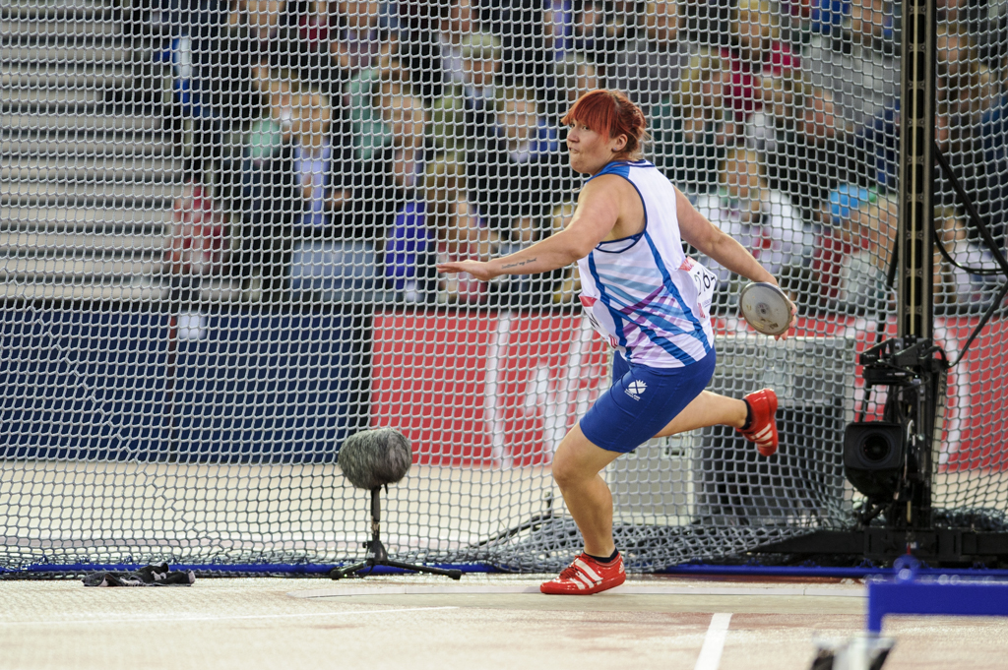
Dates:-
GP1 – 11 & 12 April - 2015
GP2 – 6 & 7 June - 2015
GP3 – 25 & 26 July - 2015

GP Final – 5 & 6 September

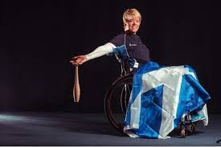
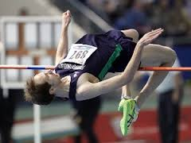

Supporting Field Events in Scotland
Save money by pre-entering

Pre Comp Entries: £5 per event.
On the day £10 per event.
Series Entry: £16 per event (series entry fees will be collected at the first GP Meeting

Entries close 1 week prior to each event
Prizes will be awarded throughout the age groups. Details to be announced later

Entries should be sent to:
Mary Anderson
Scottish Athletics
Caledonia House
South Gyle
Edinburgh
EH12 9DQ

Or e-mail
mary.anderson@scottishathletics.org.uk

Entry Fees will be collected on the day at registration

- Declarations will close 1 hour prior to event.
- Weigh in for personal implements 60 min prior to
Event
- All athletes will get 6 attempts (throws and horizontal jumps)
- 2 Warm up attempts will be allowed

Official Entry Form

Name____________________________________

Club/School_______________________________

Date of Birth_______________ Age Group _____________________

Address ____________________________________________

Email Address______________________

Telephone Number_____________ Mobile Number________________

SAL Membership No ___________________________________

Classification_______________________________________

Favourite music track_________________________________

Event 1 ____________ PB_____________

Anticipated Performance_________

Event 2_____________ PB_______________

Anticipated Performance _______________

Event 3_____________ PB_______________

Anticipated Performance _______________

GP1 – Saturday 11/Sunday 12 April 2015

GP2 – Saturday 6/Sunday 7 June 2015

GP3 – Saturday 25/Sunday 26 July 2015
GP Final – Saturday 5 Sunday 6 September 2015

