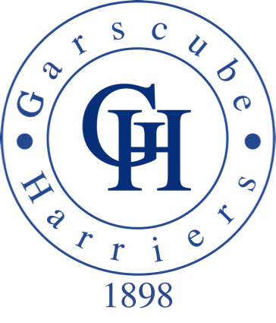


Club Together Officer - Garscube Harriers
19 months fixed term, part time contract

Salary - £7,163 15 hours per week

An exciting opportunity has arisen within Garscube Harriers for a Club Together Officer in partnership with scottishathletics and Glasgow Sport. Club Together is a fundamental project within Scotland’s National Club Development programme for Athletics, Club Legacy 2014 that places a key focus on supporting the development of athletics clubs in the country.

The role will have a significant impact in the growth and development of the club coaches and officials and the twin aspects of our vision of increasing participation and performance sit at the heart of everything we do - neither however is possible without athletics clubs playing their part.

This part time post is funded through a partnership between Garscube Harriers, scottishathletics and Glasgow Sport. Club Together is exactly that – clubs, scottishathletics and Local Authority coming together to deliver once and for all a programme that will make the athletics vision happen.

Application Process
Applications should be made by submitting the application form and covering letter to scottishathletics. The application should be marked confidential and sent to:

Dawn Allan
scottishathletics Ltd
Caledonia House
South Gyle
EDINBURGH
EH12 9DQ

Or email: dawn.allan@scottishathletics.org.uk

Closing date: Sunday 15th February 5pm
Any offer of employment would be subject to a satisfactory PVG check and references.
scottishathletics is an equal opportunities organisation.

Down Loads: 1. Application Form 2. Job Description 3. Person Specification



