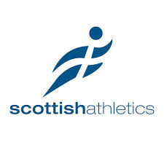Scottish Athletics Annual Awards Dinner

Saturday 22nd November 2014

Hampden Park, Glasgow

Ticket Booking Form

Contact Name:

Contact Telephone Number:

Email:

Names of attendees: Dietary Requirements:

|  |  |
| --- | --- |
|  |  |
|  |  |
|  |  |
|  |  |
|  |  |
|  |  |
|  |  |
|  |  |
|  |  |
|  |  |

|  |
| --- |
|  |

Tickets are £40 per person Total Cost £

Cheque (enclosed)  Visa  Visa Debit  Switch  Mastercard 

    ..... 

Issue No. ______ Valid From _________ Expiry Date _________ Security Code 

**scottish**atheltics contact is Claire Archbold email [events@scottishathletics.org.uk](mailto:events@scottishathletics.org.uk) tel. 0131 476 7335

Scottish Athletics Limited, Caledonia House, South Gyle, Edinburgh, EH12 9DQ

**t.** 0131 539 7320 **f.** 0131 539 7321 **w.** [www.scottishathletics.org.uk](http://www.scottishathletics.org.uk) **e.** [admin@scottishathletics.org.uk](mailto:admin@scottishathletics.org.uk)

Registered Company 217377 VAT reg no 596971174

Honorary President: Rt. Hon Sir Menzies Campbell CBE QC MP