GIRFEC AND THE WELLBEING OF CHILDREN

The Children and Young People (Scotland) Act 2014 is principally focussed on improving the wellbeing of children and young people. The Act is wide ranging and includes key parts of the Getting it right for every child approach, commonly known as GIRFEC.

Wellbeing sits at the heart of the GIRFEC approach and reflects the need to tailor the support and help that children, young people and their parents are offered to support their wellbeing.
Wellbeing is broader in scope than child protection which is a response to abuse or a crisis in the child’s life. A child or young person’s wellbeing is influenced by everything around them and the different experiences and needs they have at different times in their lives.
To help make sure everyone – children, young people, parents, and volunteers/staff that work with them in our clubs, has a common understanding of what wellbeing means, they are described in terms of eight indicators, commonly referred to by the acronym - SHANARRI.
The wellbeing wheel below provides detail on what the indicators mean.

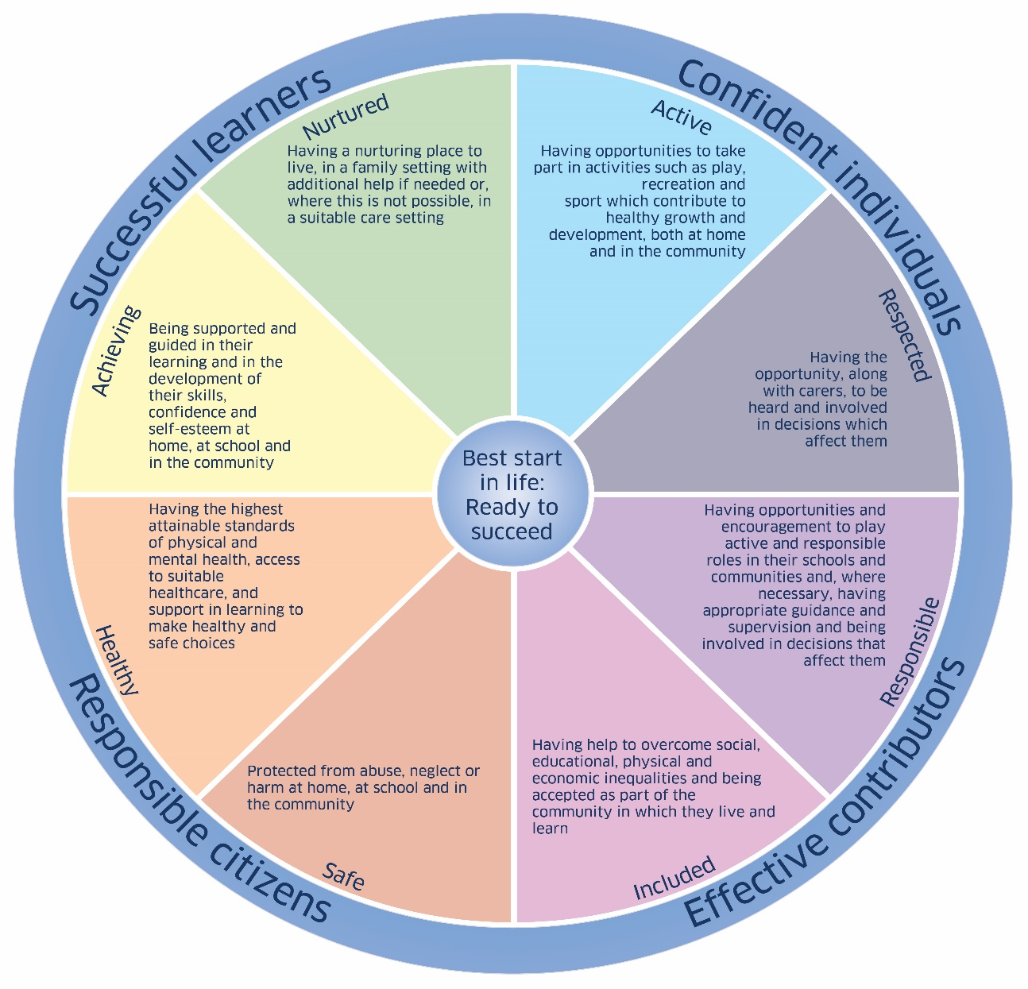

By having a universal language and understanding for all people that work and volunteer with children, we can collectively contribute to promoting, supporting and safeguarding a child’s wellbeing, whether they are in an educational, community, or sports setting. Welfare officers should note that when making a concern referral to social work they may be asked which of the SHANARRI indicators the case includes.

It is essential that we understand not only how participation in sport contributes to these wellbeing indicators, but also what we need to do if we are ever worried that something is impacting a child’s wellbeing. As such this guidance should be read in conjunction with the documents on;

- Child Abuse: Definitions, Signs and Indicators
- Responding to a concern about a child

GIRFEC and the SHANARRI indicators are an important element of Scottish Athletics child wellbeing and protection policy and practice. Sport Scotland and Children 1st have incorporated them as the central principle of the new standards for child wellbeing and protection in sport launched in January 2018.

The SHANARRI Indicators can be used to identify when a child may be in need of support, but they can also be used to review existing policies and processes. We would encourage every club to incorporate the indicators into their local policies and guidelines. For examples of how clubs can use the indicators in this way see the table below:

Safe | Ensure all those volunteering/working with children have joined the PVG scheme prior to starting in the role, have signed up to the club code of conduct for their role, and have, or are scheduled within 3 months, to attend safeguarding in sport training.
Healthy | Create and environment which enables all children in your club to experience the physical and mental benefits of being active and support them to make healthy and safe choices.
Achieving | Develop an environment that both supports and encourages children to develop their skills, confidence and self-esteem through participation and the achievement of personal goals.
Nurtured | Ensuring the athletics environment is stimulating, enabling children to develop a range of skills and realise their potential.
Active | Providing opportunities for all children to be physically active through participation in athletics.
Respected | Making sure all children are treated with respect by adults and peers regardless of what they may have done or may have failed to do.
Responsible | Educate children on the importance of rules, etiquette, and honesty in athletics, and encourage them to take an active role in decisions that affect them.
Included | Ensure all children are included and can help to make a valuable contribution to the sport.

