

Annual Coaching Conference
20/21 September 2014
Emirates Arena, Glasgow

Kelvin Giles
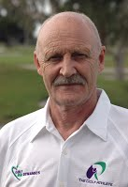
Giles is the former UK National and Olympic Track & Field Coach, and spent 30 years in Australia’s high performance sport environment. He was Head T&F Coach at the Australian Institute of Sport in Canberra and Head of the Athletic Development department at the Queensland Academy of Sport in Brisbane. Kelvin spent six years at the helm of the Brisbane Broncos Rugby League team as Director of Performance and also led the Australian Rugby Union’s Elite Player Development section. Giles coached 14 Olympic and World Championship athletes over a 40-year career. Kelvin is currently CEO of Movement Dynamics UK Ltd and currently consults across a range of National Governing Bodies and Federations, including scottishathletics, and is the author of the Physical Competence Assessment resources.
Giles will be headlining the weekend with a keynote on physical competencies and future directions for the sport, along with leading practical sessions on conditioning and movement for the developing athlete.

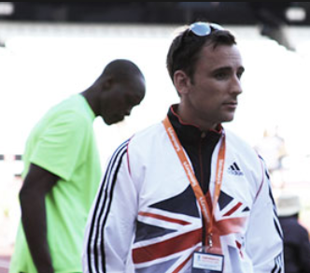
Steve Fudge
Steve Fudge is currently employed by UK Athletics as an Institute sprint coach, where he has enjoyed early success in his coaching career, guiding the previously injury-plagued James Dasaolu to the European Championships Gold Medal in the 100m and Adam Gemili to the 200m Gold Medal, arguably making his name as one of the world’s top sprints coaches.
With expanding interests in therapy, nutrition, philosophy, and neuro-science, as well as a background in strength & conditioning and massage, Steve has been able to successfully apply his studies to the science of his sport, where Dasaolu has credited him with transforming him into a sub-10 sprinter after years of injury problems caused by over training.
Topics covered will include block positions, acceleration and high speed mechanics and speed development through the year.

Benke Blomkvist
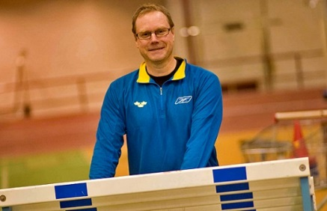
Blomkvist is currently working at the National training centre in Falun, where he is the coordinator for sprint hurdles at National level for Swedish Athletics. For the past 20 years Benke has been working as a professional coach where he has coached athletes from the youth level to the world elite, including women’s 60mH World record holder Susanna Kallur and her sister Jenny Kallur.
During 2007-2009 Benke working for UK Athletics as a senior performance coach with the mission of developing sprinters and hurdlers to world class, where he coached William Sharman, Dai Greene and Rhys Williams.
Topics covered will include functional conditioning through hurdles, take-off and landing positions and acceleration runs.
John Trower
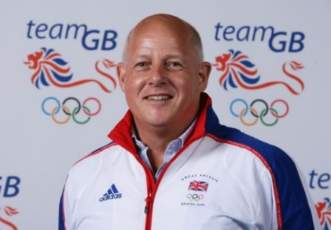
John Trower coached the Javelin to an elite level for over twenty five years, where he personally coached Steve Backley, Michael Hill, and Kelly Morgan, javelin throwers who have won major games medals at Olympic Games and World Championships since 1990, and in Backley’s case broke the javelin world record on three occasions during the period 1990 to 1992.
Trower was the Deputy Team Leader for the GB Athletics Team at the Beijing Olympics 2008, and Team Leader with the very successful GB U23 Team at the U23 European Championships in Kaunas Lithuania 2009.
Topics covered will include transfer of power in the throws along with a coaching on Javelin. Trower will also be delivering a coaching seminar on bridging the gaps in throws
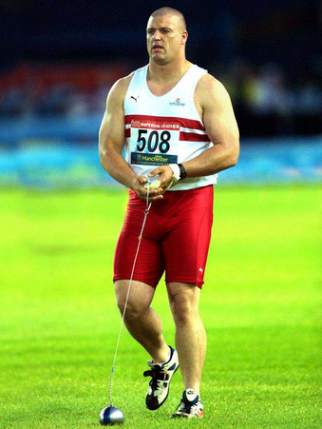
Mick Jones
Mick Jones is the former Commonwealth Champion at the 2002 Commonwealth Games in Manchester, and previously coached by the late Alan Bertram.
Jones competed in British athletics for over 20 years and captained the Great Britain team to victories in the European Cup. Jones is currently ranked fourth in the British all-time British thrower in the hammer, and is currently coaching Scottish Commonwealth athlete, Chris Bennett.
During the conference, Jones will deliver a number of practical workshops on fundamental conditioning for throws along with a Hammer coaching clinic. Jones will also be teaming up with scottishathletics National Coach Mentor, Hugh Murray in a coaching clinic covering Shot and Discus.

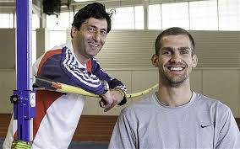
Fuzz Ahmed
During his 22 year coaching career, Fuzz has worked with a number of major championship medallists which include 2008 Olympic silver medallist Germaine Mason and 2012 Olympic Bronze medallist and European Champion, Robbie Grabarz. Fuzz also achieved coaching success at the 2006 Commonwealth Games with Silver medallist Julie Crane in Melbourne, and more recently coached England’s Isobel Pooley to the silver medal at the Commonwealth Games in Glasgow, with a lifetime best of 1.92m.

As well as coaching Robbie, Fuzz is also working Italy’s Marco Fassinotti (2.34m), and Scottish athletes David Smith (2.25m) and Allan Smith (2.26m).
Over the weekend, Fuzz will be delivering a keynote along with a number of practical sessions on conditioning and the technical development of the high jump. With Fuzz’s background as an actor, his unique coaching style and personality will make for the weekend to be enjoyable and informative.

Dr Barry Fudge
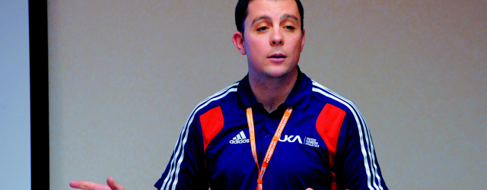
Prior to his appointment as Head of Endurance, Dr. Barry Fudge managed the delivery and the development of physiological services for UKA’s World Class Endurance Programme. Fudge specialises in researching the benefits of altitude training in terms of its ability to facilitate world-class performance, and it is this work that has seen him work closely with double Olympic and double world Champion Mo Farah. He has looked after Farah at every major championships since 2009, and his work has been a vital component in delivering Farah to the podium.
Topics covered will include the development of endurance running and Priming for competition. At the end of the weekend Stephen Maguire will host a special Q&A with Dr Fudge and his brother Steve on their experiences and lessons learned through their coaching journey.

David Rowland
Dave Rowland is the England Athletics National Coach Mentor for Physical Preparation and provides support to coaches across the National Coach Development Programme. Dave is a Strength and Conditioning consultant at University of Bristol and former head of S&C at Bristol Rugby. He has coached at both senior and junior international level through to grass roots level. He has qualifications in sports injury management as well as experience of working alongside medical and other practitioners in athlete support teams.

Over the weekend David will be delivering practical workshops covering the conditioning of the endurance athlete and exploring the physical competencies for the endurance athlete.

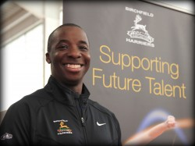
Femi Akinsanya
Femi is the current England Athletics National Coach Mentor for Triple Jump. He has worked with elite, high profile athletes such as Phillips Idowu and Louise Hazel. Femi still coaches many developing athletes in sprints and jumps, his coaching experience ranges from club to Olympic level, giving him a wealth of knowledge that is invaluable.
Femi has supported the scottishathletics National Coach development programme by leading on the horizontal jumps for the past two years. Over the weekend, Femi will be delivering practical sessions on plyometric conditioning of the power athlete, delivering a coaching clinic on horizontal jumps for beginners and exploring the speed development for the horizontal jumper.

Rodger Harkins
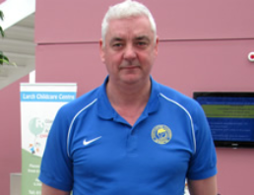
Rodger is the current scottishathletics National Coach Mentor for sprints & relays. He has worked with elite, high profile athletes and is well known for his work in developing Scotland’s 400m and 4x400m star Lee McConnell. More recently Harkins was the team coach at the Commonwealth Games where the Scotland men’s team broke the Scottish National record in the 4 x 400m, booking their place in the Commonwealth Final. Harkins will be leading on a practical session looking at the technical drills for sprints at club and development level.

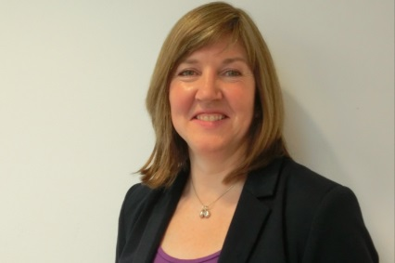
Alison Johnstone, MSP
Alison is currently a Member of the Scottish Parliament (MSP) for Lothian representing the Green Party, and previously a City of Edinburgh Councillor, Alison is closely involved with sporting issues and is Co-Convenor of the Cross Party Group on Sport among other related interests.
With a competitive athletics pedigree as a middle distance athlete, Alison is now involved in coaching as a member of Edinburgh AC, and has been involved directly with Women in Coaching activities and leadership within athletics, which will be one of the key seminars during the conference over the weekend.

Sean Tough
sportscotland Strength and Conditioning Coach Sean Tough will be supported by scottishathletics Ian Mirfin at the annual coaching conference when they deliver a workshop on strength and conditioning for the para-athlete. The workshop will discuss the implementation of a conditioning programme, led by the coach and will be presentation based, involving practical demonstration.

