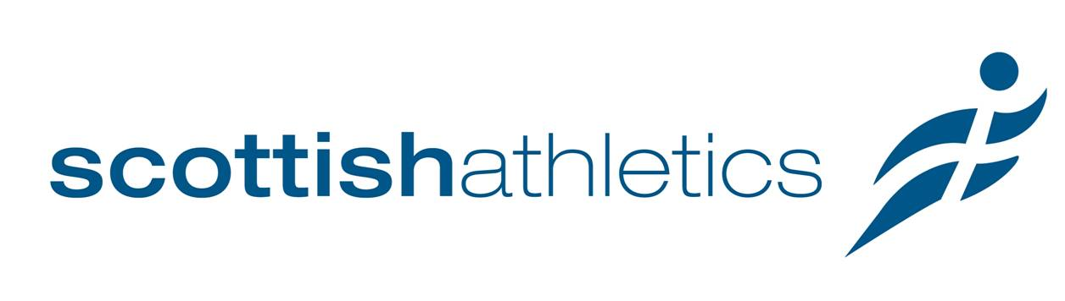

Scottish Eligibility

Standard international matches
To be considered for selection to compete for Scotland, an athlete must be born in Scotland, have one or more parents born in Scotland or have confirmed residency of three years in Scotland.
To have Scottish eligibility confirmed, please email francesca.snitjer@scottishathletics.org.uk and where appropriate forward original documentation, eg. birth certificate.

Commonwealth Games
Eligibility is as determined by the Commonwealth Games Federation and is detailed in the Commonwealth Games Council for Scotland General Selection Policy. In summary this is:
To be eligible to compete for Scotland in the Commonwealth Games, an athlete must be a citizen of a Commonwealth country. The following criteria must also be met:
Be Born in Scotland
and/or
Have one or more parents born in Scotland
and/or
Show they have resided in that country for five years immediately prior to those Games
and/or
Have previously competed for Scotland in the Commonwealth Games or Commonwealth Youth Games.
If none of these categories are met, then the athlete may not be eligible to compete for Scotland at the Commonwealth Games.

