Active Multi Stage Warm-up
By Vern Gambetta

The workout begins with the warm-up! It sets the tempo for the workout to follow. It is the bridge from normal daily activities to actual training. There is too much emphasis in warm-up on raising core temperature and heart rate. The main physiological objective is neural activation, getting everything firing and connected to prepare for the more intense work to follow in the actual workout. From a psychological perspective the warm-up should almost be a ritual. This can serve as a security point or anchor for the athlete. Try to stay away from stationary bikes and stair steppers as part of warm-up because of the restricted range of motion they shorten the psoas.

The warm-up can vary in length from as short as ten minutes for the warm-up before a second session to as long as thirty minutes. The length ultimately will be determined by the objective of the workout. The warm-up should be “active” not continuous. That distinction is important. Active refers to the fact that the warm-up consists of movements that are active as opposed to passive. Continuous means that the there are no breaks between warm-up activities. Continuous warm-up means that warm-up goes for a set period of time with all the exercises fit into that period. This can be used occasionally, especially on a recovery day or on a work capacity emphasis day where the subsequent workout is of low neural demand. The warm-up should build progressively in intensity into the workout. There is an emphasis on joint mobility not on static flexibility. Flexibility is trained as a separate training unit, after the workout. In a cold environment proper clothing can greatly prolong and enhance the effect of warm-up. After warm-up it is especially helpful to be able to towel off, hydrate well and change into dry clothes for the actual workout.

Active Multi-Stage Warm-up
1) Progressive Strides 6 – 8 x 50 meters
This serves to raise core temperature. These are not jogs but relaxed strides that serve to enhance good running mechanics. The last thing we want is to have the athletes start the workout by plodding. Start at 60 % and end at 80%.

2) Leg Swings
a) Swing Forward & Back b) Side to side across the body
This dynamically loosens the hip girdle

3) Mini Band Routine (12” band above ankles)
a) Sidestep b) Walk - Forward/Back c) Carioca d) Monster Walk
This is designed to strengthen and activate the small intrinsic muscles of the hip. This segment is a key factor in prevention of low back and groin injuries.

4) Balance & Stability (Alternate Static and Dynamic)
Static - Single Leg Squat (Hold each position five counts)
a) Straight 2 x ea leg b) Side 2 x ea leg c) Rotation 2 x ea leg
Dynamic - Balance Shift
Shift & Step Right - Shift & Step Left
Forward Step Right - Forward Step Left
Back Step Right - Back Step Left
The single squat addresses static balance and the balance shift addresses dynamic balance. This segment serves to help with neural activation and increase body awareness.

5) Walking Rotations (3 Kg Med Ball)
Wide Rotation x 20 - Forward & Backward
Tight Rotation x 20 - Forward & Backward
Side to Side x 20 - Forward & Backward
Figure x 20 - Forward & Backward
This segment activates the core in functional positions

6) Multi Dimensional Stretch
Lunge & Reach Series (2 reps in each plane – Forward/Side/Rotational)
Reach Up Reach Out & Down Reach Across
This series is designed to work through wide rages of motion to promote mostability.
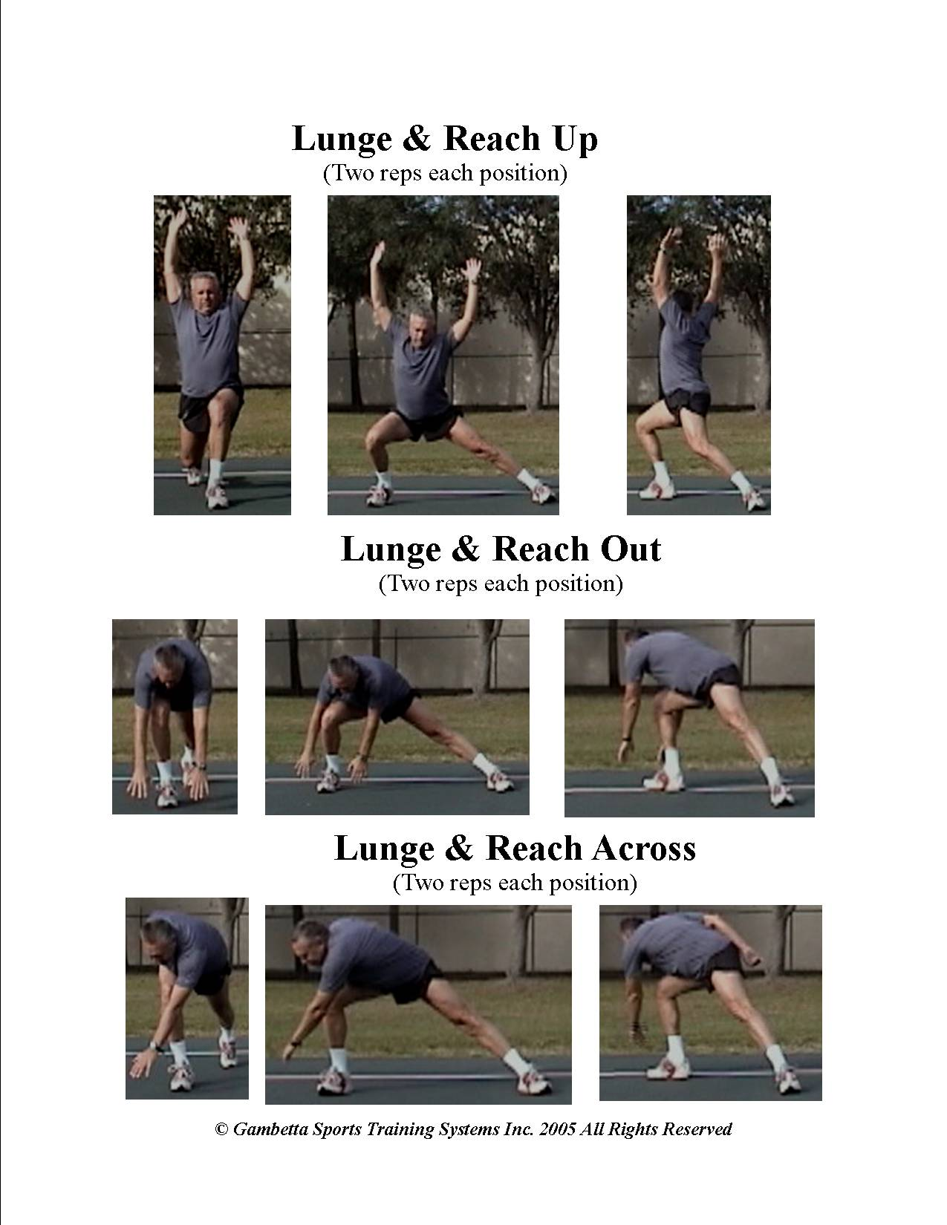

7) Active Stretch
The emphasis here is active stretching in three planes of motion for the key target areas that are needed by that individual. Every individual should have their own routines based on their individual needs.

8) Crawls
Inchworm x 5
Spiderman x 5
To work the core and reinforce opposition.

9) Hurdle Walks (Five Hurdles)
Hurdle Walks – Over
This segment addresses dynamic hip mobility

10) Coordination
Coordination I (Two reps of each exercise)
Skip
Crossover Skip
Side Step
Carioca (low & long)
Carioca (short & quick)
Backward run
High Knee Skip
High Knee Skip w/Rotation

Coordination #2 (Two reps of each exercise)
Serpentine Stride 2 x 30 yards
Crossover Skip with rotation 2 x 30 yards
Angle Sidestep 2 x 30 yards
Carioca Quick Change 2 x 30 yards
360 Turns 2 x 30 yards (Four Turns)
Line Touches 2 x 30 yards
Forward into Backpedal 2 x 30 yards
Backpedal, Turn and Go 2 x 30 yards

The coordination segment is just that, it is designed to promote coordination and body awareness. There are two modules coordination 1 which is more linear and coordination 2 which involves more change of direction. Alternate the two based on the objective of the subsequent workout.

